
(VIEW AT YOUR OWN RISK! CERTAIN SPOILERS MAY HAVE SLIPPED IN)
Thanks a lot for downloading my second game RPGM2k/3 game, TOTAL CHAOS. Hopefully you’ll enjoy this project, and if you haven’t already, download ONYX!

~*Gary Holt Jr.

CAST:
NAME: Ronald Johnson
AGE: 18
OCCUPATION: High School Senior
BIO: Ron’s young life has so far been filled with drama. And unfortunately, that’s not about to change anytime soon. After finding her husband in bed with another man, Mona took her son, Ron, and moved into a large city where no one could ever find her. Unfortunately, if she doesn’t come out of hiding soon, she could face jail time, plus a mountain of load of Child Support checks she never paid. Ron’s difficult lifestyle often frustrates him, and he wants out, but will a fateful meeting with a certain stray dog change that?
NAME: Squamus “Peppersticks” Maxillius
AGE: 25
OCCUPATION: Celestial Knight
BIO: Squamus is a Celestial Warrior from the heavens, who came to Earth to stop the Ultimate Evil that’s soon to be awakened. He is strong and determined, always thinking things through. Because of the maturity (or lack there of) of the group, he’s forced into a leadership position, because if someone doesn’t take charge, the world as we know it will cease to exist.

NAME: Lindsay Lohan
AGE: 20
OCCUPATION: Celebrity
BIO: Lindsay Lohan is an over-privileged celebrity. She gets whatever she wants and she has no regard for other people. Her publicist, Jessie, constantly nags her about her lack of concern for her career. After a fateful meeting with Ron, Lindsay finds herself pushed into this madness, and she can’t escape. Now, she must assist Ron and Squamus in saving the world while saving her career all the same.

NAME: Aneah “Ginger” Klaus
AGE: 22 physically, 422 mentally
OCCUPATION: Housewife/Succubus/Virus
BIO: Aneah was once a normal woman. She had a husband, kids, and a happy life as a 17th century housewife. On one unfortunate day, her husband left her. Heartbroken, Aneah tapped into the black arts to try to get her husband back. Her plan backfired when she was changed into a Succubus demon, and sent four hundred years into the future. Now, Society has her, and plans to use her for evil purposes. Aneah doesn’t know what is in stored for her, but she wants answers.

NAME: Quentin Ross
AGE: 20
OCCUPATION: Bully
BIO: Quentin is a rude, mean, cocky, arrogant showoff who only seems to think about the number of girlfriends he can have at the same time. He travels with his two “groupies”, Alana and Clare. They travel around the world, looking for something to do. However, this cocky side of Quentin may only be a façade. Maybe there’s more to him than what meets the eye?
NAME: Stephenie LaGrossa
AGE: 25
OCCUPATION: Reality Star
BIO: Stephenie is one of Survivor’s most popular contestants, appearing on two seasons back-to-back. Since then, the public has become somewhat tired of Stephenie. Her attempts to keep her fame have failed, and she has no other routes to turn but to Lindsay’s show. Stephenie dreams of one day creating her own reality television show. While Stephenie can have a bit of an ego, and can be a bit “slow” at times, she’s generally a nice, sweet person, always willing to help out those she loves.

NAME: Beverly Rubin
AGE: 22
OCCUPATION: Caller
BIO: Beverly is a “Caller”, a rare breed of species with the ability to contract the Supernatural for help. She’s a bright woman who attended the best schools all through childhood, and because of such, she has a bit of a chip on her shoulder. She talks down to everyone, and has a tendency to be very critical. Despite her book-smart intelligence, there have been many times when Beverly behaved foolishly, even though she condemns others for doing so.

NAME: Mina “Squelle” Washington
AGE: 27
OCCUPATION: Actress
BIO: Mina comes from a rich family of actors and actresses. The acting field never interested Mina, but because of her family’s obsession with keeping their wealth, Mina was practically forced in it. Because of such, Mina was constantly watched by the paparazzi. She wasn’t allowed to say certain things, do certain things, or talk to certain people. This often frustrated Mina, who preferred to stay in her room most of the time. She went into the show to finally act out against her parents after all these years, but will it work?

NAME: Herald “Slay” William Scott III
AGE: 24
OCCUPATION: Male Model/Freelance Demon Specialist
BIO: Herald was just your ordinary guy. He lives alone while working for a male swimsuit agency. One evening, he was attacked and nearly killed by a demon. He promised himself to never to let that happen to him again, so he decided to become an independent demon slayer. During the day, he’s a normal guy with a normal job, but at night, he devotes his life to killing demons. He has a huge demon vocabulary, which makes him useful to the group.
NAME: Jose Fernandez
AGE: 18
OCCUPATION: Best Friend
BIO: Jose is Ron’s the best friend; the two have been close for years. He’s the lively, more outgoing one between the two, having the engaging personality Ron wishes he had. Jose is naturally curious, causing him to get into all sorts of trouble. His naturally loud, wild, “party-starter” personality is an object of envy for many people around him. Jose also possesses a dangerous power within him that even he isn’t even aware of…

NAME: Jerri Spencer
AGE: 17
OCCUPATION: Ex-Stalker
BIO: Jerri is a young girl from the town of Koudo born with special, magical powers. Because of her gifts, she was teased and picked on throughout her life, causing her to become shy, quiet, and a bit introvert. Jerri doesn’t get much attention at all from anyone besides her dad, whom she loves dearly. After Ron begins paying attention to Jerri, things begin to take a turn for the worse as she begins pursuing him relentlessly.

NAME: Alronio “Al” Pal
AGE: Physically 26, mentally over 1000 thousand years old
OCCUPATION: Legendary Warrior
BIO: Like Ron, Al was once a normal male, when suddenly; he became possessed by a being from Celestia, sent to stop the Ultimate Evil. Alronio managed to do so, however, at the expense of his own life. When Vayne was awakened, the spell keeping Zeke sealed began to weaken. Because of this, Al knew that one day, the battle between him and Zeke would resurface. However, Zeke has grown in power, so defeating him may be impossible, even with the Celestial’s Prince’s help…

-battling-

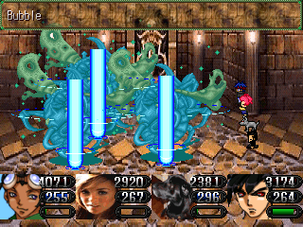
There are three types of characters, “Mage”, “Fighter”, and “Neutral”. Mage characters specialize in powerful magic. Their resistances against Magical-Elements are high, but their vulnerability to Physical elements is raised as well. Fighters are just the opposites. They’re powerful in Physical, but weak in Magical. Neutral warriors aren’t vulnerable in any element; however, they aren’t resistant against any, either.

-CLASS-
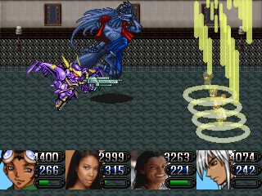
RONALD - Neutral
LINDSAY - Mage
PEPPERSTICKS - Neutral
GINGER - Mage
QUENTIN - Fighter
STEPHENIE - Fighter
MINA - Neutral
BEVERLY - Mage
SLAY - Fighter
JOSE - Neutral
JERRI - Mage
AL - Mage

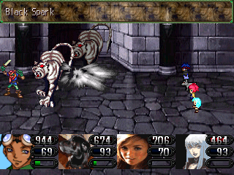
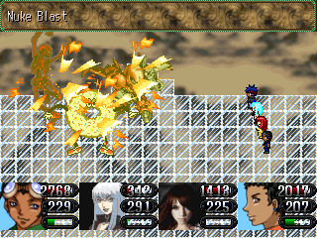

-ELEMENTS-

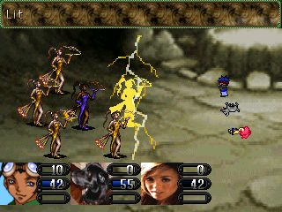

PHYSICAL (claws, gloves) – Consists of everything physical. Weak against magic.

MAGICAL – Consists of everything magical. Weak against physical.

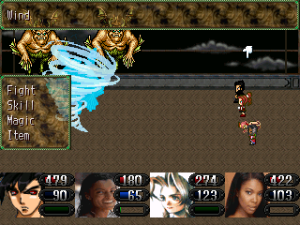
FIRE – Power of heat. Opposite of Ice.
ICE – Power of coldness. Opposite of Fire.
THUNDER – Power of storm. Weakened by Water.
WIND – Power of air and deadly winds. Stopped by Earth.
WATER – Power of the sea. Is destroyed by Thunder.
EARTH – Power of the land. Settled by Wind.
HOLY – Power of the Sacred land. Resists the Darkness.
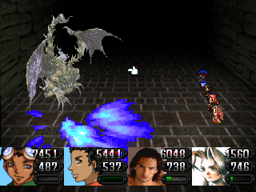
DARKNESS – Power of the underworld. Repels Holy.
BLADED – Power of swords and blades.
THRUST – Power of Pikes.
WHIP – Power of Whips or Chains.
THROW – Power of throwing darts or boomerangs. Ariel weapons.
STAFF – Power of sticks, rods, or staffs.
CELESTIAL – The ultimate power. Is stopped by nothing.

-ITEMS-

HEALING ITEMS:

Chocolate Chip Cookie – Restores 100 HP
Cookie Dough - Restores 100 HP to everyone
Watermelon – Restores 60 MP
Ham Sandwich – Restores 500 HP
French Fries – Restores 300 HP
Fruit Punch – Restores 250 MP
Lunch Box – Restores 800 HP & 200 MP
Pizza – Restores 2500 HP
Fish Sandwich – Restores 2000 HP
Juicy Fruit – Restores 500 MP
Green Glow – Restores all HP
Pink Glow – Restores all MP
Medicine – Heals Poison
Green Lazer – Heals Blind
Cough Drop - Heals Silence
Tame Medicine – Heals Berserk
Brain Juice – Heals Confused
Toy Hammer – Heals Sleep
Movement Set – Heals Paralysis
Healing Herb – Heals Everything
Energy Pill – Restores Life by 25%
Cell Pill – Restores Life by 50%
Life Pill – Restores Life by 100%
Lucky Charm – Recovers entire party.
Soul Drinks – Restores all HP to everyone
Donut – Restores 460 HP
Chocolate Donut – Restores 900 HP
Powdered Donut – Restores 170 MP
Donut Holes – Restores 600 HP to everyone
Coffee – Restores 45 MP
Sunny Delight – Restores 125 MP
Guard Potion – Restores 600 HP
Beetle Juice – Restores 133 MP
Magic Potion – Restores 200 MP
Demon Juice – Restores HP by 50%
Deer Park Water – Restores 75 MP
Huhung Arm – Restores 1000 HP
Doyle Wings – Restores 100 MP
Sugar Cookie – Restores 1000 HP
Mini Chips – Restores 1000 HP to everyone
Bear Meat – Restores 3000 HP
Rabbit Tail – Restores 1500 HP
Thunder Bird Meat – Restores 1900 HP
Lace Potion – Restores HP by 20%
Dream Potion – Restores MP by 20%
Fish Tail – Restores 1250 HP, and 125 MP
Oyster – Restores 2000 HP to everyone
Vito Drink – Restores 3000 HP
India's Cup of Life – Restores and Revives to full health
Nut Sandwich – Restores 80% of HP and MP
Yak Guts – Adds an additional 50 Health Points
Elixir Circle – Recovers entire party. Five uses.

WEAPONS (Swords/Blade)

Blade - Attack+5 (Everyone)
Sword - Attack+20 (Ron, Slay, Mina)
Broadsword – Attack+35 (Ron, Slay, Mina)
Long Blade – Attack+45, Agility-5 (Ron, Slay, Mina)
Magnum Blade – Attack+55 (Ron, Slay, Mina)
Tempest Blade (Wind) – Attack+67 (Ron, Slay, Mina)
West Sword – Attack+78 (Ron, Slay, Mina)
Chopper's Edge – Attack+85 (Ron, Slay, Mina)
Giant Sword – Attack+105 (Ron, Slay, Mina)
Grand Sword – Attack+150 (Ron, Slay, Mina)
The Holiday – Attack+180 (Ron, Slay, Mina)
Grand – Attack+214 (Ron, Slay, Mina)
Neo Slash – Attack+235 (Ron, Slay, Mina)
Craver – Attack+266 (Ron, Slay, Mina)
Lurk Blade (Blind) – Attack+276 (Ron, Slay, Mina)
Bravery – Attack+300 (Ron)
Rose Slash – Attack+390 (Slay)
Mars Sword – Attack+500 (Ron)

WEAPONS (Claws)

Claw – Attack+10 (Peppersticks, Quentin)
Venom Claw (Poison) – Attack+32 (Peppersticks, Quentin)
Rat Claw – Attack+39 (Peppersticks, Quentin)
Needle Claw – Attack+62 (Peppersticks, Quentin)
Silver Claw – Attack+75 (Peppersticks, Quentin)
Mega Claw – Attack+100 (Peppersticks, Quentin)
Junior Claw – Attack+144, Agility+10 (Peppersticks, Quentin)
Dive Claw – Attack+177 (Peppersticks, Quentin)
Nail Claw – Attack+210 (Peppersticks, Quentin)
Large Claw – Attack+232 (Peppersticks, Quentin)
Crow Claw – Attack+263 (Peppersticks, Quentin)
Static Claw (Thunder, Stun) – Attack+263 (Peppersticks, Quentin)
Blood Claw (Hype) – Attack+377 (Quentin)
Claw o’ Mighty – Attack+379 (Peppersticks)

WEAPONS (Sling Shots)

Sling Shot – Attack+5 (Lindsay)
Cherry Shot – Attack+30 (Lindsay)
Pocket Shot – Attack+37 (Lindsay)
Rock Shot (Earth) – Attack+60 (Lindsay)
Flame Shot (Fire) – Attack+76 (Lindsay)
Hamfest – Attack+99 (Lindsay)
Fungus Shot – Attack+143 (Lindsay)
Iron Feathers – Attack+176 (Lindsay)
Pan Shot – Attack+208 (Lindsay)
Spray Bomb – Attack+230 (Lindsay)
Hammer Head (Instant Death) – Attack+260 (Lindsay)
Terra Shot (Earth, Sore) – Attack+271 (Lindsay)
Doomerang (Darkness, Mind Sickness) – Attack+376 (Lindsay)

WEAPON (Scythes)

Scythe – Attack+35 (Ginger)
Silver Scythe – Attack+40 (Ginger)
Power Scythe – Attack+65 (Ginger)
Cutter Scythe – Attack+79 (Ginger)
Shiny Scythe – Attack+104 (Ginger)
Hell Scythe (Darkness) – Attack+147 (Ginger)
Mega Scythe – Attack+175 (Ginger)
Lunar Scythe – Attack+204 (Ginger)
Flare Scythe – Attack+233 (Ginger)
The Striker – Attack+260 (Ginger)
Glide Scythe – Attack+265, Agility-10 (Ginger)
Sweet Scythe (Charmed) – Attack+275 (Ginger)
Incubus (Berserk) – Attack+382 (Ginger)

WEAPONS (Gloves)

Boxing Gloves – Attack+40 (Stephenie, Jose)
Baseball Gloves – Attack+75 (Stephenie, Jose)
Steel Fist – Attack+106 (Stephenie, Jose)
Frost Fists (Ice, Freezes enemy) – Attack+141 (Stephenie, Jose)
Mighty Glove – Attack+173 (Stephenie, Jose)
Robo Arm (Thunder) – Attack+185 (Stephenie, Jose)
Larva Fist (Fire) – Attack+210 (Stephenie, Jose)
Wired Glove – Attack+234 (Stephenie, Jose)
Bouncer – Attack+264 (Stephenie, Jose)
Bang-Bang Fist (Sore) – Attack+275 (Stephenie, Jose)
Golem’s Arm (Stun) – Attack+380 (Stephenie)
Grimm Glove (Instant Death) – Attack+415 (Jose)

WEAPONS (Staffs)

Staff – Attack+60 (Beverly)
Iron Staff – Attack+72 (Beverly)
Skipper – Attack+97, Agility+10 (Beverly)
Slam Dunk – Attack+140 (Beverly)
Dream Rod – Attack+171 (Beverly)
Spike Bat – Attack+203 (Beverly)
Head Buster – Attack+231 (Beverly)
Divine Rod (Holy) – Attack+262 (Beverly)
Metal Pole – Attack+290 (Beverly)
Court Rod – Attack+280 (Beverly)
Summoner (Slow) – Attack+374 (Beverly)

WEAPONS (Whips)

Whip – Attack+70 (Mina, Jerri)
Love Whip (Charmed) – Attack+80 (Mina, Jerri)
Clash Whip – Attack+108 (Mina, Jerri)
Jennifer Whip – Attack+122 (Mina, Jerri)
Sonet Whip (Silence) – Attack+145 (Mina, Jerri)
Ana-Lucia – Attack+172 (Mina, Jerri)
Thorn Whip (Poison) – Attack+205 (Mina, Jerri)
Sand Twigs (Earth) – Attack+236 (Mina, Jerri)
Cannon Whip – Attack+269 (Mina, Jerri)
Back Pain – Attack+279 (Mina, Jerri)
Stamp Pat (55% Critical Bonus, 100% Hit Ratio) – Attack+375 (Jerri)
Ocean Whip (Water, Frozen, Attack Twice) – Attack+379 (Mina)

WEAPONS (Rocket Launchers)

Grenade Gun – Attack+150 (Al)
Busto – Attack+180 (Al)
Sand Gun (Blind) – Attack+204 (Al)
Flash Gun – Attack+230 (Al)
Earth Blaster (Earth) – Attack+248 (Al)
Behemoth – Attack+260 (Al)
Freezer (Ice, Frozen) – Attack+289 (Al)
Dynamite Blaster – Attack+300 (Al)
Terminator – Attack+450 (Al)

ARMOR (Body)

Wife Beater – Defense+7
Under-Under Shirt – Defense+10
Doggie Suit – Defense+18, Agility+3 (Peppersticks)
Sap Beater – Defense+20
Yellow Jumper – Defense+30, Agility+3 (Peppersticks)
Sexy Tank Top – Defense+30 (Ginger)
Power Beater – Defense+28
Gentle Jumper – Defense+40, Agility+5 (Peppersticks)
Extra Beater – Defense+35
Tiki Beater – Defense+46
Shield Beater – Defense+58
Roger Jumper – Defense+66, Attack+25 (Peppersticks)
Runner Jumper – Defense+80 (Peppersticks)
Oak Beater – Defense+70
Borg Jumper – Defense+90, Agility+10 (Peppersticks)
Glass Beater – Defense+88
Bell Jumper – Defense 100, Agility+15 (Peppersticks)
Golem Suit – Defense 130, Agility+15 (Peppersticks)
Body Armor – Defense+100
Robo Scraps – Defense+150
Confidence Suit – Defense+120
Faith Suit – Defense+147
Polar Bear Jumper (Ice) – Defense+170 (Peppersticks)
Celestial Armor – Defense+160
Magic-Proof Vest – Defense+200 (Magic/Abnormalities down 25%, Casts “Barrier”)
Angel Jumper – Defense+200 (Peppersticks)
Mars Armor – Defense+230 (Ron)

ARMOR (Arms)

Armlet – Defense+3
Blue Armlet – Defense+10
Hard Armlet – Defense+16
Court Armlet – Defense+22
Silver Armlet – Defense+28
Iron Bangle – Defense+34
Star Bangle – Defense+40
Beau Armlet – Defense+51
Chip Buckler – Defense+60
Plow Buckler – Defense+75
Moon Shield – Defense+89
X Lid – Defense+100
Celestial Shield – Defense+105
Mars Buckler – Defense+160 (Ron)

ARMOR (Head)

Cap – Defense+5
Fur Hat – Defense+10 (Female)
Raven Hat – Defense+11
Helmet – Defense+15
Cap Hat – Defense+20
Lue Hat – Defense+27
Shade Hat – Defense+33
Marco Hat – Defense+40
Calm Hat – Defense+40
Cuffer Hat – Defense+53
Cowboy Hat – Defense+62
Giving & Sharing Hat – Defense+73
Hat of Serenity – Defense+88
Celestial Helmet – Defense+100
Mars Helmet – Defense+175 (Ron)

ACCESSORY

Glass Eye – Agility+10
Ruby Ring – Attack+10
Cape – Intelligence+10
Sneakers – Agility+20
Bio Ring – Prevents Poison
Medic Bangle – Casts “Heal”
Freeze Bangle – Prevents Frozen
Dodge This! – Prevents Critical Attacks
Flame Ring – Resists Fire
Can't-Touch-Me Ring – Increases chance of evasions
Remedy Ring – Protects against abnormalities
Auto-Haste – Automatically casts “Haste”
Fiery Passion – Attack+30
Jolt Badge – 50% Lightening Protection
Can't Buy Me Love – Protects against “Charmed”
Aquatic Ring – Resists Water
Chill Ring – Prevents “Hype” and “Berserk”
Chance Bracelet – All stats+30, Inflicts “Hype”
Ring of the Elves – Resists Earth
Caffeine Ring – Prevents “Sleep”
Superior Badge – All stats+20, 25% protection against everything
Regeneration Ring – Regenerates the user
Icy Ring – 50% Ice Protection
Frosted Flakes Box – Agility+75, Prevents Critical, Increases Evasions
Violet Ring – 50% Darkness Protection
Bio Function – Prevents “Poison” and “Bio”
Knee Pads – Prevents “Sore”
Holy Spirit Ring – Prevents Curse
Realm of the Tide – 50% Protection against everything
Mercedes Ring – Half MP consumption
Mind-Over-Matter Pin – Prevents Mind Sickness
Coyote Shoes – Prevents “Slow”
Gene Bracelet – Stops Absorption
Ring of Clear Head – Prevents Confusion
Gold Chain – Prevents Instant Death
Jaeda’s Ring – Casts “Magic Regeneration”
Exploding Ring – Casts “Explode”, protects against Burns and Fire.
Night Ring – Increases Evasions
Night Ring UPGRADE - Increases evasions. Blinds and Silences enemies.
Might Chain – 100% protection against all Physical
Watch – Prevents “Stopped”
Energizing Ring – Casts “Regeneration”, “Mind Regeneration”, and “Haste”

EXTRA ITEMS

Fog Machine – Blinds all enemies
Lab Top – Deals damage on all enemies (Ginger)
Jail Suit Defense+60, Agility -10
Auto-Cabin – Allows you to select party members
Night Stars – Deals damage to enemy
Goat Head – Defense+25
Zebra Head – MP+50
Rock – Defense+10
Lit Shock Belt – Thunder damage on enemies
Lionheart – All stats+25
Locket – Unlimitedly revives fallen character.
Purple Apple – MP/Intelligence+25. Can use five times.



THE BEGINNING:

The game begins with a short scene between a mysterious man (maybe?), and you, the player. The name selection screen shows up, giving you the freedom to name your character, Ron (if you choose to name him at all). When the conversation ends, you, the player, awaken.

TOWN: MONTANE CITY
SHOPS: Bakery, Weapons (Closed), Armors (Closed), Items (Closed), Accessory (Closed)
ENEMIES: None

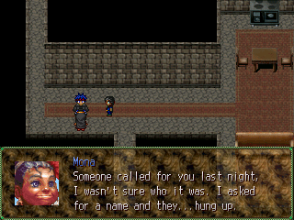
You awaken into the present world. While thinking about your dream, your mother suddenly interrupts, saying that one of your friends decided to come over. Annoyed by the sudden entrance, you get dressed, and greet the friend.

You’re given the option to name Jose, and afterwards, Mona, your mom, will explain that you received a phone call, but the person hung up when asked for identification. Jose interrupts the conversation suggesting that you hurry up before someone steals your preordered food. Your mom lets you go, and you and your best friend are off alone. Once in control of Ron, simply leave the room. You can talk to Mona if you choose to.
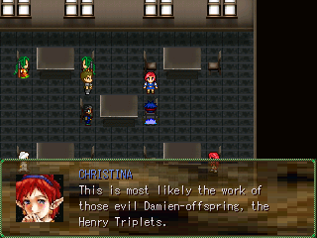
Exit the Apartment Building, but if you want, you can talk to some of the residents first.
After leaving the Apartments, you’ll find yourself in the city of Montane.
You can talk to the town residents if you like, otherwise, just head to the Bakery. Inside, you’ll talk to a friend named Christina. Not before long, her co-worker notices that the food is gone, thus canceling out your order. Christina asks for you help, and because you’re such a nice guy (and you need the money), you agree to help her.

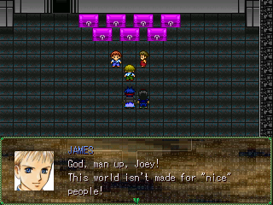
The Abandoned Factory is located all the way on the Southwestern side of town, more specifically, the last building of the city. Before going inside, make sure you save your game if you haven’t done so already.
After you’re done, enter the building. A discussion will take place, resulting in your very first battle.

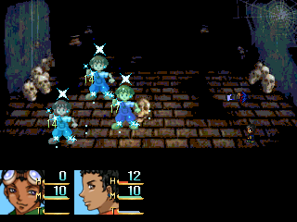

BATTLE: Henry Triplets

Though this is a “first” battle, it can be tricky if you’re not careful. The first person you should target is James, the furthest one on the right. He’s the strongest and the fastest of the three, and he takes the longest to kill. When he’s out of the way, go after Billy, the one on the far left. He isn’t as strong as James, but he is stronger and more threatening than Joey. When Billy’s gone, your next obvious target is Joey. He’s weaker than the other two, but he has an annoying spell called “Sparkle” which can heal everyone, but since it takes only two or three hits to beat Joey, it shouldn’t be much of a bother.

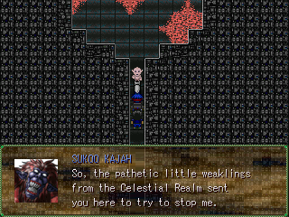
After several minor events, Ron and Jose find themselves back at the Abandoned Factory. Jose suggests checking it out. Ron declines, but Jose persuades him to check it out anyway. After the conversation, you’ll be in control of the two party members again. Explore the factory a bit to collect the items, and once you’re done, approach the two characters blocking the hallway. But, before you do, SAVE!

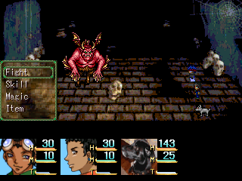

BATTLE: Sukoo Kajah

This battle is not difficult at all. Squamus is nearly three times faster than both Ron and Jose, allowing him to gain at least two or three hits in before you or the enemy can attack! Sukoo Kajah has a number of dangerous attacks, but he’ll be defeated before he can even get a chance to use them.

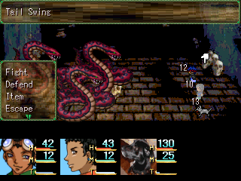
After the battle, Squamus will join your party. Squamus is a great addition. His vast speed will prove to be a great asset in the tough battles you’ll face here in this dungeon. Later in the dungeon, you’ll find a weapon called a “Boxing Glove” for Jose. Equip it immediately! Doing so will allow Jose to become the “powerhouse” of the party, making up for his lack of speed, with super strength.
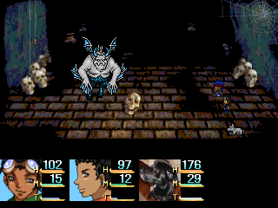

BATTLE: Sukoo Kajah 2

This battle is nothing more than just a “toned up” version of the first one. Sukoo Kajah 2’s elemental attacks are more powerful this time around, although, not by much. He likes to silence your characters and put them to sleep, so beware of his “Dream Wave” and “Silent Punch” attacks. To beat him, use the same strategy you used the first time. Jose and Squamus will most likely be your frontrunners, so have Ron heal the party if (when) necessary.

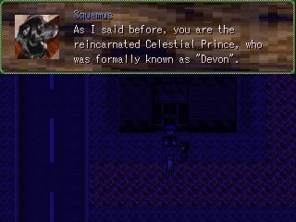
After the battle, the little group will meet outside of the Abandoned Factory. There, Squamus will go into full detail on the seriousness of the situation. Reluctant to join at first, but after being persuaded by his best friend, Ron eventually decides to join the “good fight”, fulfilling the “Celestial Prince” prophecy.

ACT ONE: The prince, the princess, and the dog


The first Act begins with the usual; Ron sleeping in his bed. He’s awakened by his mother, who gives him an invitation to a “Special Seminar” being held this evening. After the event, you’re free to control Ron.

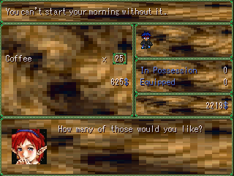
To progress the storyline, talk to Squamus in front of the large building in the middle of the city. However, before doing so, it’s recommended that you buy new supplies. The shops are all open, and Christina and Bob are also selling new items at the Bakery. You should have plenty of money, so buying new items shouldn’t be a problem. If you want, you can talk to James, Billy, and Joey Henry at the Abandoned Factory, although, you won’t be able to re-enter the dungeon area.

DUNGEON: Montane Studio
DEMONS: Junior, Fray, Beetle, Possessed Fog, Buckle
TREASURES: Cookie Doughx4, Sling Shot, Fur Hat, Fog Machine, Pizza, Cape, Under-Under Shirt, Doggie Suit

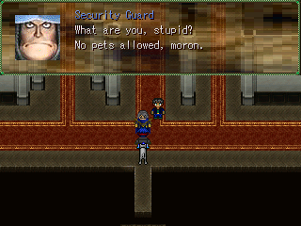
After talking to Squamus, you enter the Montane Studio. You try to sneak your dog in, but the Security Guard catches you, and antagonizes you by calling you all sorts of names. You try to persuade him to let Squamus inside, but to no avail. After that plan fails, you decide to run into the Auditorium anyway, hoping that the Security Guard doesn’t find you.

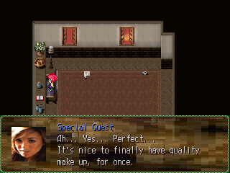
In the next scene, you’re introduced to the next main character, Lindsay Lohan. Her publicist, Jessie, scolds her for not taking her job seriously, while Lindsay remains nonchalant about it. You’re given the option to name her, and after that, you’re shifted to the next scene…the mayor of Montane City, Christopher Vaughn, and Lindsay’s stage performance…
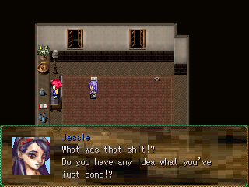
Because of the incident on stage, everyone’s confused and upset. Jessie is infuriated with Lindsay, but Lindsay still doesn’t understand the seriousness of the situation. After growing frustration of both ladies, the whole building suddenly becomes dark.

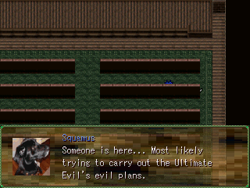
In the Auditorium, the lights cut back on, revealing Ron and Squamus as the only two people to still be around. Jose has disappeared, as well as the rest of the audience. Suddenly, a girl can be heard screaming from a distance. Being the good hero that you are, you decide to help the endangered girl.

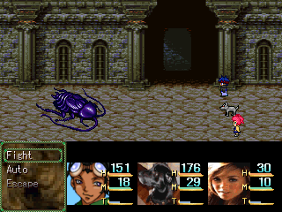

BOSS BATTLE: Roach Warrior

This is a little more difficult than the Sukoo Kajah battles, but still shouldn’t pose much of a threat. Being only at level one, Lindsay is very vulnerable in this battle, and she won’t be very helpful. As always, Squamus’s “Bite” skill will be extremely useful here. However, if Ron is at level 5, he should have learned the “Burn” spell, a level one Fire Elemental spell. Fortunately, Roach Warrior is weak against Fire, so Ron’s Burn spell will take away 300+ damage on the roach! Watch out for the Roach’s Antenna skill. It attacks all characters, and poisons them.
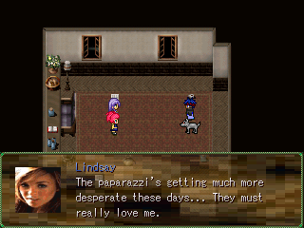
After the battle, Jessie begins to panic. Ron explains the situation to her, but she accuses him of making a joke out of it. Lindsay agrees to join the crew, thinking that saving the world will help salvage her career. Jessie, on the other hand, protests, but Lindsay refuses to listen to her. After the event, Lindsay will join. Jessie will stay behind, however, she carries plenty of First Aid Kits, so talk to her if you need healing. Monsters will now appear in this dungeon from here on out, so hopefully you bought new equipment and food from Christina.

Possessed Fog (Element: Holy (Weak against Fire, Strong against Death)
Beetle (Element: Ice)
Buckle (Element: Darkness)
Fray (No element)
Junior (Weak against Thunder, Strong against Wind)

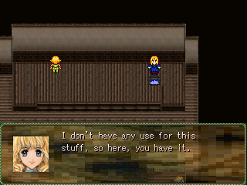
The enemies in the earlier parts of the dungeon work alone, so disposing of them won’t take much work at all. If you’re running low on items, go to the first Broadcast room on the second floor. Talk to the blonde girl on the upper left-hand corner for some items.
Afterwards, leave, and continue to navigate the dungeon. The dungeon is straight forward, and the enemies are weak, so this should be a walk in the park.

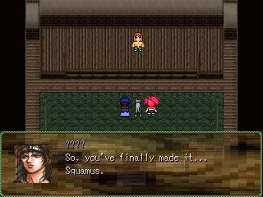
On the Fifth floor, enter the final Broadcast room. An important event will take place there, and a boss battle will begin.

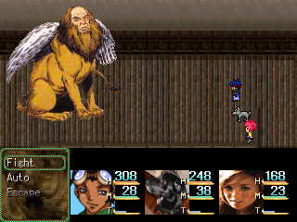

BOSS BATTLE: Gaziro

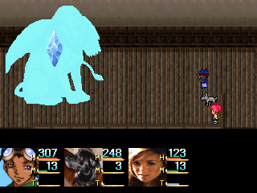
Before entering this battle, make SURE Ron that is at level 7. Gaziro has a ton of HP, and if Ron hasn’t learned his “Freeze” spell, defeating him will be quite a hassle. Gaziro’s attacks are all powerful, plus, he increases his own stats, making him, but if Ron has learned “Freeze”, he’ll die long before he can use his more powerful attacks. His most frequent move is his “Wing Flap” skill which, on average, deals about 50+ damage to all party members. Ron and Squamus should always use their turns for attacking Gaziro. Since Lindsay won’t be very useful in this battle, have her heal the other two fighters with the items in your inventory. Refrain from using Ron’s “Burn” spell. It’s useless against this boss, as well as Lindsay’s “Scream” and “Kisses” skills.

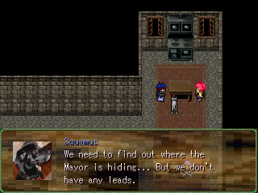
After the battle, Ron learns the devastating truth about one of his friends. Afterwards, he, Squamus, and Lindsay regroup at his house. Jessie and Lindsay share a private moment, which becomes interrupted by Squamus and Ron. Jessie leaves, and Lindsay and Squamus become permanent members of the party, but first, you’ll get the option of naming Squamus…err…“Peppersticks.”

DUNGEON: Montane Roads
ENEMIES: Watcher, Winged Psycho, Gunner, Evil Hound
ITEMS: Cookie Dough, French Fries, Fish Sandwich, Green Glow, Life Pill

Watcher-None
Winged Psycho-Wind
Gunner-(Weak against Thunder and Aqua)
Evil Hound-Darkness

This dungeon isn’t long at all. Just make your way to the top to enter the next town.

TOWN: Tore
SHOPS: Weapons, Armors, Items, Café
ENEMIES: None
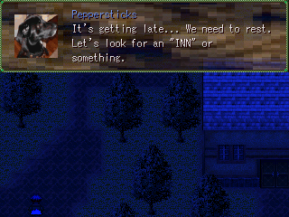
After entering the town, Peppersticks suggests sleeping at an INN. Lindsay disagrees, but nonetheless, you wind up sleeping at the INN anyway, much to her dismay.

Since it’s late, the townspeople are all inside, so there isn’t much to do here, so restock on items. The items here are better than the ones sold at Montane City, and cheap, so you should be able to afford everything here.

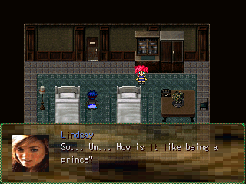

When you enter the INN, Lindsay will explain to Peppersticks that pets aren’t allowed inside. Afterwards, she and Ron will share a private moment, where she reveals a bit of her sensitive side.

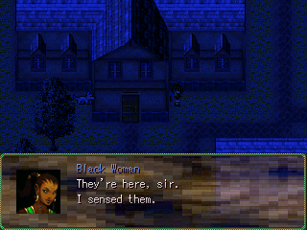

The game then shifts to a suspicious woman having a suspicious phone call. Peppersticks overhears her, and is confused.

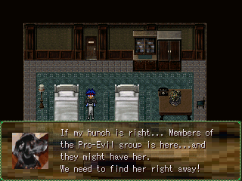
Peppersticks quickly reports his findings to Ron. He also discovers that Lindsay is missing, too. The two go off to find her. Lindsay is currently not in your party. To find her, go in the building with the large bell on it. It’s impossible to miss.

DUNGEON: Society Shrine
DEMONS: Bat, Fly Trapper, Mini Golem, Charmer
TREASURES: Donut Holes, Coffee, Medicinex5, Sneakers, Fog Machine, Lunch Box, Juicy Fruit, Bio Ring, Medic Bangle

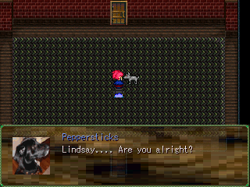
When you find Lindsay, she’s alone and nearly unconscious in the large, empty room. She doesn’t exactly remember what happened, but all leads point to her new friend, Delilah Fields. Lindsay rejoins the party, and the trio decides to look for her, pulling you into your next dungeon.

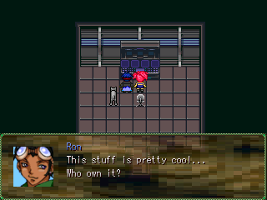
Enter the next room. You can’t enter the stairs just yet; Peppersticks won’t let you, so simply enter the room ahead of you. Inside, Ron notices a slick looking computer screen. Lindsay wants to have it. Not before long, you’ll end up with a new item, the “Lab Top”. This won’t come into play yet, but it will later…

Bat-Ice
Fly Trapper- None (Weak against Fire)
Mini Golem-Earth (Strong against Physical)
Charmer-None

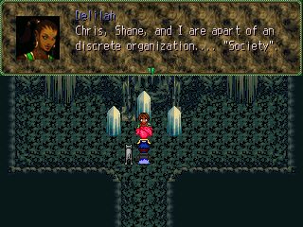

After you work your way through the dungeon, you’ll encounter Delilah once again. She’ll explain her mission to you, and afterwards, she’ll attack.

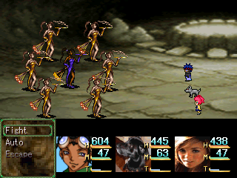

BOSS BATTLE: Delilah, Society Memberx6

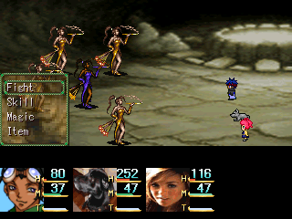
Delilah will attack the group after her speech. This can be an extremely difficult battle if you aren’t prepared. By now, Ron should have learned “Lit”. If he hasn’t, learn it. You won’t survive this battle without it. Ideally, Ron should be around level eleven. If he’s below that, don’t worry. As long as he has “Lit”, he should be fine. Six Society Members surround Delilah. Take them out as SOON as possible! Each of them posses a 150+ Elemental attack that could potentially ruin your entire party. To add to the mix, Delilah can increase her party’s agility, thus further putting you in a disadvantage.
Each Society Member has 300 HP. One hit with Ron’s Lit should easily knock them out. To make things easier, have Lindsay attack using her boomerang, and have Peppersticks use “Blood Bite”.

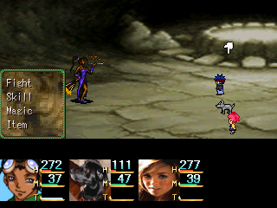
Once her sidekicks are gone, Delilah is on her own. Delilah is difficult in her own right, possessing numerous high-powered Thunder-elemental attacks. Watch out for her devastating “Thunder”. It strikes all party members, plus has a shot at shocking them. Be prepared to use those nifty items, such as the Lucky Charms. You’re definitely going to need ‘em.

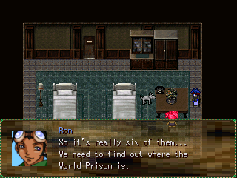
After the battle, Delilah will run off. The party will then regroup back at the INN. Afterwards, Danielle will give you a car, so you can get a free ride to Montane City without having to fight any monsters. The same can be done if you wish to travel back to Tore, as well.

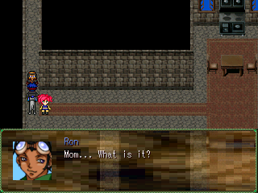
Travel back to Montane City. Visit Ron’s mother, who’s in a seemingly bad mood. To talk to her, and she’ll explain why.

Afterwards, talk to the Henry Brothers, who are at their usual spot, the Abandoned Factory. When you’re done talking to them, leave the town. Take the exit on the far, Southeastern side of the city.

There, you’ll meet up with your jeep again. Simply ride it to the next town, Koudo.

TOWN: Koudo
SHOPS: Corner Store
ENEMIES: None

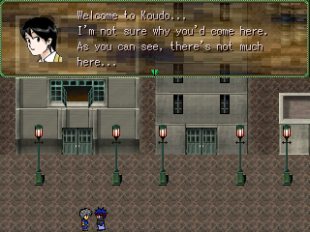
Before entering Koudo, make sure you park the jeep close to the town, but not actually inside. :p
Overall, Koudo is a very small town. Talk to the townspeople if you like, but as always, make sure you stock up on new items, armors and weapons. There isn’t any food being sold here, so hopefully you stocked up on that in Montane City. If not, you can always travel back (but make sure you handle that now).

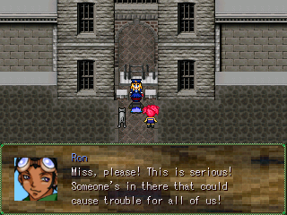
When you’re doing shopping and (or) talking to the folk wandering around, attempt to enter the World Prison. The police officer standing in, Kelly, will stop you from entering. You attempt to plead your case, but it doesn’t work. Kelly doesn’t budge.

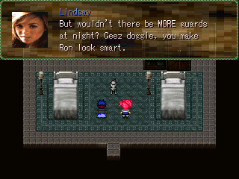
After the failure, the group attempts to come up with another plan. Ron and Lindsay break into another argument, which forces Peppersticks to once again make a decision for the group. He offers to spy on the Prison while the two teens stay in the hotel room. They all agree.



Lindsay decides to take a break and use the Lab Top. Suddenly, there’s a bright flash. A swirling spirit attacks Lindsay and takes over her body. It becomes quite clear that Lindsay’s not herself…

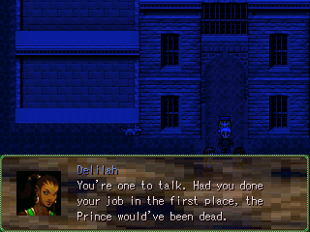

Meanwhile, Peppersticks is spying on the evil trio, with Kelly as their sidekick. As it turns out, Chris, Shane, and Delilah aren’t that different from Peppersticks, Ron, and Lindsay after all.

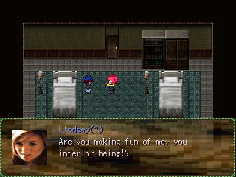

Meanwhile, Ron runs into problems of his own when Possessed Lindsay suddenly attacks him. Peppersticks arrive at the nick of time, and a boss battle begins.

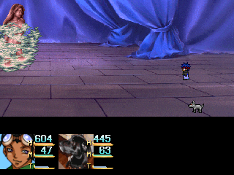

BOSS BATTLE: Aneah

This battle isn’t difficult at all, a much needed breathier from Delilah. Aneah’s most frequent attack is “Blink”, which deals about 150+ damage to a single person. Sometimes she uses a Blink spell that attacks both party members, so be on the lookout. Aneah also uses some Status-changing spells, but most of them will never work. Have Ron attack her with his spells, and Peppersticks attack her with “Bite”, and she’ll fall without much of a hassle.

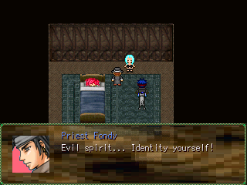
After the battle, Lindsay passes out. She’s taken to the priest of the town, Priest Fondy. After the exorcism, Lindsay regains consciousness, and the evil spirit possessing her appears. The woman calls herself Aneah, and after she explains her story, Peppersticks suggests that she join the crew, but first she must change her name. Lindsay takes it upon herself to rename Aneah by calling her, “Ginger”. And with that, a new party member joins the group!

After Ginger joins, travel back to the World Prison. It’s time to travel through your next destination.

DUNGEON: World Prison
ENEMIES: Steroid-Using Guard, Jail Hound, Criminal, Prison Babe, Earthly Beetle, Blood Roach, Prison Preacher
ITEMS: Freeze Bangle, Lucky Charm, Lunch Box, Jail Suit, Beetle Juice, Magnum
Blade, Fog Machine, Ruby Ring, Dodge This!

Steroid-Using Guard-Strong against Physical
Jail Hound-None
Prison Babe-None
Criminal-None
Earthly Beetle-Earth
Blood Roach-Ice
Prison Preacher-Holy

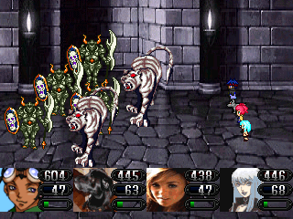
Immediately after entering the Prison, you’re thrown into a battle. This battle is a slight change from what you’re used to. The monsters have high HP, forcing you to use your skills or magic to survive. Ron and Ginger will be doing most of the work here, although Peppersticks’s “Blood Bite” will be useful, as well. Use Lindsay for support if her skills aren’t effective on the enemies.

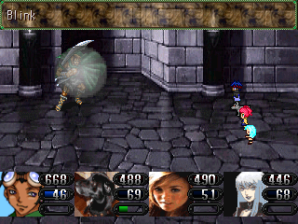
To access the basement, you first will need a Staircase Key. The only way to get it is by defeating the Jail Guard on the first floor. The battle won’t be difficult at all. Pummel the foe with your strongest attacks, and he will surely fall, giving you a decent amount of experience as a reward.

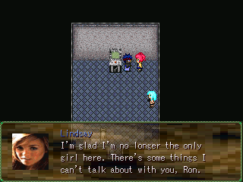
After you obtain the key, use it to unlock the door that leads to the basement. Once inside, talk to some of the prisoners in their jail cells. Many of them have valuable information to share.
To progress through the dungeon, collect the items and take the elevator up to the second floor.

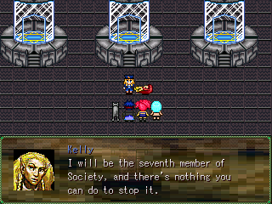
When you arrive at the final door, make sure you SAVE before entering. This should come across as common sense, but also, make sure you’ve healed your HP and MP completely as well. This next battle may prove to be a tough one.
When you’re done, enter the room. You’ll confront the members of Society. After learning Chris’s plans, he runs off, leaving Officer Kelly to clean up the mess, namely you.

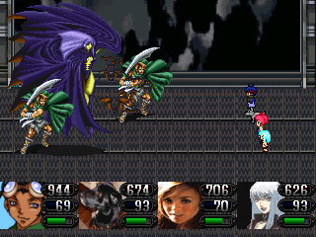

BOSS BATTLE: Officer Kelly

Before attacking Kelly, make sure you get rid of her two goons first. Ron, Lindsay, and Ginger should all have “Bubble” by now, as well as Peppersticks’s “Bum Rush” attack. If they’ve learned it, they can easily get rid of the guards in one turn. If not, then use your best attacks to get rid of them. Once they’re out of the way, focus all of your attention on Kelly. Have Ron attack her with his “Burn” spell, and have Peppersticks act as the healer of the party (or Ron, if you need two healers). Lindsay and Ginger will/should be the powerhouses of the battle. Their combined strength can take up to 1000+ damage against Kelly, making both of them valuable. Watch out for Kelly’s “Freeze Wind” spell. It can freeze the entire party, and if someone isn’t wearing the “Freeze Ring”, that can spell trouble.

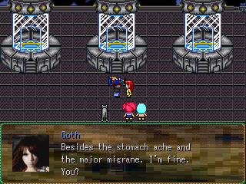
After the battle, Kelly becomes unconscious. Ron helps the girl, who identifies herself as Jerri.
Ron and crew takes Jerri back to her father, who, despite being kidnapped and nearly sacrificed, still gives his daughter chores to complete. This angers her.
Afterwards, the crew regroups outside of the small church. Ginger shares some insightful intellect on the party, which explains the next destination. After the event, take the far right exit out of town.

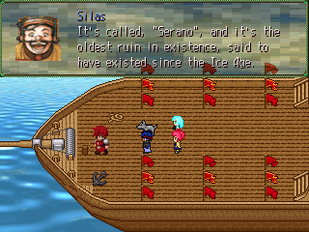
When you leave the main section of the town, you’ll come across a small building. Enter it. Inside, you’ll meet a sailor named Silas Micchi. Speak with him to access the next event.
Once you’re aboard the ship, Silas will explain the past of an ancient ruin called, “Serano”.
During the conversation, a demon suddenly attacks the ship, and you’re pulled into a boss battle.

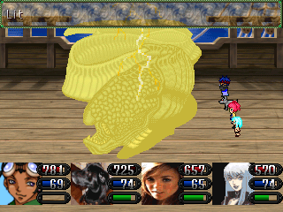

BOSS BATTLE: Leva

This battle is much easier than the boss battle before. However, unlike most bosses, Leva’s defenses are high in just about every element which the exception of Physical. Being a water creature, he uses water attacks and is weak against Lightening. He’ll hardly attack your party, so getting rid of him will be easy. Just have Ron pummel him with “Lit”, and have everyone else use his or her strongest moves on him.

TOWN: Dati
SHOPS: Item, Weapon, Armor, Extra
ENEMIES: None

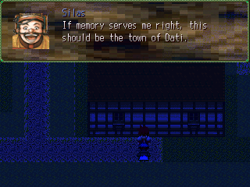
After the battle, Silas will be in shock. Peppersticks will explain the situation to him, calming him down. Not before long, you arrive at the town of Dati. Silas will drop you off leave. Ron becomes controllable.
Several story arcs will take place here. Buy new supplies, and make your way towards the Inn. After the events, your party will regroup, and you’ll be on your way to the next dungeon.

DUNGEON: Dati Road
ENEMIES: None
ITEMS: Lucky Charm, Magic Potion, Beetle Juice

There’s nothing much to do here. Just collect the treasures, and follow the road.

DUNGEON: Serano
ENEMIES: Wizardess, Land Mass, Ancient Queen, Toku, Demonite, Flare Bit
ITEMS: Demon Juice, Extra Beater, Deer Park Water, Cap Hat, Remedy Ring, Flame Ring, Beetle Juice, Magic Potionx2, Auto Haste, Bio Ring, Can’t-Touch-Me Ring!

Wizardess-Holy
Ancient Queen-None
Land Mass-Earth
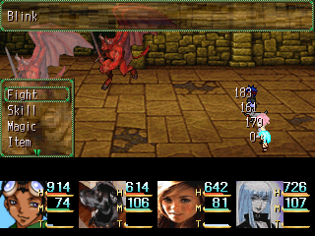
Demonite-Darkness
Flare Bit-Fire
Toku-None

In terms of monsters, this dungeon isn’t very difficult at all, although, you should watch out for the Demonite enemies. In groups, they can be tough.
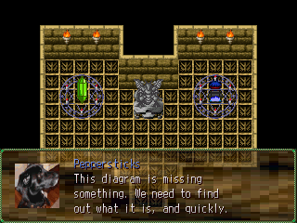
At the end of the dungeon, you’ll notice that something is wrong. The diagram is incomplete. To complete it, you’ll need an orb identical to the one next to it. But where can you find it? The path is simple. Simply leave the room and head south. Then turn east, and head south again. Keep going south until you can’t go any further. Then head east until you enter the next room.

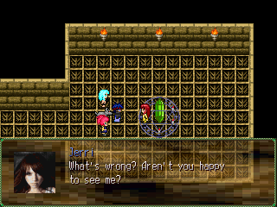
Jerri is back once again to cause some trouble. This time, she’s blocking the orb, the same one you need to finish the diagram. After a discussion, you hurt Jerri’s feelings. She runs off. You want to apologize, but Peppersticks suggests finding Society first. With the orb in hand, simply return to the diagram room from where you came.

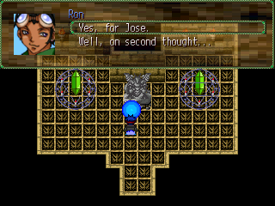
After you retrieved the Orb, go back to the Warp Room and place it on the empty design. The room will shake, and a portal will appear. Make SURE you heal before entering the portal. A dreadful boss battle lies ahead…

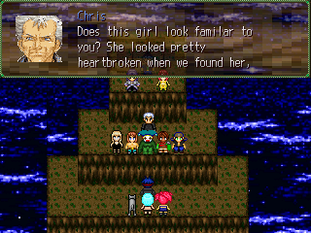

In the room ahead, Chris and his fellow Society members are in the room, planning to carry out the final steps in awakening the Ultimate Evil. You protest, and a boss battle awaits.

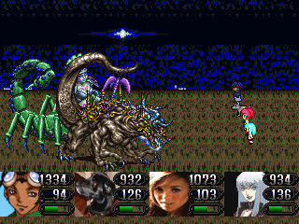

BOSS BATTLE: Chris Vaughn X, Doom

First and foremost, you will not survive this battle if Peppersticks haven’t learned “Sparkle”. It’s impossible, unless you’ve been saving up all of the Lucky Charms you’ve found thus far.

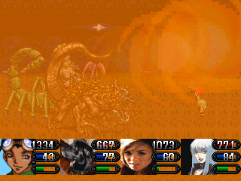
Take out “Doom” first, the dog demon standing in front of Chris. While not as strong as his boss, the two of them together can easily make short work of your party. All of his attacks range from 200-300 points of damage, and all of them attack every member of the party, making “Sparkle” vital for survival. In addition to those deadly moves, Chris also has several attacks that range from 500-700 points of damage, making it easy to kill off a weakened character.
Defeating Doom is easy, but Physical and Darkness attacks, namely Ginger’s and Pepperstick’s moves, won’t hurt him as much as it would hurt Chris, but still have everyone attacking Doom. After he’s out, go after Chris by using your strongest attacks. When he’s out, you’ve completed the first section of the game!

ACT two: LIGHTS, CAMERA, ACTION!

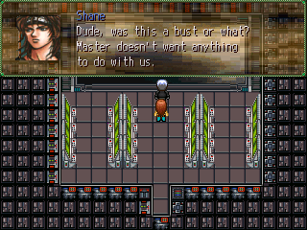
This act begins with a flashback of the ending of the first act. There appears to be friction within Society, and Ron realizes the seriousness of this situation.
When you’re finally in control of Ron, talk to everyone in the building if you like. However, to progress the story, simply enter the Casting Room.

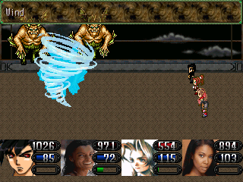

BATTLE: Mock Sukoo Kajahx3

After the event, your new party members, Stephenie, Quentin, Beverly, and “Squelle”, will engage in their first battle. This battle won’t be difficult at all. While the Sukoo Kajahs do possess some powerful spells, Quentin’s “Shock” skill will easily take care of that. Use your strongest moves to beat them.
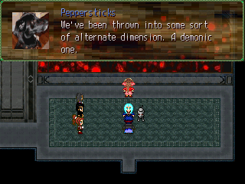

Once you’re finally in control of Ron, have him speak with Lindsay in her room. Afterwards, check the exit. You’ll notice that it’s locked. Then, check the Training Room. After the discussion, Quentin, Stephenie, Beverly, and Squelle will finally join the party, giving you the option of choosing your party members.

DUNGEON: Casting Agency
ENEMIES: HuHung, Doyle, Smiley, Hoopz, Pumpkin
ITEMS: Flame Ring, Lucky Charm, Sunny Delight, Jolt Badge, Extra Beater, Silver Claw, Magic Potion, Aquatic Ring, Cap Hat, “Can’t Buy Me Love”, West Sword

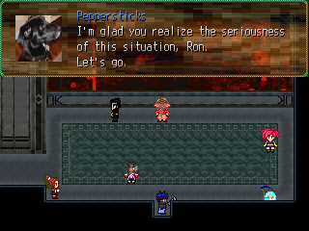
Before entering the dungeon, obviously, it’d be a smart idea to choose a full party of four. If you’d rather use the main four, Ron, Lindsay, Peppersticks, and Ginger, that’s fine, but the other four are just as powerful. The enemies here vary in elements, so it’s best to bring “Squelle” for her set of element spells. Quentin and Stephenie are both tied when it comes to physical attacks, and Beverly possesses strong summon magic and healing spells. So, just bring anyone you like!

HuHung-Fire
Doyle-Water
Smiley-Wind
Hoopz-Thunder
Pumpkin-Wind

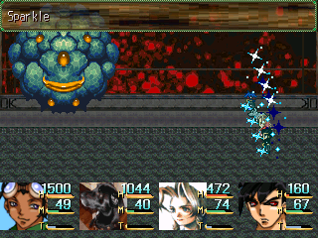
The monsters here aren’t terribly difficult. Some of them pack quite a punch, but you can take them down quickly with your magic and skills.
Hopefully you still have some items leftover from the first Act, because you’re definitely going to need them. Some of the heavier skills require a lot of MP, and without any way to recover your magic; you’ll be spending a lot of time beating your enemies with just physical attacks.

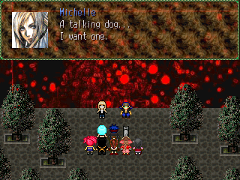
At the end of the dungeon, the crew runs into Nilynn and Michelle, the duo that trapped them in this dimension in the first place. After some taunting coming from both sides, Nilynn and Michelle decide to fight you along with their “pet”, Turquoise!

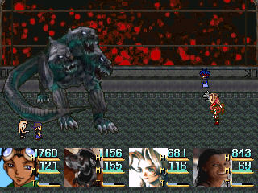

BOSS BATTLE: Turquoise

Nilynn and Michelle are impossible to defeat here, so ignore them. Instead, focus all of your attention on Turquoise. Since he doesn’t have any strengths or weaknesses, you bring along any type of party you like.
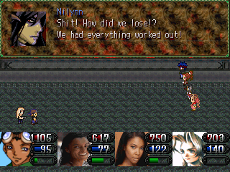
This battle isn’t very difficult. While Turquoise is strong, Nilynn and Michelle, who can’t be harmed, provide their own annoyances as well. It’s suggested that you bring “hard-hitters” such as Ginger, Stephenie, and even Lindsay. Hopefully Peppersticks learned “Sparkle” in Senaro, because it’s nearly a must-have to survive this battle. Turquoise and Nilynn both love to “Hype” your characters. It’s similar to “Berserk”, except that it lasts longer, and it boasts all basic stats. You can cure that with “Tame Medicines” and “Healing Herbs”.
To defeat Turquoise, use your most powerful attacks on him, and cure any character that becomes “Hyped”. After he’s dead, Nilynn and Michelle will flee, giving you the victory!

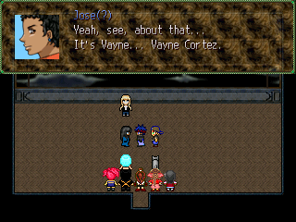
After the battle, the barrier will disappear. Jose will appear before Ron, only a bit…“different”. The Casting Agency will revert back to normal.
The next day, Ginger returns to the party with a new party member, Slay. Name him if you like, and afterwards, you’ll receive the “Auto-Cabin” device, which allows you to change your party members at any given time. After the event, Ron’s controllable, and head back to Koudo!

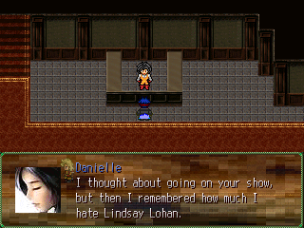
Now that you’re finally back into the big city, it’s best to stock up on items and new equipment. The townspeople in Montane, Tore, and Koudo all have something new to say, so spend some time talking to them if you like. You’ll learn some pretty interesting facts. Everyone’s shaken over the possibly of the world ending, and Society even have their own tabloid magazine! Crazy, crazy times.

DUNGEON: Leanna Hill
ENEMIES: Poison Ivy, Bear, Suckler, Blood Bat
ITEMS: Lue Hat, Chance Bracelet, Lucky Charm, Soul Drink, Sunny Delight, Sugar Cookie, Chopper’s Edge, Watermelon, Pizza, Life Pill, Magic Dragon, Glass Eye

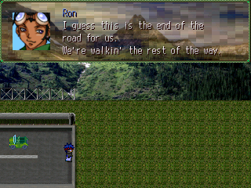
To reach Leanna’s Hill, simply drive pass Koudo and keep heading East until you’re unable to move forward. Exit the vehicle, and approach the tall bushes to enter Leanna’s Hill.

Poison Ivy-None (Fire = DANGER)
Bear-Strong against everything
Suckler-None
Blood Bat-None
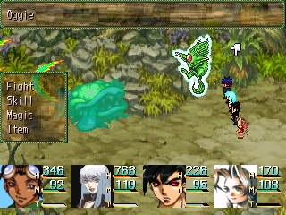
The monsters in Leanna’s hill can be very HP draining, and if you’re not careful, many of your characters could end up dead. Watch out for the Poison Ivy demons. They use the skill, “Suck Dry” quite often, and it completely drains a character of his or her HP, thus killing them. You can easily get rid of them using Quentin’s “Nuke Blast” spell, which can deal over 1400 points of damage to one a single one. That’s over half of their HP!

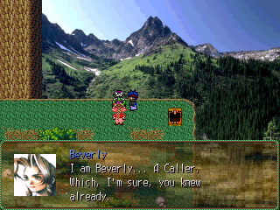
Close to the end of the hill, you’ll run into a green fellow staring at the mountains. He is Ezra, the next summon creature of Beverly. Obviously, the only way he’ll talk to you if as if you’re in the presence of a Caller, who, as you know, is Beverly. Add Beverly in your party to access the optional event. After a brief conversation, a battle between the Caller and her creature will be begin.

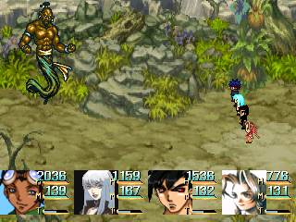

BOSS BATTLE: Ezra

Ezra packs a lot of powerful moves, with his most powerful one attacking the entire party. Having a low HP count, it’s nearly impossible for a fighter to survive. If he or she is not at a high enough level, or if they’re not equipped with any of the recent material, expect to revive them a lot. Defeat Ezra by pummeling him constantly with your most powerful moves. You’ll definitely want Peppersticks around as the token “Healer”, if Ron hasn’t learned Sparkle yet. After so many turns, Ezra will fall, and Beverly will have a new summoning ability!

DUNGEON: Cabin Basement
ENEMIES: Lumpy, Water Bug, Roaring Rat, Nika
ITEMS: Aquatic Ring, Ham Sandwich, Fruit Punch, Green Glow, Cell Pill, Tiki Beater, Mini Chips

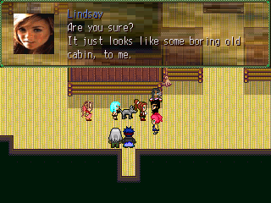
After climbing through Leanna Hill, you arrive at the empty cabin. The party splits up and begins looking for clues. During this time, the Auto-Cabin becomes unavailable for use.
Once in control of Ron, walk upstairs. After the event with Lindsay and Quentin, check the bookshelf for the switch. Afterwards, a secret staircase will open, allowing you entrance to the second portion of this dungeon.

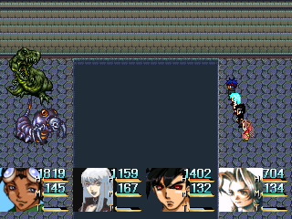
Lumpy-None
Water Bug-Water
Roaring Rat-Water
Nika-Water

The majority of the monsters here are Water-elemental, making lightening skills extremely useful here. The enemies here are a bit easier than the ones outside, although, some of them, Nika in particular, love to cast stat-ailment spells on your party.

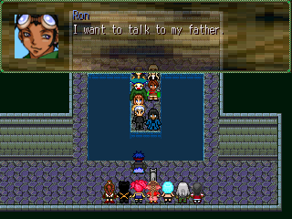

At the end of the hideout, Ron confronts Society. Ron and his father, Carene, engage in a heavy…yet, slightly psychotic conversation. Deciding he had enough, Vayne throws a monster at you, Nookie.

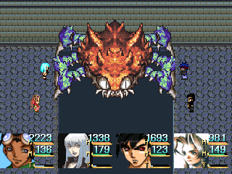

BOSS BATTLE: Whacked Nookie

The party has Nookie surrounded, enabling you to get a free turn. However, during round 2, Nookie recovers himself to pull strength, unfortunately, rendering everything you did previously, useless.
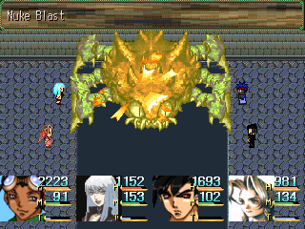
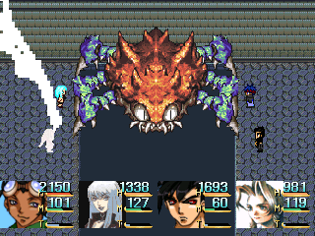
Noookie is very fast. He’ll be able to get in many more turns than you will. Nookie has several dangerous moves. His weakest, Nibble, takes away about 400+ damage from the whole party, and then absorbs it within himself. His most frequent deadly move his is “Crab Bite”, which drains 1000+ HP from a party member. However, Nookie’s most dangerous move is his “Take In” skill. It completely renders a character useless, and drains a portion of their HP until either the effects ware off, or the character dies. This move is used quite often as well, and if the whole party is under that effect, that could spell trouble. Despite Nookie’s powerful attacks, defeating him is quite simple. Although he is weak against Lightening, Ron most likely hasn’t learned the second level Thunder spell (Which is fine. That would far surpass the recommended level), so his weak “Lit” spell is practically useless against Nookie. Pummel him with your strongest moves, and heal with Sparkle or Blessed Light. Characters with a low HP count such as a mage may have to be revived once or twice before the battle is over.

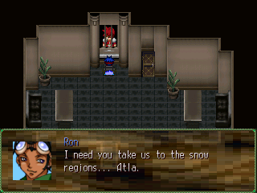
After the battle, Society once again, disappears. After the event, Ron becomes controllable, however, he’s alone and the Auto-Cabin won’t be available for use at this time. Have Ron enter his house, and afterwards, several events take place.
After those events, Ron is controllable again. Create your party, and head to Koudo to see Silas Micchi. New weapons and armors are on sale in Koudo, and several people such as the crew, cast, and your friends in Montane all have new things to say, including “brainless” Jessie and Jerri.

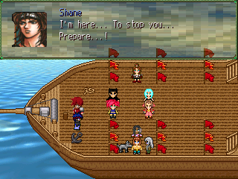

After talking to Silas, you’re taken back to his ship. Beverly suggests that something is wrong with Ron, but Ginger doesn’t believe so. Mina notices someone in the water and suddenly, Shane jumps onboard, albeit seasick. After he vomits a couple times, the party engages in another boss fight with Society.

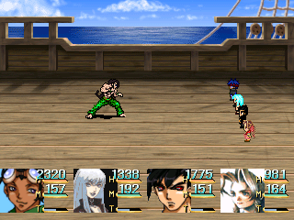

BOSS BATTLE: Shane

Shane is the master of speed and strength. He has high defenses in everything, with Earth-Elemental attacks as his only source of weakness. Beverly with Ezra, and Mina with her second level Earth spell would do wonders here. The problem, however, is keeping them alive…

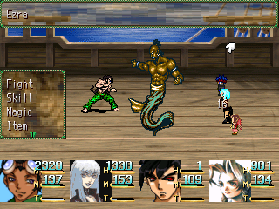
Being one of the strongest Society members, Shane has several powerful moves at his disposal, his most dangerous being his “Clean Sweep” move, which does 800-1000 points of damage to the whole party. Furthermore, Shane casts “Physical Break” quite often, tearing down one’s defenses. His most frequent move, “Uppercut”, takes away an extraordinary amount of damage from a character, which may even have the potential to kill them if they’re weakened.
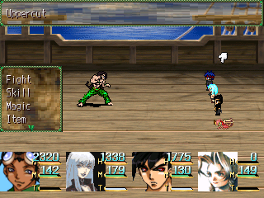
The trick to beating this battle is to keep everyone’s HP up as high as possible at all times. Ron will serve as your primary healer this battle, with Peppersticks and Beverly serving as back up healers incase Ron is killed. Pummel Shane with your strongest moves. If you keep attacking him with high-powered Earth moves, he’ll fall in no time. The experience earned at the end of the battle is great, so keep everyone alive!

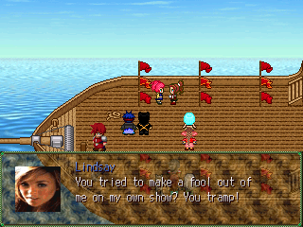
After the battle, Shane explains his motives. He outs Stephenie as a mole, which upsets the party. Stephenie pleads her case, accusing Shane of lying. She attempts to win back her teammate’s trust, though, Lindsay doesn’t buy it all.

Soon after, Beverly gets a feeling from the spirits of Atla. Shane disappears, and Silas arrives at the frozen continent.

DUNGEON: Atla
ENEMIES: Woodstock, Polar Bear, Juggs
ITEMS: None

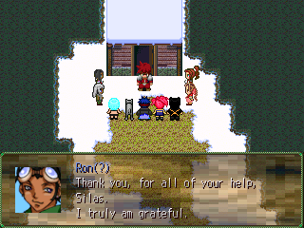

Silas arrives at the snow lands. Ron thanks him, and he leaves. After this, Ron becomes controllable. If you’re running low on supplies, feel free to talk to Silas, and he’ll take you back to Koudo.

Woodstock – None
Polar Bear – Ice (Strong against Physical)
Juggs – None

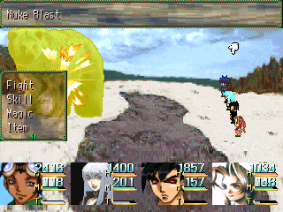
This “dungeon” isn’t hard at all. While it’s mostly a large land mass, it’s fairly easy to make your way around. The only objective here is to get to Pina Pita’s house, although, if you have Beverly in your party, there’s a small quest for her to do...

With that said, the monsters are pretty easy. While the Polar Bears pack quite a punch, you can easily take them out with a second-level Fire spell.

DUNGEON: Lizzie’s Domain
ENEMIES: Jumpy, Skellie, Rat
ITEMS: Mini Chips, Rabbit Tail, Iron Bangle, Can’t Touch Me Ring, Shield Beater, Bear Meat, Chance Bracelet

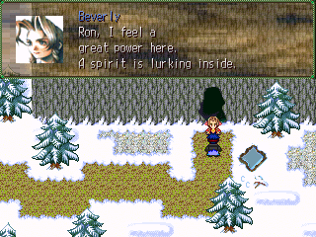
If you’re using Beverly, go to the far west side of Atla. Head all the way up north and then head south until you see a small path. Approach it, and you’ll find yourself near a cave with Beverly standing in front of it. Approach her, and she’ll explain that there’s a power inside. After the brief conversation, she rejoins the party, and you’ll be free to enter the dungeon, however, you can only enter with Beverly in your party.

Jumpy – Darkness
Rat – Earth
Skellie – Darkness
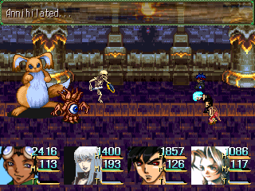

These enemies are TOUGH. Watch out of the Skellie enemies. Their most frequent attack, “Gas Spill”, is also their most dangerous. It has enough power to completely annihilate your entire party in just one go, often times, not even damaging them. If you come across one, defeat them with your strongest moves. You’ll definitely want them dead as soon as possible.

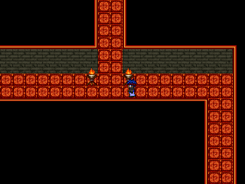

All in all, this dungeon is really short. There’s a pretty basic path to follow (always go north), but this place is loaded with rare treasures, so it’s recommended that you get them. Plus, if you feel that you are a little under leveled, this would be a great place to do some leveling up (you should be in your early thirties by now).

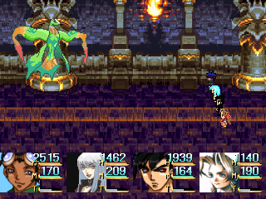

BOSS BATTLE: Lizzie

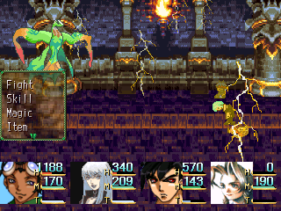
Lizzie lurks below her temple. She attacks the crew. Ezra was only a warm up compared to Lizzie’s powers. Lizzie uses a variety of high-powered lightening attacks. Before entering the battle, make sure you equip your weakest fighter with the “Jolt Badge”. If you don’t, prepare to suffer the consequences when he or she begins dying from all of Lizzie’s attacks. “Storm” and “Shock Bomb” are Lizzie’s most dangerous moves. “Storm” takes away a huge amount of HP from the whole party, while “Shock Bomb” paralyzes everyone. “Shock Bomb” followed by “Storm” followed again by “Shock Bomb” could lead to a quick and easy game over. Besides “Thunder”, Lizzie doesn’t have any other defenses, allowing you to bring a diverse party. Bring Mina in the battle to speed things up, but only if she’s learned her second-level Water spell. If she hasn’t, keep her out of here.

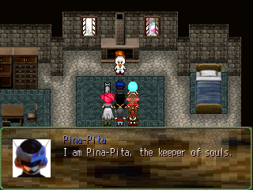
When you’re finished with the optional events (if you chose to do them) head southwestern of Atla until you arrive at a house. Enter it. Inside, the dark figure in Ron’s dreams is finally revealed. After he introduces himself, a discussion takes place, leading you to the next dungeon, “The Chamber of Souls”.
However, make sure you have all of your shopping done (buy plenty of life-restoring items) BEFORE entering Pina-Pita’s house, because once you enter, you won’t be able to leave.

DUNGEON: Chamber of Souls
ENEMIES: Lamia, Slayer, Thunder Bird, Growl, Oldie, Dark Soul Plus
ITEMS: Icy Ring, Bear Meat, Shade Hat, Sugar Cookie, Marco Hat, Rabbit Tail, Green Glow, Runner Jumper, Demon Juice, Jennifer Whip, Jennifer Whip, Deer Park Water, Lunch Box, Pink Glow, Life Pill, Lucky Charm

Slayer-Fire
Growl-Darkness
Oldie-Darkness
Dark Soul Plus-Darkness
Thunder Bird-Lightening
Lamia-Earth

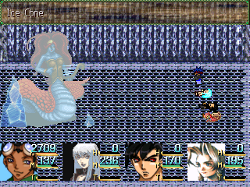
The enemy to fear here is the Lamia. She’s slow, but her “Death Wave” attack is brutal. She has high HP, strength, and defense, making her a tough opponent to beat. If you’re running low on Life-restoring items, it’s wise to flee from her. But if you accept the challenge, a great reward will be rewarded in experience by defeating her.

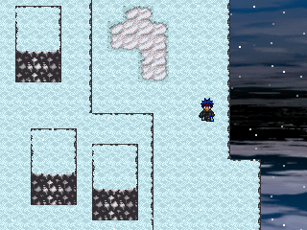
The dungeon itself is pretty straight forward. There are few twists and turns, making this dungeon less of a maze than usual. The experience awarded here, especially from the Thunder Bird trio and Lamia, are great, making this place an excellent level-builder for your weaker characters.
Also, the majority of the enemies here are “Darkness”, so unless Ginger has learned “Ernest Bow”, don’t expect her to be very useful here.
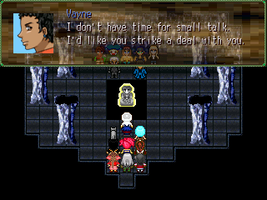
In the final room of the dungeon, you’ll come across Vayne, Zeke, and the Society members. Several important events will take place, so pay attention. Vayne and Zeke strike a deal with each other, forcing you into the final boss of Act Two… Jose.

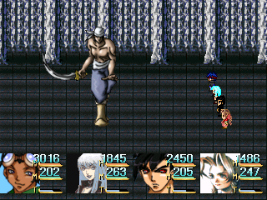

BOSS BATTLE: “Best Friend”

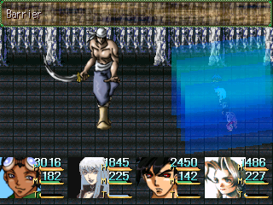
Vayne’s speed is incredible, and as you should know now, high speed = dangerous. To top it off, Vayne’s attacks each take way over a thousand points of damage or higher, with some even attacking the whole party. Having at least two people casting “Sparkle” is nearly a must here. Also, one of Vayne’s more annoying attacks is called “Charm Bracelet”, which confuses the whole party, in addition to the-oh-so-familiar “Shock Bomb”.
For starters, cast “Barrier”. That’ll save you from the attacks somewhat. Then, pummel Vayne with everything you have. He’s strong against everything, so it’ll take some time, but it’s possible. To win this fight, pummel Vayne with your strongest moves, heal when necessary, and recover your party members if they fall victim to “Charm Bracelet”.

After the battle, watch the events that follow, and then you’re on to Act Three!

ACT three: THE BOY AND THE STONES

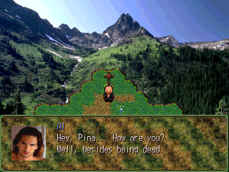

The new scenario opens up with a private moment with Al.
Following Al are many important cut scenes including many of your party members, and Society.

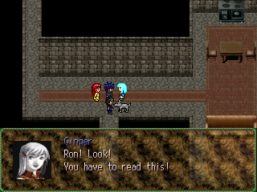

Next, Ron is confronted by Ginger and Peppersticks concerning his mom. Ginger shows him the note. The rest of the party engages in a group meeting, deciding that Velva is the next place to go. After Ron becomes controllable, pick out your party of choice, and then head out to Koudo.

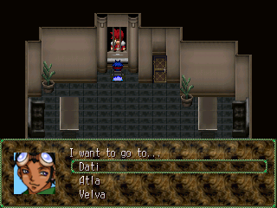
When meeting Silas, to progress through the game, go to Velva. However, if you’re using Beverly as one of your main party members, Dati is the place to go, or, if you haven’t obtained Lizzie yet, you can still go back to Atla.

TOWN: Dati
SHOPS: Item, Weapon, Armor, Extra
ENEMIES: Dentine
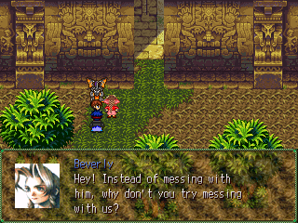

If you choose to come to Dati, make sure that you place Beverly in your party; otherwise, you won’t be able to see the event. Once you include her in your party, head to Senaro.
A demon, Dentine, will be attacking a kid. Beverly and Ron will approach it, resulting in your first “official” boss of the new scenario.

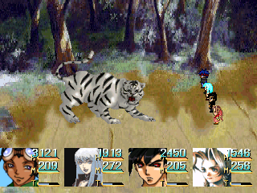

BOSS BATTLE: Dentine

Dentine is purely physical, so refrain from using physical attacks against him. They won’t work at all. Fortunately, all types of magic will work against him, so bring along a party full of hard-hitting spell-casters like Ginger, Beverly, Jerri, or even Al.

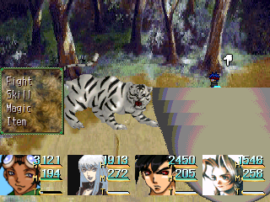
Dentine has many attacks you need to watch out for, with his most frequent move being his “Busy Claws” skill. Characters with low HP or defense will surely get it, so equip them with items or accessories that increase defense power.
To defeat Dentine, attack with your most powerful skills repeatedly and HEAL, HEAL, HEAL! Two healers are nearly a must for survival. It’s also wise to bring along several Life-restoring items, because you will definitely need those.

TOWN: Velva
SHOPS: Item, Weapon, Armor
ENEMIES: None
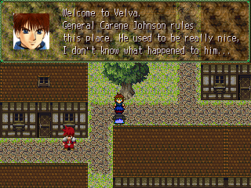

Once you enter Velva, shop around for new supplies and, if you like, talk to some of the residents. You’ll learn more about Carene Johnson and this town. When you’re done, head north of the town and enter the large building.

TOWN: General’s Headquarters
ENEMIES: None
ITEMS: Night Star

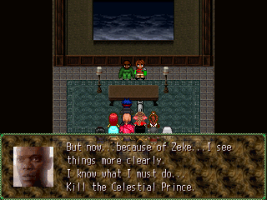
It’s time to confront Carene Johnson, Ron’s father. There’s nothing much to do here, but if you want, head north from the first room to collect the Night Star item. Afterwards, you can find the elevator location on the far left side of the building. Enter it, and head to the only other room on the next floor. Before entering, make sure you save first, because once you enter, you won’t be able to leave until this section is over.
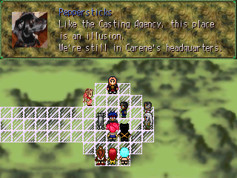

Carene, now in his White Face uniform, warps the party to another dimension, similar to the one Nilynn and Michelle created. After a discussion, the party realizes what they must do, find Carene, and stop him.

DUNGEON: Clown’s Domain
ENEMIES: Telly, Possessed Food, Red Raven, Fumpy, Weeeble
ITEMS: Violet Ring, Bio Function, Knee Pads, Lace Potion, Rabbit Tail, Mini Chips, Sugar Cookie, Calm Hat, Deep Park Water, Bear Meat, Dream Potion, Oak Beater, Goat Head, Life Pill, Cell Pill, Night Star, Green Glow, Lucky Charmx2

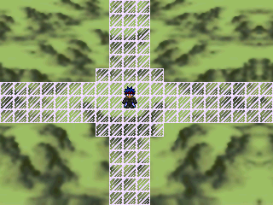
As if it couldn’t get anymore obvious, the layout of this dungeon is quite strange, throwing in many twists and tricks to confuse you. To advance, you’ll need to jump on several tiny platforms.
Besides the weirdness, this dungeon is home to some of the rarest items in the game, so it’s strongly advised that you collect all of them.

Fumpy-None (Weak against Throw)
Possessed Food-Ice
Red Raven-Fire
Weeeble-None (Weak against Thrust)
Telly-None

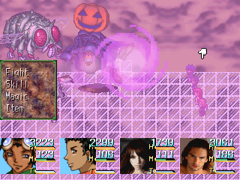
The enemies aren’t very difficult, though, they can be troublesome, especially Telly’s “Charm Bracelet” move. Taking the enemies down with just weapons alone won’t cut it here. To survive these foes, you must use your skills often, so hopefully you have plenty of MP-restoring items, notably Velva’s “Dream Potion”, which is relevantly cheap considering all the money you’ve earned this far. If you don’t have any new items, you should find some here.

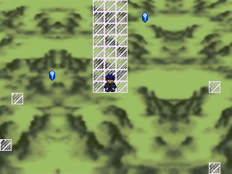

Around the middle of the dungeon, you’ll come across a platform that appears to be a dead-end, except, it’s not. Simply press the action key and the path will appear. There are other platforms like this, except, you’ll need the powers of the gems to reveal the hidden pathways, however, you’ll need to find the gems first.

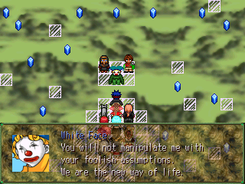

After the end of the dungeon, the party confronts White Face. After a discussion, White Face attacks the crew!

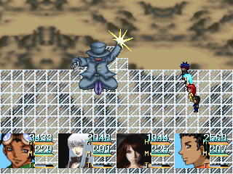

BOSS: WHITE FACE

White Face is the only member of Society whom you haven’t fought yet. White Face is strong against all types of magic, so having a physical party such as Stephenie, Slay, or even Peppersticks would be ideal. And, if you’re using Beverly, her newly found “Dentine” summon monster would work wonders here. Hard-hitting spell casters like Jerri, Ginger, and Mina will have a tough time. While White Face’s powerful spells won’t hurt them as much, it works the same way for them. Many of their spells will be ineffective against him.
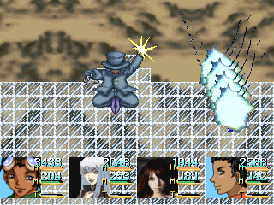
White Face has plenty of lethal attacks you need to look out for, with his most frequent move being “Blue Spark”, which deals about 1000+ damage to everyone. “Pearly Gates” and “Sanctuary” are his most damaging moves. All of them hit the entire party, and Ginger, being weak against Holy, will sure die by one of those attacks. While White Face’s HP is quite high, he isn’t the most difficult boss you’ve faced, so defeating him won’t take long.

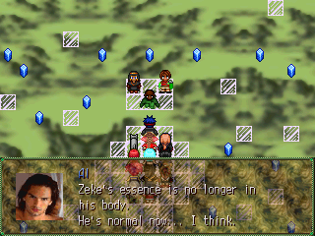

After the battle, White Face returns to normal. The event continues, leading you to several important scenes. After everything’s over, Carene Johnson will guide you to your next location.
When you’re back in control of Ron, buy the new items, weapons, and armors on sale in Montane City, and if you’re using Beverly, a new summon spirit is available. You can find it at the Abandoned Factory.

DUNGEON: Abandoned Factory
ENEMIES: Boom, Nails, Jules
ITEMS: Same as before

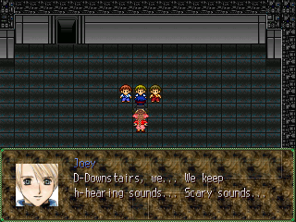
Before entering, place Beverly in your party, otherwise, you won’t be able to view the event. Afterwards, save, and enter. A discussion will take place, telling you your goal for this dungeon. Hopefully you brought plenty of supplies, because though short, once you enter this dungeon, you won’t be able to leave. After the event, proceed to complete the dungeon. It’s exactly the same as before, so you should remember your way around.
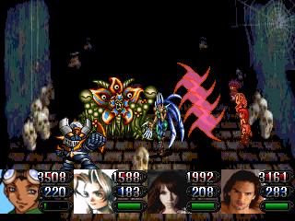
Obviously, with the new boss in town, the monsters here have changed as well. The new weapons you bought from Montane will prove to be very useful here, as well as the armor. Some of the enemies can be tough, such as the Boom enemies, for an example. Their Gunshot skill can easily take out a weak character if used enough times, especially one weak in the physical realm. Other than that, these enemies shouldn’t be hard at all to defeat.

Nails-None (Strong against Physical, Bladed, Whip, Weak against Throw)
Boom-None (Thunder = DANGER)
Jules-Magical

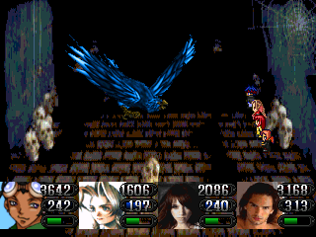

BOSS BATTLE: Eeegle

Other than his default strengths and weakness (Wind, Earth), anything else can be used against him. Throw as many Earth attacks at him as you can. Beverly with Ezra and Mina with her second-level Earth spells will be very useful here.

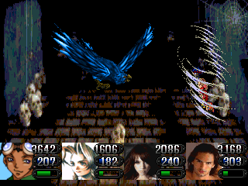
Typically, battles against the ancient spirits are hard, and this one is no exception. Eeegle has both high powered physical and Wind attacks, making him extremely dangerous. His most dangerous attack is “Carry Off”, and while it technically isn’t an instant-death move, it might as well be. It’ll most likely kill a character, and there’s no way to shield against it. The trick to this battle is speed, so if you have the Auto-Haste ring, give it to a healer, preferably Ron, so you’ll always be prepared to dish out the healing when necessary.
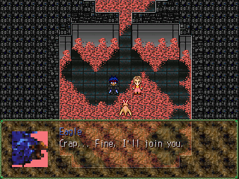

After the battle, Eeegle agrees to join Beverly, giving her a new summon spirit. Afterwards, the event will end. To leave the dungeon, simply go back the way you came.

DUNGEON: Mines
ENEMIES: Crest Warrior, Spore, Mr. Crab, Sea Spirit, Black Pug, Mud Golem
ITEMS: Glass Beater, Fire Extinguisher, Ana-Lucia, Fish Tail, Mercedes Ring, Mind-Over-Matter Pin, Beau Armlet, Cuffer Hat, Golem Suit, Lucky Charm

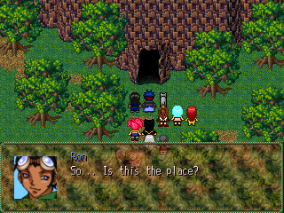

The goal here is to obtain the first chaos stone, the Star Ruby, before Society.
The group finds themselves gathered in front of the Mines. A discussion will take place, and Ron becomes controllable. Make sure you’re stocked on plenty of restoring items before entering. If not, then go to Velva or Koudo for good supplies. Otherwise, simply enter the dungeon.

Crest Warrior-Holy
Black Pug-Earth
Sea Spirit-Thunder
Mr. Crab-Water
Spore-None (Fire = Danger)
Mud Golem-Earth

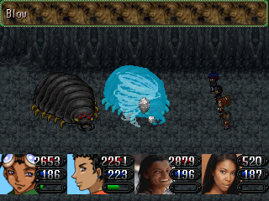
The monsters here have some high-powered attacks, and if you aren’t careful, a character will die before you know it. As always, healing in this dungeon is a mUst. It’s wise to have both HP and MP restoring items, though, if you can’t afford to have both, then stock up on MP restoring items instead.
Overall, the enemies aren’t hard, if you have Mina and Ginger with you, you can breeze through these battles with no trouble at all.

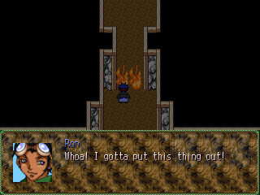
As soon as you enter this dungeon, you’ll notice the flares blocking the path. To get rid of them, head to the path on the right. Follow it to the next section. In that section, simply walk down the long path and obtained the Fire Extinguisher. After you have that, return to the front and use that to put the fires out. Use this to put out the fires for the render of the dungeon, but be careful, some blocked paths may lead to dead-ends.

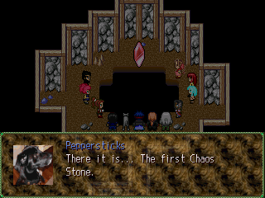

At the end of the dungeon, heal, and enter the doors. You’re taken into the room holding the Star Ruby. Al uses his powers to obtain the stone. Suddenly, the room shakes, and a monster attacks.

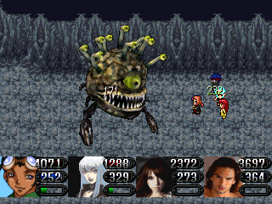

BOSS BATTLE: Janlee

Janlee is the master of poison attacks, especially Bio, so make sure you’re equipped with something that protects against that. Other than that, Janlee doesn’t have any other powerful moves, so just pummel him and heal until he dies.

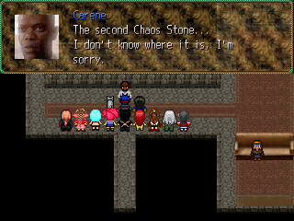
After the battle, the Star Ruby becomes yours for the taking. Exit the dungeon, and return to Carene in Montane. A series of important events will take place, so pay attention. After that, regroup, restock, and head to Silas. A new option, Zagi, will be opened. Go there. However, everyone has something new to say, including the staff, crewman, and your party members so if you want, you can spend sometime talking to them.

TOWN: Zagi
SHOPS: None
ENEMIES: None

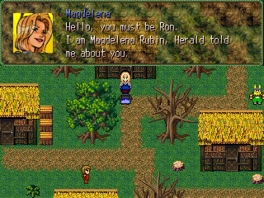
Make sure you have all of your shopping done before entering this town, preferably from Velva or Koudo. Once you’re down, head to Zagi. This is a small town with little things to do. Approach the blonde woman standing in front of her house. She’ll share some character history with the party, which will ultimately lead you to your next designation.

DUNGEON: Underground Shrine
ENEMIES: Shell Fish, Magic Toad, Mighty Fisto, Sprout Bug, Soul Hacker
ITEMS: Oyster, Fish Tail, Coyote Shoes, Gene Bracelet

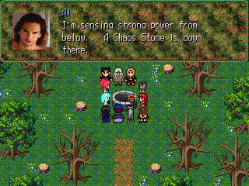
After the conversation with Magdelena, the woods become assessable. You can enter them through the small path at the upper part of town. In the woods, simply follow the short path to the well. However, make SURE you’re fully stocked, because once you enter, you won’t be able to leave.
Once you enter the well, the party will have a discussion. The group decides to enter, sending you into the next dungeon.

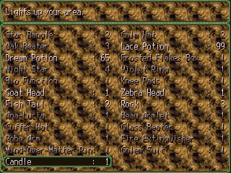
As soon as you enter the dungeon, the first thing you’ll notice is how dark it really is. Unless you have good eyesight, it’ll be difficult to navigate this dungeon (though, still very possible). However…there’s a solution for this. The candle.
Throughout the dungeon, you’ll find several candles lying around. Grab them ALL. To grab the first candle, from the start of the dungeon, head south, then west, a little north, and then west again to enter the second section of the dungeon.
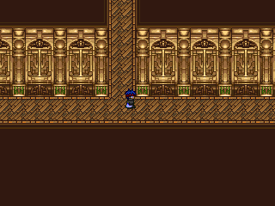
In the second section, simply head all the way to the west. There are two doors there. Enter them from the left side. In that room, head north until you come to a stop. Press the “enter” key. There, you’ll find the first candle. Find the candle from the inventory (should be the last item) and click on it. Within a few seconds…you’ll have light!
Mighty Fisto-Physical
Shell Fish-Magical
Sprout Bug-Magical
Magic Toad-Magical
Soul Hacker-Darkness

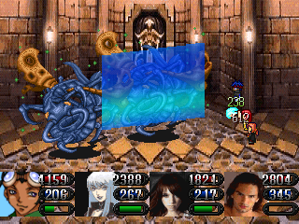
Many of the enemies here are magical, rendering many of the heavy mage characters like Jerri, Al, and Ginger, quite useless. Hard hitting-physical fighters like Quentin, Stephenie, and Slay would be ideal here. Though, characters like Jose, Peppersticks, and Mina, who specialize in all forms of attack, would be the best characters to bring.
The enemies themselves aren’t difficult alone, but be careful when you start facing them in groups.

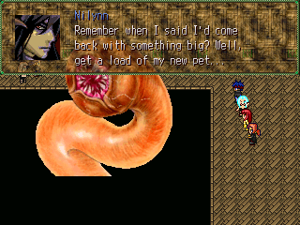

BOSS: Saber Tooth Worm

Saber Tooth Worm’s high speed, mixed with his constant speed-boasting and speed-lowering moves, can make for one difficult battle. Of course, like with Turquoise, Nilynn and Michelle are here to make things even more troublesome, especially Nilynn’s “Red Bullet” which hypes a character. Unfortunately, once again, you can’t harm them. You can try, but you won’t succeed.
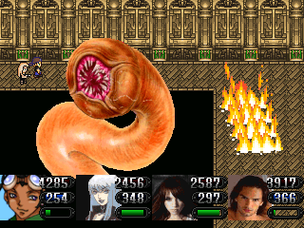
There are several things in this battle that should be of concern. One, the speed factor, which you can easily encounter by equipping items that boasts speed, casts haste, and prevents slowness.
Secondly, Michelle will constantly cast a 5000+ healing spell called “Recovery”. While this sounds bad, most of your party should already have skills that dish out 1500+ damage each. Have your party pummel Saber Tooth Worm heavily with hard hitting spells to counter Michelle’s constant healing attack. However, if your party is too slow, Michelle’s healing will completely takeover the battle, which, obviously, isn’t good.
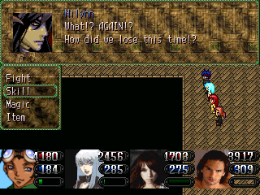
Saber Tooth Worm doesn’t have any default strengths or weaknesses, so bring along your most hard-hitting party to win this battle. Healing is, of course, necessary, but make sure you have your party attacking the worm constantly to counter Michelle’s healing. After the battle, like before, Nilynn and Michelle will free, handing you the victory. Oh, and don’t even try to escape. It won’t help. :p

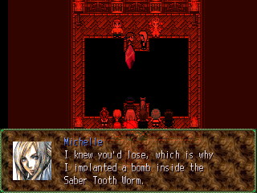
After the battle, Society escapes with the Star Crystal. Al warps the party back on land. Afterwards, head back to Montane.
In Montane, enter Ron’s house. A series of events will take place. Afterwards, you’ll be back in control of Ron. The next destination is the Montane Television Studio, which is just above Ron’s apartment building. Though, if you want, you can buy the new supplies on sale, and see some of the new things the townspeople have to say.

DUNGEON: MONTANE TELEVISION STUDIO
ENEMIES: Julie, Mophisha, Blue Cobra, Wolf, Rifle Happy Cutting, Cozolt, Samantha, Bufella
ITEMS: Body Armor, Vito Drink, Soul Drinkx2, Sunny Delight, Robo Scraps, Zebra Head, Fish Tail, Pizza, Lucky Charmx2, Earth Blaster, Chip Buckler, Oyster, Cowboy Hat, Ring of Clear Head

Mophisha-Earth
Wolf-None (Dangerously weak against Thrust and Whip)
Rifle-None (Dangerously weak against Thunder)
Happy Cutting-None (Strong against Bladed and Thrust)
Blue Cobra-None (Dangerously weak against Throw)
Julie-Holy
Cozolt-Ice
Samantha-Thunder
Bufella-Darkness

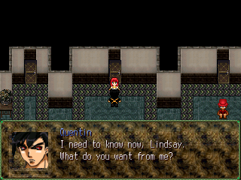
Upon entering the Studio, Ashlee and Paris will snatch Lindsay, taking her away from the rest of the party. The three girls then meet in Lindsay’s dressing room. The three discuss some things, and afterwards, Lindsay becomes fully controllable. Save your game and exit the room. Lindsay then runs into Quentin, and the two have a less than pleasant conversation. After that, you gain control of Lindsay again. The Auto-Cabin device won’t work here.

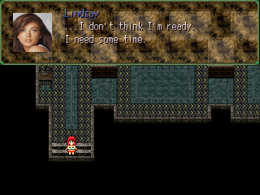
After the scene with Quentin, check the stairs. Lindsay will get nervous, and claim to need more time. To progress through the story, have Lindsay enter the final door on the far right. However, if you want, you can have her talk to the numerous guests and performers in their respective rooms. When you’re done, or, if you choose not to, enter the final room on the right.

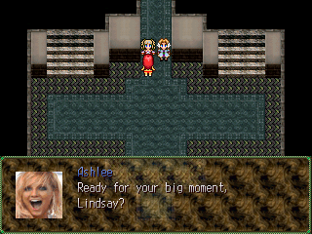

When you enter the room, you come across two very familiar faces. An event takes place. Afterwards, you’re back in control of Lindsay. Head downstairs and approach Ashlee (or Paris, whichever one) to start the next event.

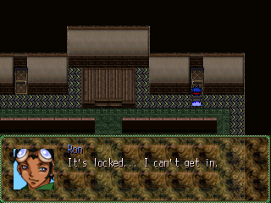
After the events, the party regroups, and Ron becomes controllable again. Choose your party, and head to the “Performance Room”. To get to the room, from the entrance, climb the stairs to the right. On the next floor, simply enter the room. Collect the treasures, and examine the door on the right. You’ll quickly notice that it’s locked. To find the key, head over to Lindsay Lohan’s dressing room on the other side of the second floor.

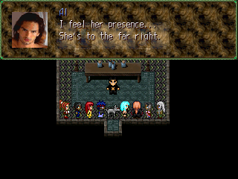
Once you enter Lindsay’s room, Al will sense her current location. So, afterwards, head to the previously locked doors to the far right of the hall, where the green carpet is sitting. If you want, you can talk to the guests, as they have new things to say. It’s recommended that you talk to Johnny Depp. He gives you an important item that’ll be very useful if used in shops.

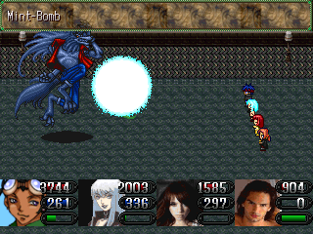
Hopefully you bought new weapons from the shops, because you’ll definitely need them here. These enemies pack quite a lot of strength, leaving some of the spell-casting characters a bit vulnerable. Watch out for Wolf’s “Treat Bite”. It drains many HP and MP from a character, and if a character is weakened enough, it can even kill them.

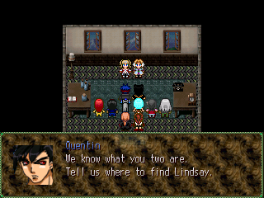

Head to the far right. Collect the, “Ring of Clear Head” below, and follow the carpet trail that leads to a room. Enter it. Ashlee and Paris are lurking inside. After a discussion, the women attack, sending you into a boss battle.

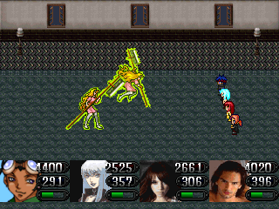

BOSS: Ashlee Simpson (top), Paris Hilton (bottom)

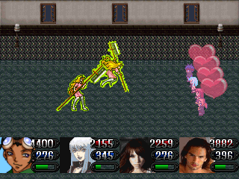
Ashlee is the attacker, and Paris is the healer. This type of strategy you’ve dealt with before, except this time around, it’s a little trickier. To take out Ashlee, use magic, and to take out Paris, use physical moves. Magic doesn’t work quite as well for Paris and vise-versa for Ashlee.
Aside from her healing, Paris’s main attack is her devious “Seduction” spell, which “Charms” or “Confuses” all characters. You can guard against this by equipping “Can’t Buy Me Love” or “Ring of Clear Head” to a party member. If not, then hopefully you’ve brought a long plenty of “Brain Juice” items. Secondly, equip “Auto-Haste” to the character you’ll be using as your main physical “hit man”, otherwise, Paris will probably out heal you.

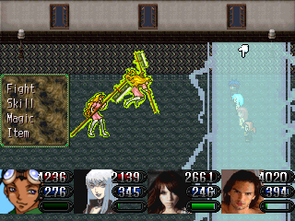
Ashlee, on the other hand, has several powerful attacks lined up. She frequently uses “Axe Strike”, a physical attack, which could be quite hazardous to a physically weak character. However, her most dangerous move is her “Heather” spell, which takes out a tremendous amount of HP from a fighter character, and in most cases, killing them. Fortunately, once Paris is out of the way, Ashlee is a complete pushover.

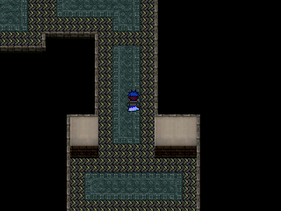

After the battle, Ashlee hands over the key. Afterwards, head back to the performance room and enter the previously locked door. In the next section, work your way up to the end, making sure to collect all the treasures along the way.

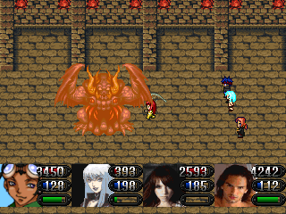

Once you arrive at the basement, you’ll quickly notice that it’s none other than just a cover up for the Chaos Shrine. There are new monsters to face here. They’re a little harder, but still nothing you can’t handle, though watch out for Bubella’s Bio Bite. The power of the attack itself, combined with the power of Bio, could lead to a very nasty situation.

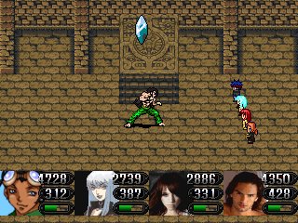

BOSS: Shane McDonald

In the final room of the dungeon, you’ll face two battles, with the first one being Shane. Though Shane possesses buffed up versions of his old moves, this battle isn’t hard at all. He’s completely resistant to physical attacks, though, Earth Spells, especially level three Earth spells, will work wonders here. Pummel him down and heal when needed.

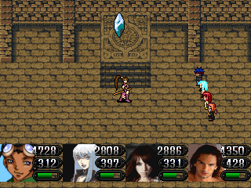

BOSS: Chelan Cortez

Chelan has two forms, her mage form, and her summon form. She changes between these two forms quite often. In both forms, Chelan is strong against everything, leaving few attacks that’ll attack work well on her.

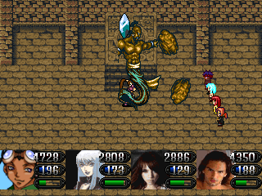
In her mage form, Chelan uses a variety of healing spells, including an advanced version of Jerri’s “Mint Bomb” spell, which has a high chance of stunning a character. This form isn’t too difficult, however, when Chelan raises her arms, she then possess the ability to summon numerous summon spirits at the party, all of which you’ve seen before. Heal constantly while hammering Chelan with your strongest moves. Al and Ginger would be great characters to use here, if they’re leveled up high enough.

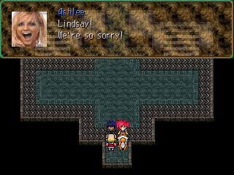

After the battle, Lindsay and Beverly rejoin the party. You’re sent back to the start of the dungeon. The monsters are gone; however, you are unable to go anywhere. Confront Ashlee Simpson and Paris Hilton one last time to complete the event.

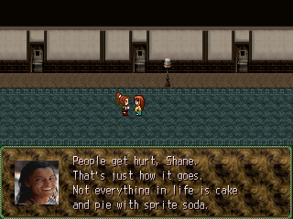

After the events, stuck up on new supplies if you need to, and head back to Ron’s apartment. Stephenie and Shane will share a scene, followed by many other scenes. Afterwards, Ron becomes controllable again. Altar is the next dungeon, so head to Silas in Koudo.

DUNGEON: Altar
ENEMIES: Grimm, Serena, Blow Out, Scruffy, Ruby Shevalla, Atlar’s Holy Sacred
ITEMS: Golden Chain, Zebra Head, Soul Drink, Oysterx2, Fish Tail, Vito Drink, Plow Buckler, Large Claw, Lucky Charm, Powdered Donut, Lit Shock Belt, India’s Cup of Life, The Striker

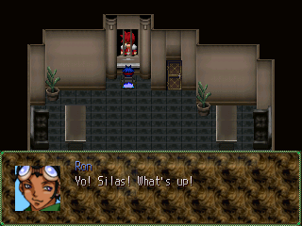
Once in Koudo, talk to Silas. He changes his accent yet again, thus leading to a somewhat bizarre conversation. Afterwards, Silas takes you to the Desert Domes.
In the Desert Domes, you can find two people there selling supplies. You can purchase items if you need to, but if not, simply enter the caves.
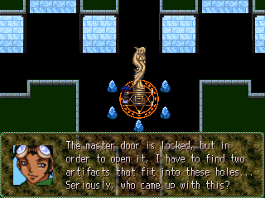
Venture through the caves. Pick up the Gold Chain, and speak with your party members. Exit the caves, and enter Atlar. Once inside, examine the tall statue in the middle of the floor. Like Ron said, you must find two “Moon Pieces” to fit into the holes on the statue. Once you find them, the statue covering the “Master Door” will disappear. There’s a Moon Piece on each side of the dungeon, the right and the left. It’s recommended that you grab the artifact on the left side, first.

Blow Out – Thunder
Serena – None (Celestial & Whip = DANGER)
Scruffy – Darkness
Altar’s Holy Sacred – Holy
Grimm – Darkness
Ruby Shevalla - None

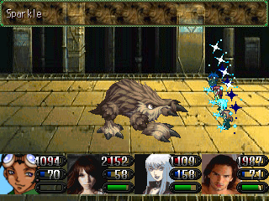
The Blow Out enemy is probably the most frequent enemy you’ll face in this dungeon. They aren’t too tough, but their Thunder spells can shock you. The Scruffy’s only weakness is Holy. They’re strong against everything else. They also have powerful physical attacks, so make sure you protect your mages. Ruby Shevalla’s HP is sky high, but the experience earned from defeating one is great. The other enemies are a piece of cake.

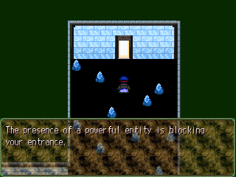

Late in the left-side dungeon, you’ll come across a small room. If you try to enter it, an invisible force will stop you from doing so. This is because a Summon Creature is lurking inside. To gain entrance, place Beverly in your party, and walk inside.

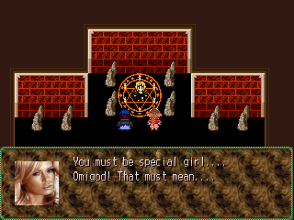

Inside the room, if you choose to go inside, that is, Beverly will identity the spirit as being Jenna Jameson. A strange conversation takes place, followed by a boss battle. Get ready.

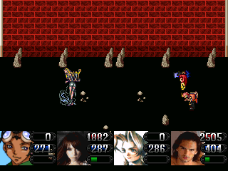

BOSS: Jenna Jameson

First of all, without any equipment to protect against Confusion and Charmed, it will be VERY hard to survive this battle. If you do, equip those items on your “healers”, who’ll most likely be Ron and Beverly.

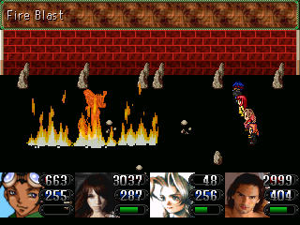
Jenna’s element is Ice, so Ron’s high-powered Fire spells will make short work of her, if he gets to use them, that is. Many of Jenna’s moves can Silence a character, among other things. If Jenna uses “Lullaby”, watch out. Not only will it put a character to sleep, it’ll also kill a character slowly. It isn’t curable, and it will only disappear after 10 turns…if the character is still alive. Other than defaults, Jenna doesn’t have any other strengths or weaknesses, so use what you can to take her down.

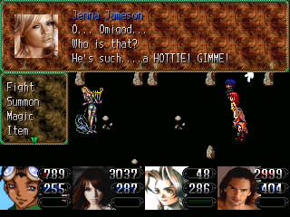
HOWEVER….there is a MUCH easier way to win this battle. During the Television Studio dungeon, hopefully, you’ve talked to Johnny Depp after the demons appeared. If you did, he would have given you a poster of himself. Considering that you haven’t sold it for large sums of money yet, you can actually use it here. Jenna will go insane and snatch the poster for herself. She will become “Enticed” for twenty-five turns, automatically giving you the victory!

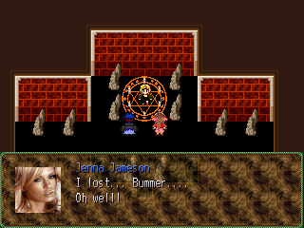

After the battle, Jenna accepts her defeat rather quickly. Beverly will then gain her as a new Summon Creature.

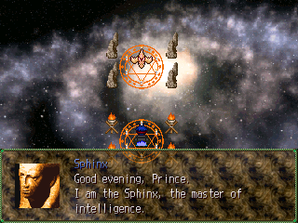
Continue with the rest of the dungeon, and you’ll come across a small room. You’ll encounter the Sphinx, who’s carrying the first Moon Piece. He’ll ask a series of questions, and to gain the artifact, you must answer all of them correctly, or else you’ll be faced with consequences. If you truly don’t know the answers, or, if you’re lazy, the answers are as follows:

- – 18
- – She doesn’t have one
- – 9
- – Stephenie
- – 3

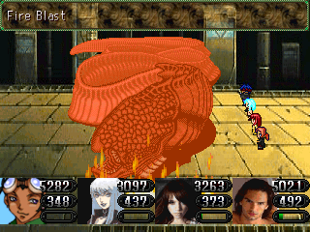
The second side of the dungeon is a lot longer, and thus, the enemies are a bit stronger, and more of them appear. Hopefully you’ve bought plenty of MP-restoring items, because physical attacks alone won’t help you survive. Use your high-powered attacks to make short work of these foes. If your characters are weak, this would be a great place to level them up.

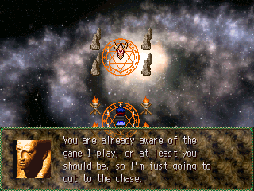
Once you arrive at the end, the Sphinx reappears. He’ll ask you another set of questions. The answers are:

- – Cassey
- – Sukoo Kajah
- – Delilah and Shane
- – 10
- – Hate

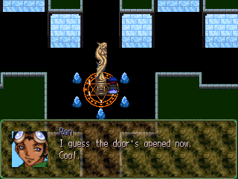

After you obtain the second Moon Piece, you’re automatically taken back to the “base” floor. Place the stone inside the statue, and the statue blocking the Master Door disappears. Heal, and go inside to face Society.

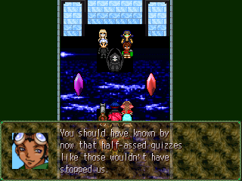

In the Master Room, the group confronts Society. Not before long, Michelle and Nilynn unleash their latest creation at the group, forcing you into a boss battle.

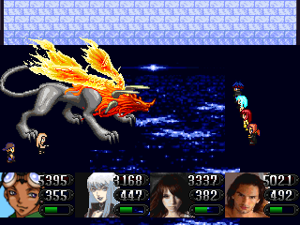

BOSS: Flaming-Flame Raven

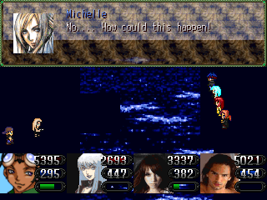
As you can tell from his appearance, the Flaming-Flame Raven is weak against “Ice”. Having Ron cast his level two (probably three) ice spells while having someone heal would be ideal. Nilynn and Michelle are now more annoying than ever. Not only are they a lot faster, Nilynn’s new “Blue Bullet” attack freezes a character, making them inactive for five rounds. Once again, high speed is the only way you’ll survive this battle, so speed-boasting skills and (or) equipping your party with items that boasts speed or casts Haste is essential. Aside from ice, water-type spells can also work, so pummel the raven with constant Ice and Water attacks to end the battle quickly. Though Michelle’s healing may seem ruthless at first, if you dish out enough damage, it won’t matter; you’ll still kill the raven in very little time. After you defeat the monster, in typical fashion, Michelle and Nilynn will flee the battle, giving you the victory.

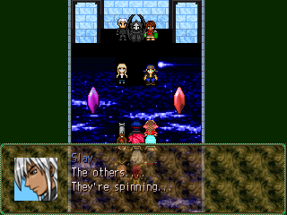

After the battle, the Chaos Stones begin reacting to each other. A great power is unleashed, and Nilynn and Michelle, this time, without their pets, attack the party.

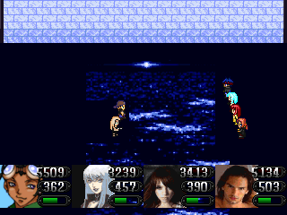

BOSS: Nilynn, Michelle

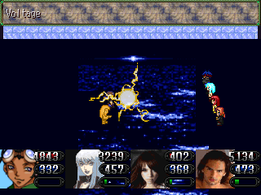
If you’re using Ginger for this battle, be careful. She’s stuck an incurable disease that’ll slowly chip away her HP, making her extremely vulnerable. Keep an eye on her at all times. Both Michelle and Nilynn have high HP and high defenses, making this battle a long one. However, they have some weaknesses. Nilynn is weak against Thrust and Bladed attacks, while Michelle is weak against Thunder. Immediately have Ron take out Michelle with his thunder spells. Nilynn is strong on his own, and he doesn’t need someone healing him constantly. Nilynn’s Bullet moves are strong enough, and they’re even more lethal when used against a Mage character. Nilynn’s “Glow Bullet”, which inflicts “Slow” and “Mind Sick” on a character, will surely knock a mage out. If you equipped your party with speed-increasing items for the last battle, than this one will be a piece of cake. Nilynn and Michelle aren’t the quickest of enemies, so you’ll be dishing out damage long before they get a chance to.

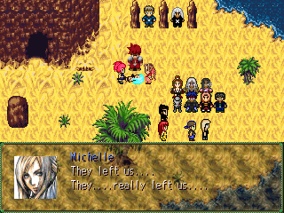

After the battle, Nilynn and Michelle are rejected by the remaining members of Society. Jerri gives them a few words of encouragement, and now the two are left with taking control over their own lives. Meanwhile, Ginger’s condition worsens, and the group decides to head back to Ron’s house.

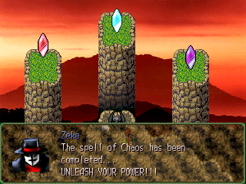
Return to Montane and enter Ron’s house. A variety of scenes take place, including a scene between Ginger and Al and the introduction of a potential new foe. Zeke releases chaos onto the world, changing everyone’s behaviors drastically. After the events, Ginger rejoins the party cured of her disease. Everyone has something new to say, so if you want, you can talk to them. If not, head to Koudo, and re-enter the World Prison. New weapons are also on sale in Koudo.

DUNGEON: Zepa’s Hideout
ENEMIES: Lackey, Red Rose, Ivy, Clay, Junk
ITEMS: India’s Cup of Life, Zebra Head, Rock, Night Star, Life Pill, Watermelon, Magic Dragon, Guard Potion, Rabbit Tail, Craver, Thunder Bird Meat, Moon Shield, Vito Drink, Watch, Metal Pole, X Lid, Lucky Charm

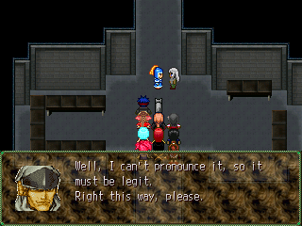
If you haven’t done so, buy new supplies at Koudo. They’re a bit steep, so if you can’t afford them, don’t worry. Anyway, once inside the prison, an event takes place. You’re taken downstairs. Follow the path to the only available room. Another even takes place. You’re taken to Zepa’s ship, and into a boss battle.
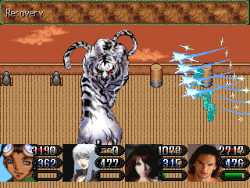

BOSS: Tigga

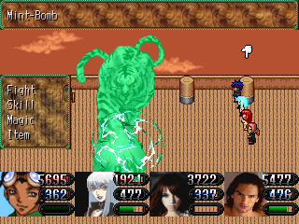
Tigga has incredible speed. His powers are weak on their own, but since he gets at least two turns before you do, they can get deadly. Bringing two healers into the battle is an absolute must. ALWAYS have someone available to heal during the battle. Whether it’s Ron, or Beverly, Peppersticks, or Al, someone must be prepared at all times. Tigga is Wind elemental, so Mina’s level two (especially level three) Earth spells will work wonders here. However, watch out for Tigga’s “Busy Claws” skill. Fighters won’t be at risk, but it’s deadly for mages. Two hits of that can wipe out a party of mages (which is why you need a backup healer available just incase). Bash Tigga with Earth and your strongest moves, and he’ll (eventually) fall. Watch out for his constant “Slow” spells, however.

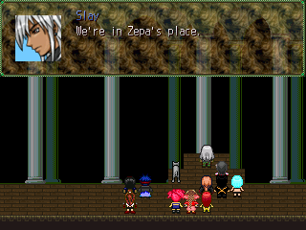
After the battle, Zepa abandons ship. The ship begins to crash, but Al warps everyone to safety. The group is taken into an unfamiliar place, which Slay reveals as Zepa’s headquarters. A discussion takes place, and Ron becomes controllable. Grab the treasure to the far right, and proceed to the first floor. There are three other paths to take. The southern path leads to the exit, but since you can’t leave, don’t go there. The northeastern path is the right way to go, but there’s something important on the southeastern path. Go there, first.

Ivy – None (Fire = DANGER)
Clay – Water
Lackey – None (Bladed = N/D, Throw = DANGER)
Red Rose – None (Fire = DANGER)
Junk – Thunder
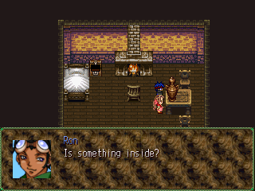

Enter the southeastern path. Your ideal room is to the far right, but you should collect the treasures from the other rooms as well. Once you’re done, include Beverly in your team, and examine the large bottle. Sayah appears, and the battle begins.

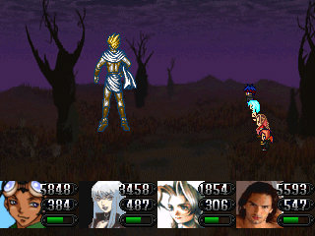

BOSS: Sayah

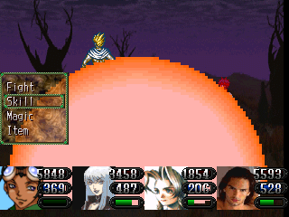
If you overload Sayah with Ice attacks, he’ll fall in very little time. For this battle, bring a party full of Neutral characters or Mages. Sayah’s “Explode” spell is simply devastating, powerful enough to completely wipe out a party of fighters. “Sun Spot” is another dangerous skill. It causes Burns, and it’s non-elemental. You can guard against it by having Al cast “Regeneration”, if you’ve power-leveled to get it. If not, then always have someone ready to heal. Other than that, Sayah uses run-of-the-mill Fire spells. If you plan properly, he’s much easier than Jenna Jameson. After the battle, Sayah hands over his power to Beverly, earning her a new summon spirit.
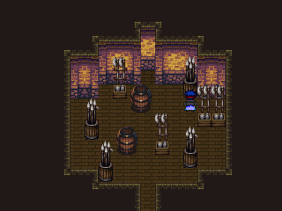
There are two powerful weapons to gain here, a “Craver” sword, and a “Metal Pole” for Beverly. To get “Craver”, head to the northeastern staircase on the first floor. Follow the path until you arrive at a three-way intersection. Enter the room on the left. In there, head all the way north to the stack of spears to the right. Examine it to get “Craver”. Beverly’s “Metal Bat” is hidden in one of the rooms later in the dungeon.

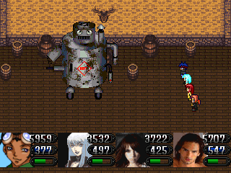

The enemies here are relevantly simple, though, Junk is the strongest. He heals himself constantly, and his “Gas Spill” attack can leave you frustrated. Without Mina’s water spells, beating him may be tough. Fortunately, Junk is slow, so after his first move, you can defeat him easily by pummeling him with your strongest moves.

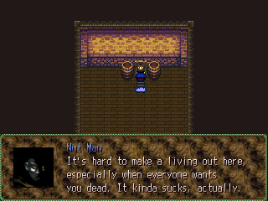

Later in the dungeon, you’ll come across a man known as the “Nut Man”. He sells an item called “Nut Sandwich”, made from coconuts. You can only find them here, and they’re cheap, so buy 99 of them.

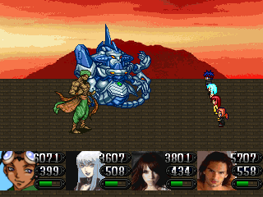

BOSS: Zepa Matili

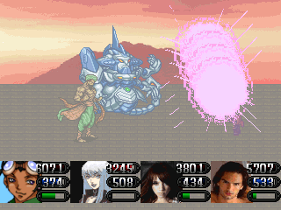
Zepa and his Guard Bot can make for one annoying battle. Guard Bot heals himself and Zepa for a lot of HP, so go after him before going after Zepa. Water attacks will put a serious hurtin’ on him, but any other powerful attack will do. Zepa’s “Nuclear Spill”, an advanced version of “Gas Spill”, can be brutal, so hopefully you’ve found the “Watch” somewhere around the dungeon. If not, then surviving this battle will solely be determined by luck. Equip it on Ron and have him heal the others if they become “Stopped”. Furthermore, equip anything that boasts speed and guards against abnormalities. In addition to “Stopped”, Zepa’s “Seal” causes “Sore”, and while it isn’t any nearly as dangerous as “Stopped”, it can get annoying.
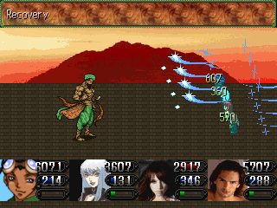
Zepa Matili’s most dangerous attack, besides “Nuclear Spill”, is his “June Tuesday” spell. June Tuesday is a very unpredictable spell. It can take away 1000-2000 HP from one character, and 5000+ on the next. Each time it’s used, it’s guaranteed that at least two of your party members will die. Hopefully you’ve saved up your lucky charms, because you’ll need them here. Use those to bring back all of your fallen comrades while restoring yourself in the process. Just make sure you always have someone ready for healing, just like with Tigga.
After Guard Bot’s dead, Zepa Matili won’t be as difficult to handle. His attacks are still dangerous, but your powers far surpass his. Pummel Zepa with your best moves, and he’ll fall in no time. Make sure all your crew members are still alive by the end of the battle. The experience earned is well worth it!
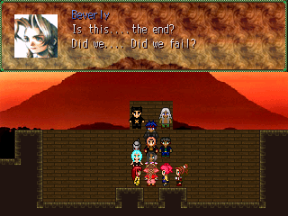

After the battle, a series of events take place, and you’re off to the next (and final) act of TOTAL CHAOS!

Final act: promise

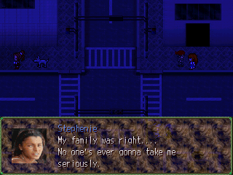

Peppersticks and Stephenie begin the scenario with their scene. After the events, Society airs a meeting, and the group decides that they must head to the Celestial Heavens. After Ron becomes controllable, head to the Abandoned Factory.

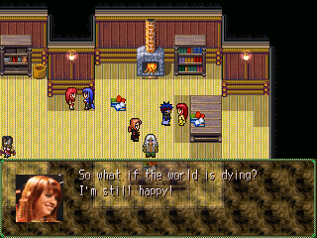

There isn’t anything new to do around the world, but everyone, including your friends, all have something new to say, so if you’re interested, talk to them.

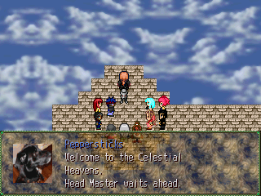

Head to the bottom of the Factory. At your levels now, these weak enemies should be a piece of cake. Avoid them if you want.
Once you’ve reached the warp point, the group engages in another discussion, and you’re taken to the Celestial Heavens.

TOWN: Celestial Heavens
SHOPS: Weapons, Items, Armors
ENEMIES: None

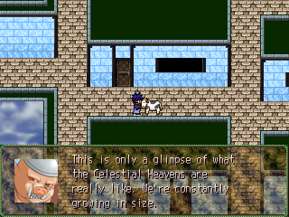

Once Ron becomes controllable, your main objective is to see the Head Master. He’s located in his temple up north. If you want to learn more about Celestia, talk to some of the “people” around town.
New weapons and armors are on sale, so buy them if you can.
The Tower of Destiny, to the east, is currently off limits, so skip it.

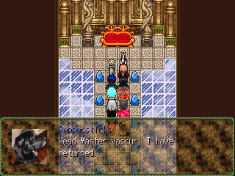

To continue on with the game, enter the large tower to the north. A series of events take place.
For a short time, you’ll have control of Ginger. Have her go to the “Landing Spot”, to the west.
Once you have control over Ron again, return to the Head Master’s tower. A brief event takes place, and you’re taken to the Testing Grounds.

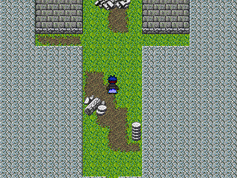
Once you’re in the Testing Grounds, you won’t be able to save, so be extra careful with the moves you make here. Thankfully, this place is short, and there aren’t any random encounters. If you have the “Realm of the Tide” and “Superior Badge” items, equip one of them on Ron immediately.

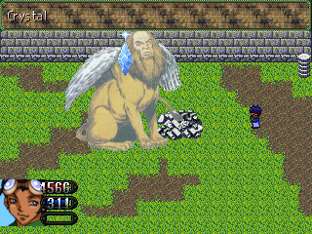
The treasures here are important, but the most important one is the Lionheart, however, you must fight a powered-up version of Gaziro to get it. Gaziro isn’t particularly difficult, and you can easily take him out with Ron’s “Crystal” spell. If Ron is equipped with “Realm of the Tide”, things will be even easier, however, watch out for his “Wing Flap” skill. It takes away about 3700+ to Ron.
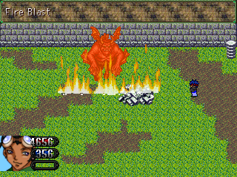

This first (or second) “boss” here is another powered-up Sukoo Kajah enemy. He’s a little stronger than Gaziro, but he still shouldn’t be very threatening. Bash him with your powerful spells and he should die in no time.

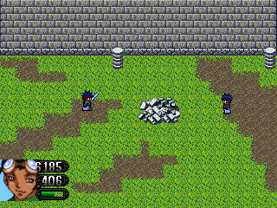

BOSS: Consciousness

The final test is to defeat Ron’s consciousness. He’s pretty much like Sukoo Kajah, and with the “Realm of the Tide” equipped, he won’t be any real threat. Simply hit him and heal when you have to. This battle won’t take very long at all.

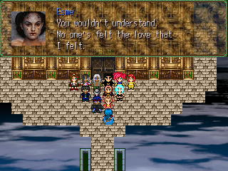
After you defeat Ron, you’re automatically taken back to the Head Master’s chambers. A discussion takes place, and both Ron and Peppersticks will gain new Celestian skills!
Not before long, however, Lady Esme strikes. Ron becomes controllable (briefly), so choose your party from the Auto Cabin. After you’re done, head outside. An event takes place, and Lady Esme attacks the crew.

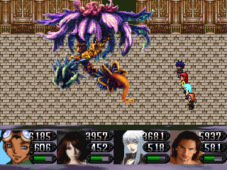

BOSS: Lady Esme

Lady Esme is the queen of magic; her “Serenity” spell will devastate your party. It doesn’t have a specific element, so nothing can block it. A character with low HP will definitely die from it, and, if you don’t heal quickly enough, the rest of your party will join them.
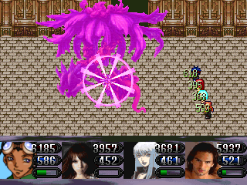
In addition to “Serenity”, another one of Esme’s powerful attacks is her “Magic Strike”. It attacks everyone’s MP, and can even cause “Mind Sickness” on a number of characters, making it a threat. If you have the “Jaeda Ring”, you’ll be fine, though, you can still cure it with “Heal”.
Thankfully, Esme’s other attacks aren’t nearly as dangerous, and she doesn’t have any set strengths or weaknesses. Spend the first few rounds boasting your stats (namely speed), and let her have it. A couple of your characters may get killed here, so just bring them back to life when it happens. A great deal of experience (as well as money!) is rewarded for defeating her, so keep everyone alive.

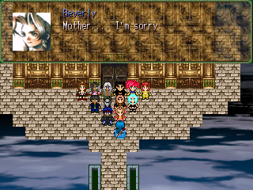

After the battle, Esme’s humanity returns, and her soul moves on. The next morning, the party gathers at the front. Vascur sends your party back to Earth.

FINAL DUNGEON: Utopia
ENEMIES: Guns Maxx, Little O’ Man, Tank, Snow King, Magic Lady, Beauty, Skull Warrior, Lightening Tiger, Cow, Average Joe, Mr. Raw-Raw, Beast Fighter, Saliva
ITEMS: Magic Potion, Celestial Helmet, India’s Cup of Life, Vito Drink, Soul Drink, Lucky Charm, Deer Park Water, Bear Meat, Dream Potion, Life Pill, Elixir Circle

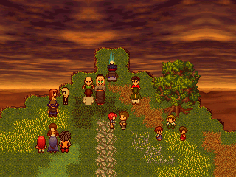
To enter the final dungeon, pass through Tore, and head north. The group will have a discussion with their loved ones, and afterwards, Ron becomes controllable. You can enter Utopia from examining the warp point up north, however, there are several optional events you can access. If you want your characters to gain their ultimate weapons (and ultimate spells for some), it’s recommended that you view these events.

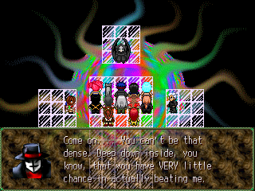
Once you enter Utopia, an event takes place. Afterwards, Ron becomes controllable. The dungeon is split into two parts, the right and the left. Delilah is on the left, and Chris is on the right. You must defeat both of them to get to Zeke. First, let’s tackle Delilah. An important item rests in her section.
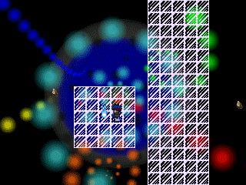

Nearly at the very beginning of the section, you’ll see a warp point. Approach it if you have Beverly in your party. This will take her to the location of the final summon spirit. This is why it was recommended that you’d complete Delilah’s path first.

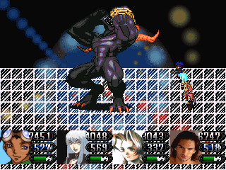

BOSS: The Tyrant

Being the final summon spirit for Beverly, this battle could get difficult. The Tyrant is weak against “Holy” spells, to bash her Holy-themed attacks repeatedly.
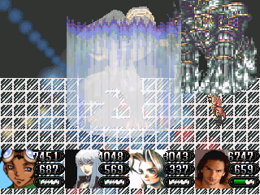
The Tyrant’s most frequent attack is “Antenna”. It’s common amongst enemies, so normally it wouldn’t be much of an issue, except Tyrant’s “Antenna” is nearly ten times stronger than usual. “Meteor” is The Tyrant’s most powerful skill. It’s an automatic-kill attack, and unfortunately, nothing can protect against this.
If you do not have any holy or ultimate spells, this battle could potentially take a long time. Expect to use a lot of your items to bring back fallen characters, especially if you’re using mages.
After the battle, Beverly earns the ability to summon “The Tyrant”, and you get two very rare and very useful items, the “Magic-Proof Vest” and the “Elixir Circle”.

Cow – None (Fire = DANGER)
Mr. Raw-Raw – Physical
Little O’ Man – Magical
Average Joe – None
Lightening Tiger - Thunder
Saliva – Water
Magic Lady - Magical
Beauty – None (Strong against everything)

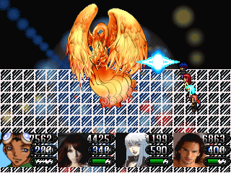
These enemies can become difficult if you give them the chance. Your ultimate weapons will be useful, but take advantage of your skills. It will be VERY difficult to survive this round by physical attacks alone. If you’re low on items, buy some. You want to be prepared for every battle here. Also, saving often is a must.

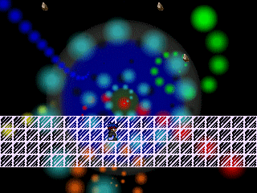

While the dungeon’s main path is short, it’s filled with crossroads, treasures, and dead-ends. Be careful. It won’t be hard to get lost here.

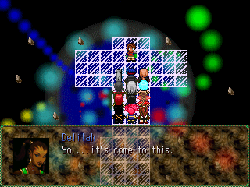

At the end of the section, you’ll confront Delilah. The battle begins.

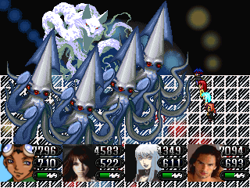

BOSS: Delilah Fields

The second (and final) battle against Delilah has arrived. Like the first time, the Power Squids will act as her companions. Get rid of these things as soon as possible. They can heal and revive each other, making them a threat. Use high-powered skills that target all of them to defeat them. Defeating them one-by-one could potentially be an impossible task.
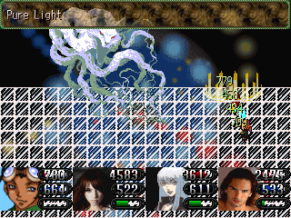
When they’re gone, handle Delilah. Delilah’s speed still remains her strongest attribute, so use items/equipments/skills that boasts speed, especially for your healers.
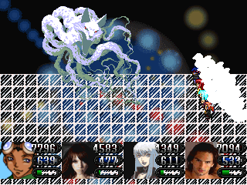
Delilah has several dangerous moves you should watch out for. Her “Cat Marathon” could definitely be hazardous to your party. For starters, it’s a physical skill, which puts your mages at risk. Secondly, some characters may fall victim to the “sleep” status. If your characters are sleep for too long, they could miss out on opportunities to heal, giving Delilah the advantage. Another one of Delilah’s powerful moves is called “Criss Cross”. It’s a non-elemental one-hit-kill spell. She uses this often, so be prepared.
Fortunately, Delilah doesn’t have any set element, allowing you to use whatever you want on her. To defeat her, have one character (either Ron or Beverly) constantly healing the party, and have the others unleash their ultimate powers on Delilah. Take every opportunity you have to beat her. If your “heal-attack” cycle continues unbrokenly, this battle won’t be long.

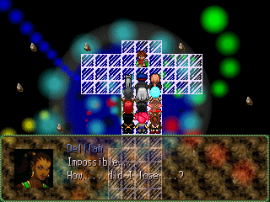

After the battle, a scene takes place. Afterwards, a warp point appears. Examine it to warp back to the start of the dungeon. Next, take down Chris. His domain is located on the right side of Utopia.

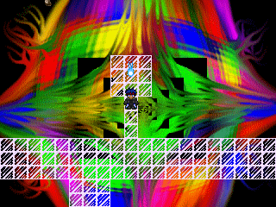
The first section of Chris’s domain could lead to some difficulty and frustration. It loops, meaning that it never ends. To reach the exit, MAKE SURE THAT YOU KNOW WHERE YOU ARE GOING! It is VERY easy to lose your way here.

Guns Maxx – Thunder & Throw
Skull Warrior – Bladed
Tank – Thunder & Throw
Beast Fighter – Darkness & Bladed
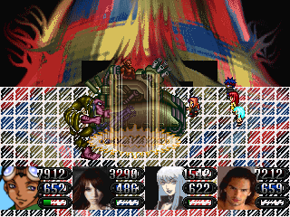
Snow King – Ice

The enemies here are a little more difficult than the enemies on Delilah’s side, especially Guns Maxx, who can easily wipe out a mage. Mina’s water-themed spells will work amazingly well here, since most of the enemies are weak against them.

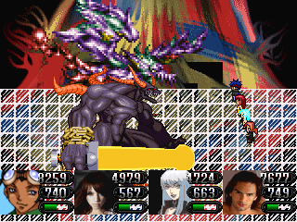

BOSS: Christopher Vaughn

Chris waits at the end of his path. Like last time, he also has a companion. Your first goal should be to take out Satan’s Bodyguard, the huge demon in front. Physical attacks will do squat on him, so only use magic to defeat him. Having attack-all spells would be ideal, but not a must.
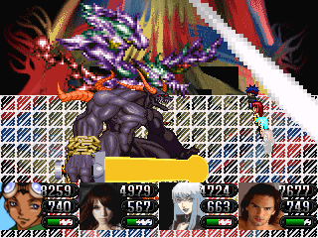
Satan’s Bodyguard’s looks do not deceive, he looks like a brute, and he is. ALL of his physical moves can take out a mage with no trouble at all. His most dominate skill is “Heavy Sword Slash”, another one-hit-kill attack which have become widely popular as of the last few battles. Thankfully, he’s not very fast, so you can quickly revive a character before he strikes again. Bash the brute with everything you have, and he will fall in little time. Now, on to Chris.
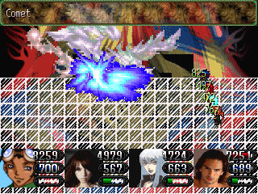
Christopher has very few attacks, but each of them is brutal, with “Celestia”, a powerful skill on its own, being the weakest. “Spray” temporarily confuses all of your party members. It isn’t life threatening, but it has potential to be a major annoyance. Watch out for “Starlit Shower”, it’s a brutal hit-all spell which also silences. Pummel Chris with your strongest moves and he will in little time.

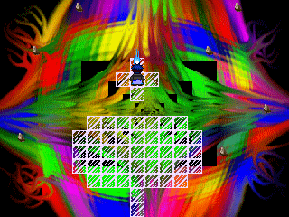

After the battle, Chris will have one last encounter with the crew. The scene ends. Examine the warp spot to take you back to the start of the dungeon. The warp point leading to Zeke becomes available. Examine it, and prepare for the final battle…

T H E ~ F I N A L ~ B A T T L E

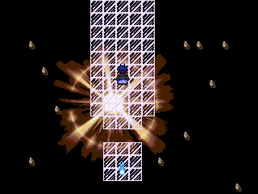

Zeke lies at the top of Utopia. Before going in, make sure that:

- You have your party’s ultimate weapons.
- You have completed the “Tower of Destiny”
- You have learned your character’s best skills.
- You have A LOT of healing items, specifically, MP restoring and resurrecting.

Beating Zeke’s first form won’t be hard, but when he transforms, be careful. Form your own strategy, and win! You know the deal. Good luck, and enjoy the ending! ;)

~:EXTRAS!:~

Aside from finding Beverly’s summon spirits, there are still many things to do in the game, especially towards the end. The first task is in the town of Tore, right before the trip to Atla. The door locks right after you find the first Chaos Stone, so it’s best to complete this as soon as possible.

DUNGEON: Old House
ENEMIES: Dead, Moo, Breader
ITEMS: Lunch Box, Hand Sandwich, Green Glow, Healing Herb, Life Pill

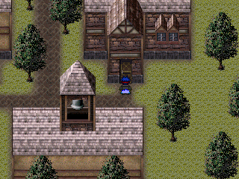
Before going to Atla, head to Tore. Enter the northeastern house. The dungeon is fairly short, however, some of the enemies can be tough. Collect all the treasures, and follow the basic path up north. Talk to the man, who identifies himself as Charles Link. He gives you a locket to place on his dad wife’s grave. You can keep the locket if you want, but it’s not recommended.

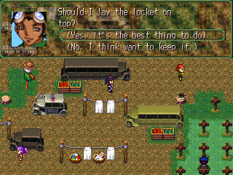
After meeting Charles, go to the Trailer Park, which is located southwestern of Montane City. Go to the second grave to the right on the third row. Choose to place the locket down, and head back to see Charles. His soul will move on, and he will leave behind an item, the “Purple Apple”. This item is important for mages. It adds an additional 25 points to your Magic Points and to your Mystic. It can be used five times, giving you a bonus of 125+ extra points!

DUNGEON: Hiding Place
ENEMIES: Da, Red Tail
ITEMS: Guard Potion, Polar Bear Jumper, Soul Drink, Life Pill,

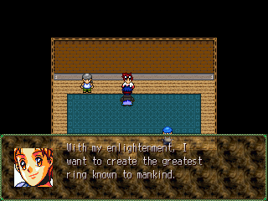
Next on the list is the “Exploding Ring”, which is the most powerful magic-accessory in the game, and it comes with the “Night Ring UPGRADE”. To get them, visit Billy-Bob in Velva after you return from the Atlar, and it’s only available until you complete Act III. So, yeah, basically, you have only one shot to get it.
First, agree to help Billy-Bob, and then leave the shop to find his dragon.

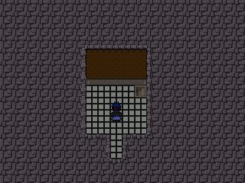
Next, place Peppersticks into your party. Have him sniff around town until you arrive at the hideout. Hint, hint, it’s VERY close to the weapon shop…. VERY CLOSE.
Once you find it, go inside. You can take Peppersticks out of your party if he’s not one of your main users. You won’t need him anymore, though; you’ll find a great Jumper for him inside.
Anyway, this dungeon is really short, and the enemies aren’t hard, so just work your way to the bottom.

Da – Holy, Water
Red Tail - Holy
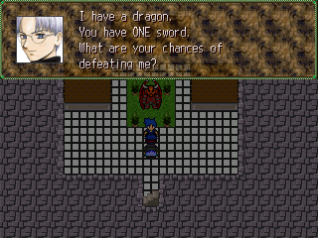

Timmy, along with Billy-Bob’s stolen dragon, waits at the bottom. He and Ron get into a brief argument, and a boss battle begins.

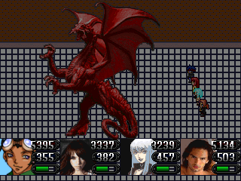

BOSS: Dragon

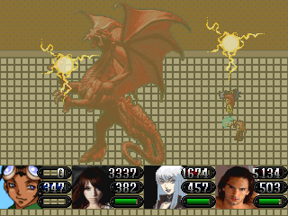
This is the first, and, well, probably only dragon you’ll ever face in the game. With that said, expect a challenge. In addition to Ron, you might want to bring in another party member for backup healing, because without one, surviving this battle will be rather difficult. Peppersticks and Beverly are ideal choices, but Al isn’t bad, either. Dragon only has a few attacks; however, most of them are deadly, especially his “Dance of Thunder” spell, which is devastating to Fighters. On the plus side, Dragon doesn’t have a “set” element, so you can bash him with your strongest moves to take him down. Though it is rare he will use this, Dragon also has the spell “Regeneration”. Since he has a lot of HP, regenerating 10% of that is a lot. If that happens, speed will be a prime factor here.

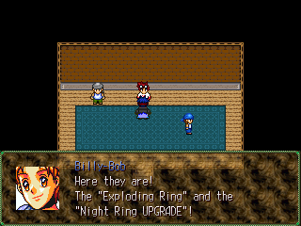
After you beat the Dragon, leave the dungeon, and speak with Billy-Bob. Agree to hand over the rings, and by the next morning, you’ll give you better ones.
When equipped, the rings aren’t much, but the “UPGRADE” blinds and silences enemies while the “Exploding Ring” deals about 2000+ damage to all enemies. You can use these rings whenever you like without consuming MP. Great deal, huh?

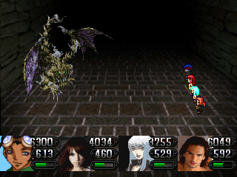

BOSS: Yak the Well Dweller

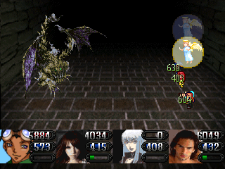
There’s a monster in the well in Zagi. You can fight it anytime after the Underground Temple, though you probably won’t be able to beat him until late in the game. Speed is the most important thing here, so definitely have someone equipped with Auto-Haste and buff up as many characters as you can.

Definitely bring along a diverse party here, preferably all Neutral characters, because a party full of mages or a party full of fighters will not work. Yak’s attacks are fierce, and most of them attack the entire party. His single attacks are rare, but when used, they will most likely knock a party member out, especially a mage. Lucky Charms and Revives are a must-have here, especially if you’re at a lower level.

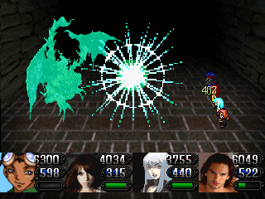
Though he may look fierce, there isn’t necessarily a “trick” to beating him (other than staying alive). Pummel him with your most powerful skills and make sure to always have a party member ready to heal when needed, though, at this point, that should come across as common sense. This battle could take some time, so don’t be hasty. If you win, you’ll gain 20 “Yak Guts”, which gives you an additional 1000 HP!

DUNGEON: Tower of Destiny
ENEMIES: Siren, Zymara, Glue, Tek, Fugly, Mystic Arachnid, Crusher, Reptile
ITEMS: Green Glow, Lucky Charm

Siren – None
Zymara – Flare
Glue – None (Strong against everything)
Tek – None
Fugly – Physical
Mystic Arachnid – Earth
Crusher – Water
Reptile - None

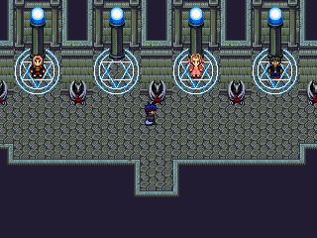

The Tower of Destiny was previously blocked off before, but it becomes accessible after you view the event before Utopia. Inside are Ron’s, Jose’s, Beverly’s and Al’s ultimate weapons and spells. However, they must complete their tasks alone, and you cannot save. So, this place can be quite difficult if your characters are under leveled.

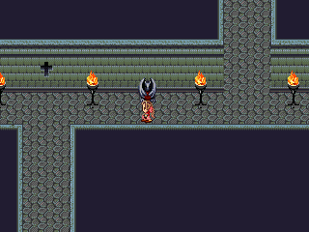
If you choose to complete the Tower of Destiny, it’s recommended that you complete Beverly’s task first. Being that she’s a physically weak character, her task may be the most difficult. Unless you’ve leveled her up enough (at least to 65) then don’t bother completing her task.

In the final room, Beverly will confront her boss.

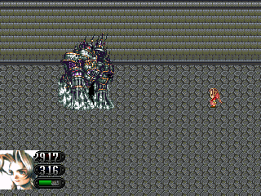

BOSS: Saint

Saint’s Holy attacks are devastating, some too great for even mages. However, if Beverly is equipped with “Realm of the Tide” or “Superior Badge”, she will receive no damage from Saint’s (magical) attacks, giving her an easy victory.

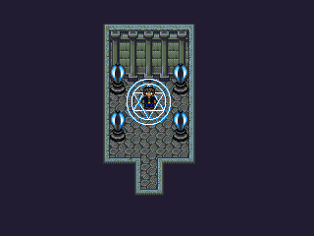

After the battle, Beverly will gain her ultimate weapon and a new summon spirit. When you’re finished with her, Jose should be your next choice. However, like Beverly, if Jose is under level 65, these enemies will crush him. It’ll be difficult to even get to Vayne, let alone beat him. The enemies here will eat you alive if you’re not careful.

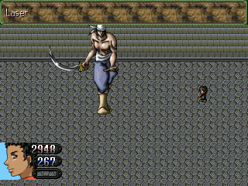

BOSS: Vayne Cortez

Defeating Vayne will surely be tough if Jose is at a weak level, so you might want to make best friends with the Gameover screen. You’ll be seeing it often. First off, increase Jose’s speed. Use “Speed” until it says “Miss”. Then, strike Vayne with your most powerful skills (though, Celestian spells won’t work on him). This battle could take some time, especially if you factor in the healing, but it’s beatable. Just make sure that Jose’s equipped with “Realm of the Tide”, otherwise, he won’t stand a chance here.

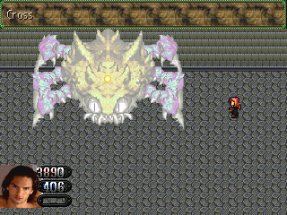
After you’re finished with Jose, go to Al. Though he is slow, the enemies here are much slower (if Al is at his recommended level). So, keep him equipped with the “Superior Badge” and work your way through the short dungeon.
Though, be wary of the Mystic Arachnids. They love to stun Al. Though it isn’t life threatening (once again, if you’re at the right level), it can become a nuisance.

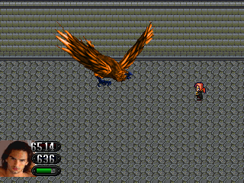

BOSS: Head Master Hart

Before entering, equip Al with the “Auto-Haste”. When it’s his turn, first cast “Regeneration”, and then pummel Hart with constant casts of “Cross”. Heal when you need to, and keep casting “Cross”. Hart will die before you know it.

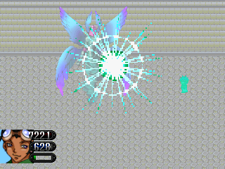

BOSS: Mysterious Being

This creature uses many Celestian skills, so be careful. Equipping Ron with “Auto-Haste” will make things go much faster (and easier). Watch out for his “Comet” spell. It takes away 6000+ HP. Heal immediately. Use “Knight Slash” repeatedly, and this creature will fall (eventually).

After that, Ron will gain his Ultimate spell and weapon, thus completing the Tower of Destiny!

~:ULTIMATE WEAPONS!:~

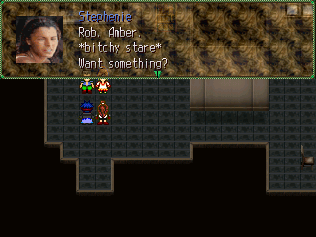

You can obtain everyone’s ultimate weapon after you view the event before entering Utopia.

To get Stephenie’s, place her in your party, and head to the bakery. She and another pair of reality stars will go at it, and a battle will begin.

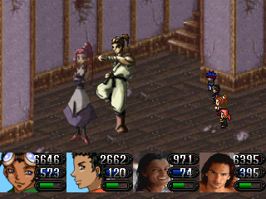

BOSS: Rob, Amber

Amber will do absolutely nothing here, so don’t bother attacking her yet. Focus all of your energy on beating Rob. He uses a variety of physical moves, so mages may be in danger. Use your strongest moves to beat him. When he’s down, attack Amber, and you win.

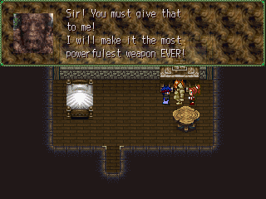

After the battle, you’ll earn the Pearl. Take the Pearl to the Golem in the Celestial Heavens. He’ll take it and use it to create Stephenie’s ultimate weapon.

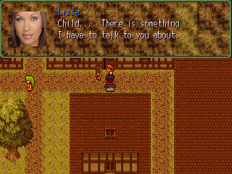
To get Mina’s ultimate weapon, place her in your party. Head to Velva, and approach Lissa from the left or the right. An event will take place, requiring Slay’s position in the party. So, go to the Hubby, talk to him, and place him in your party. If he’s already in your party, speak with him anyway.
Then, head back to Mina’s Mansion. Events will take place, and the first boss battle begins.

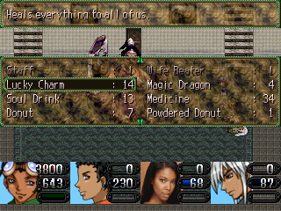

BOSS: Brittany

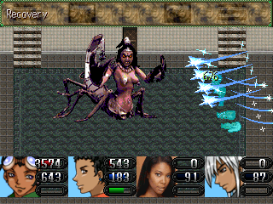
Brittany is a mage. Magic won’t hurt her as much as physical moves would. So Slay’s skills, if you’ve leveled him up enough, will definitely be useful here. If your Mina and Slay are at weak levels, don’t worry. Ron’s “Knight Slash” is good enough. Actually, you can beat Brittany using just Ron alone. So if Mina and Slay die, don’t worry about reviving them. They’ll only die again.

Brittany’s main attack to look out for is her “Sanctuary” spell. It deals large damage to the whole party, plus silence, which can become trouble when you need to heal. She also uses a couple of Whip attacks, though, they’re not deadly. Other than that, Brittany uses upgraded versions of run-of-the-mill Water spells.

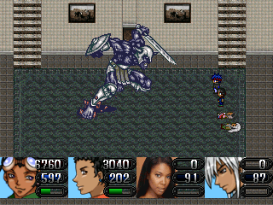

BOSS: Fredrick

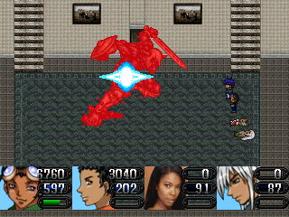
After Brittany falls, Fredrick takes the stand. He is essentially the opposite of his daughter. He’s strong against Physical, but Magical works just fine on him. While his Physical and Defense power are higher, his Agility is a bit lower than Brittany’s, allowing this battle to go a bit faster.

As a whole, this battle may actually be easier than Brittany’s battle. Most of Fredrick’s attacks hit only one person, giving some of your weaker characters (if you have any) a fighting chance here. If you want to leave them dead, that’s fine (they’ll hardly ever go, anyway) but if you choose to keep them around as fodder (or to gain experience), that’s also fine. There isn’t a “strategy” to defeating Fredrick. Just beat him ‘til he’s dead.

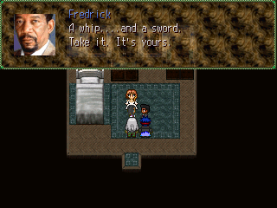

After the battle, the scene switches to upstairs. Fredrick hands over a whip and a sword, or, in other words, Mina’s and Slay’s ultimate weapons.

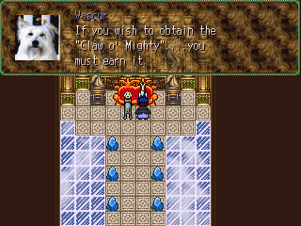

To get Pepperstick’s ultimate weapon, place him in your party, and head to the Celestial Heavens. A short event will take place, and battle will begin.

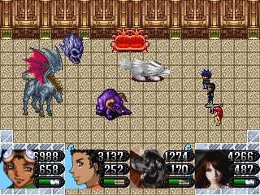

BOSS: Vascur, Edema, Fighter, Mage

Vascur is a fighter, Edema’s a mage, and they’ve brought two other mages and fighters. That said, this battle could take some time. It’s best to get rid of Edema first, and then Vascur. She’s the most dangerous, because all of her attacks strike the whole party for large amounts of damage. The other two enemies aren’t very threatening, so worry about them last.
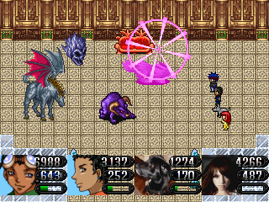
First, hammer Edema with physical moves. However, if you’re lacking in physical attacks, then focus on Vascur instead. Just make sure that one of them is dead. Secondly, speed will be very beneficial here, so Haste or Auto-Haste is ideal. Keeping everyone alive here is nearly a must (if is possible), because the experience earned is definitely one of the largest experience points you’ll ever get (all at once). After the battle, Peppersticks will get his ultimate weapon.

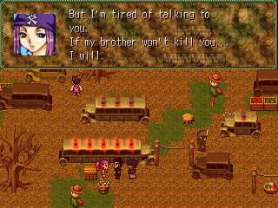

To get Quentin’s ultimate weapon, place him in your party, and head to the Trailer Park. A short event will take place, and a boss battle begins.

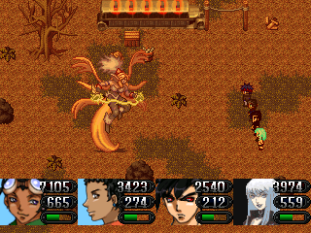

BOSS: Mellie

Mellie isn’t anywhere close to being as difficult as some of the other optional bosses. In fact, none of your characters should ever die here. Mellie uses an annoying attack called “Pork” which confuses your party members temporarily, but other than that, she’s a piece of cake. Pummel her until she falls, which won’t take long at all. However, if you have “Watch”, equip it on Ron. Mellie does tend to use “Nuclear Spill” a lot.

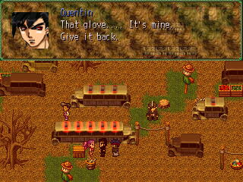

After the battle, Quentin and Melody get into another disagreement. They don’t reconcile, but at least Quentin gets his ultimate weapon, thus completing his quest.

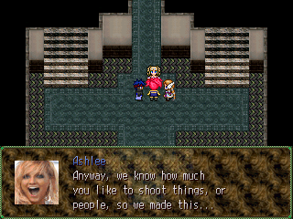

To get Lindsay’s Ultimate Weapon, place her in your party, and head to the Television Studio (if you don’t remember, it’s nearly right behind Ron’s house). The girls haven’t changed, but Lindsay manages to talk them into giving her the “Doomerang” anyway.

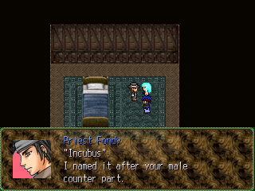

To get Ginger’s Ultimate Weapon, put her in your party, and head to Koudo. Go to the church, and you’ll notice that the Priest isn’t there. Head to the back room. An event will take place, and Ginger will receive the “Incubus”, her ultimate weapon.

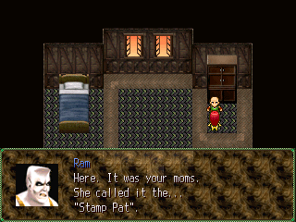

Lastly, to get Jerri’s Ultimate Weapon, place her in your party. If you’re not there already, head to Tore’s cliff (entrance to Utopia). Approach Ram, and he and his daughter will share a private scene together. Jerri will then get her Ultimate whip, “Stamp Pat”.

AUTHOR’S NOTES:

~TOTAL CHAOS was completed on Sunday, March 11, 2007 at 8:46 P.M., while trying to watch “The Amazing Race: ALL-STARS” at the same time. Oh, and Rob and Amber were robbed. Mirna can BURN!

~Test playing began March 14th 2007 and lasted for only six days. Test playing ONYX took three weeks.

~The “idea” behind TOTAL CHAOS was totally and completely spur-of-the-moment and I am absolutely shocked that I not only finished it, but that it makes (a little) sense.

~The relationship between Jose and Ron resembles the relationship I have with my cousin. We’re close, but he’s louder and more vocal than I am.

~TOTAL CHAOS began February 20th, 2006. And while TC started months after ONYX 2, it was finished months earlier, making it my second completed game of the computer RPG Maker series and my first completed game using RPG Maker 2003.

~Originally, TOTAL CHAOS had a cast of only nine playable characters. Jose, Ginger and Al are add-ons.

~Initially, Jerri wasn’t apart of the game at all. Before, she was named “Olga”, and she was a much older woman. Her face set was Jerri Manthey, and while Olga doesn’t appear in the game, Jerri Manthey does make a brief cameo. Olga and Jerri (Spencer) were supposed to be two separate characters, but at the time I thought the cast would’ve been too big, so I decided to just scrap Olga’s character entirely.

~“Slay’s” original name was “Shay”. His name wasn’t changed until very late in the game, specially, at Zepa Matili’s headquarters. I decided to change it to “Slay” simply because it made more sense.

~Tammy’s last name, “Vetrini” was taken from “Erika Vetrini” from the Apprentice’s first season. And at one point, Tammy Vetrini was even considered to be a possible secret playable character.

~If you were to ask me “why” I decided to put Lindsay Lohan in my game as a playable character, I really couldn’t give you an answer. And no, I am not a fan. However, I am a fan of Alexz Johnson and Gabrielle Union. And as far as Stephenie LaGrossa is concerned, I just think she’s really hot.

~My favorite characters were: Jerri, Ginger, Mina, Slay, Stephenie and Ron.

~So…that’s it! Thanks a TRILION for downloading and my playing my game to its ENTIRETY. I know, it’s long, but I can’t help it… My mind travels.

~So, if you have any comments, questions, complaints, rants, or insults, please email me on:

Eikichi@juno.com

Or, you could IM me on my AIM address.

Eikichi Clone

And lastly, you could contact via myspace.

~Thank you for playing, and God bless~

~Sincerely~

Gary “Yeaster” Holt Jr.

