Molly’s Personal Comics Alliance Archives, Part 1
(because who knows how long it’ll stay up)

From Ask Chris, #40

Ask Chris #40: Batman vs. Bruce Wayne
Here at ComicsAlliance, we value our readership and are always open to what the masses of Internet readers have to say. That's why we've given Senior Writer Chris Sims the punishment pleasure of stepping into the grand tradition of the Answer Man as he responds to your reader questions.

Q: As America's most eminent Batmanologist, what do you think of all the hullabaloo over whether Bruce Wayne or Batman is the mask? -- Molly, via email
A: Honestly? I think it's probably the most overrated truism in comics.
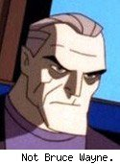I was around 13 when I first heard the idea behind it, that Bruce Wayne was just the "mask" Batman wore rather than the other way around, and my mind was totally blown by this sudden new insight into how my favorite character works. It's a very, very useful bit of shorthand that gets across the idea of how dedicated Batman is to fighting crime, and how much his life changed when he decided to devote himself to eradicating evil.
It's even been adopted by a lot of creators as a core tenet of the character, and gained a lot of traction on fans in the Batman Beyond episode where Old Man Bruce talked about how he even thinks of himself as "Batman" rather than "Bruce Wayne."
It makes a great sound bite, but it's a very simplistic view of things, when the reality -- or at least, as close to "reality" as you get with fictional characters -- is far more complex.
The idea of the secret identity and the alter-ego is one of the most appealing things about super-hero stories. The fact that Superman takes off his cape, puts on a pair of glasses, and goes to his day job isn't just a great plot device that allows for a supporting cast of nosy reporters that are constantly falling out of helicopters, it's also an aspect of his character that makes him far more relatable than any walk across the country. For all his power, he still has deadlines to make and a crush on the girl at the next desk.
Incidentally, I've often heard the "Bruce Wayne is the disguise" argument delivered as a direct contrast to Superman, whose farmboy values are usually cited as a reason why the "real" half of that relationship is Clark Kent. This is equally flawed logic, but I'll get to that in a minute.
With Batman, the idea of relating to the secret identity is blown out of the water the minute words like "billionaire playboy" and "stately Wayne Manor" hit the page, and as a result, it's easy to see the "Bruce Wayne" identity as being nothing more than a storytelling tool. Batman has no super-powers, so he has to have metal boomerangs, bulletproof Dracula costumes and a sweet muscle car to compensate, which in turn means that he needs a logical way to pay for all this stuff. Thus, he's not just a billionaire, but a billionaire who owns a company specializing in high-tech non-lethal technology that just happens to be exactly what the well-dressed vigilante is wearing this season.
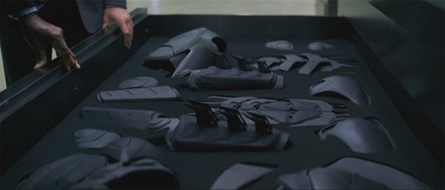
If Batman is truly the "real" version of the character, then his need to be "Bruce Wayne" starts and ends with how he can put the Wayne fortune and resources to good use fighting crime. And while there are plenty of stories where that's exactly how it works, and while that's a perfectly fine use of those plot threads, it's a very shallow characterization.

Nobody only thinks about one thing all the time -- not even when the person is me and the thing in question is Batman -- and a well-developed character isn't devoted entirely to going about their goals in exactly one way, even if it dominates his life.
Now, it's certainly true that while "Bruce Wayne" is out and about on the Gotham City Social Scene, drinking ginger ale instead of champagne and romancing supermodels, he's definitely playing the role of a wealthy dilettante, which is not what he is. But it's also true that when he drags a crook up to the top of a building and threatens to drop him fifty stories unless he coughs up the whereabouts of the Riddler's hideout, he's playing the role of a murderous psychopath, which is also not what he is. Batman would no more drop that guy to his death than he'd spend the rest of his life having cocktails with the rest of the Drones Club.
They're both acts to a point; neither one is the truth about Batman/Bruce Wayne, but neither one is entirely a lie, no more than you're lying by acting differently at Thanskgiving dinner at grandma's house than you do when you're out at a bar with your friends. We all act differently depending on the context of our situations, and Batman's no different. Admittedly, he hides a larger portion of his life than most people and his extremes are a little more, well, extreme, but he's a super-hero. They don't do things by halves.
I think that the idea that there has to be a division in Batman is a false notion that was fueled by Rorschach from Watchmen:
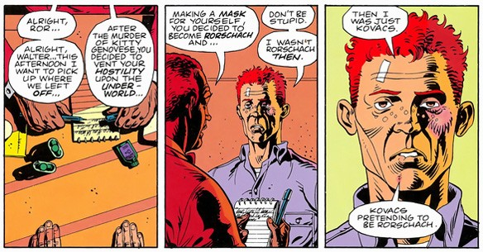
With Rorschach, there is a clear division between the two identities, specifically of one ceasing to exist when the other comes around. With Watchmen being as great and influential as it is, a lot of people latched onto this as being the definitive portrayal of the kind of masked vigilante character that Batman embodies, but there's a world of difference between the two characters. In this regard, Rorschach -- the uncompromising vigilante who came up surrounded by violence and was motivated by a tragedy to destroy what he saw as "evil" -- has a lot more to do with the Punisher.
In other words, it's Batman who punches out the abusive pimp...
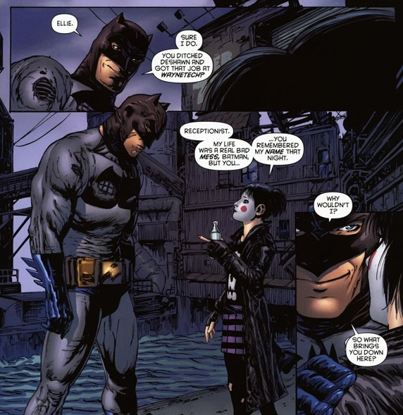
...but it's Bruce Wayne who gives the girl a way to find a better life.
Incidentally, the other major incarnation of Batman that gets this exact aspect of the character right, showing Bruce Wayne to be just as invovled in the social aspects of crime prevention as Batman is in bringing down crooks? The 1966 Batman TV show.
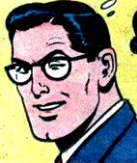"Bruce Wayne" and "Batman" are just two names for the same person, and, as I said before, the same applies to Clark Kent and Superman. Superman doesn't really need a job -- it's not like he's got rent to pay on the Fortress of Solitude -- but assuming that he wants to have a secret identity and not be Superman all the time, Clark Kent could do quite literally anything for a living. He could even stay in Smallville and work on the farm between Justice League meetings.
But instead, Clark Kent becomes a reporter for a major metropolitan newspaper, meaning that his actual day job is to seek out truth and expose the guilty to justice, in a way so American that they put it in the First Amendment. In essence, Clark Kent and Superman both stand for the same things, just like Batman and Bruce Wayne both battle against crime in specific ways. Same person, same goals, but a wide range of methods.
The end result -- and the end result of every character who has this kind of thought and development put into them over the years -- is a character that's far more well-rounded than he would be otherwise. They might act differently in different situations, but at heart, Batman and Bruce Wayne are the same person. After all, it wasn't Thomas and Martha Man who got shot in front of their young son Bat.

From Ask Chris #50

Ask Chris #50: The Next Best Batman Stories

Here at ComicsAlliance, we value our readership and are always open to what the masses of Internet readers have to say. That's every week, Senior Writer Chris Sims puts his comics culture knowledge to the test as he responds to your reader questions!
Q: I'm itching for some good, new-to-me Batman reading. Asking for the top ten greatest Batman stories, I think will give us the famous greats that most of us have probably read by now. So I want to ask about the next ten. What are the greatest Batman stories ranked eleven through twenty? -- Paul, via email
A: I've actually gotten a lot of requests for a list of good "deep cuts" for Batman lately, and while it's a tricky proposition to figure out which great stories are the ones that don't get talked about as often as the ol' standards, it's not like Batman suddenly stops being good after you read your Year Ones and Mad Loves and R.I.P.s and Killing Jokes and all manner of various Nights of the Beast. There are literally thousands of Batman stories out there, and even more if you're not limited to just the comics, and as you might expect, I think an awful lot of 'em are worth checking out.
And considering it's my 50th installment of "Ask Chris," I'm just glad you didn't ask for eleven through fifty. After all, I have to sleep some time.
So with that said -- and with a little brainstorming help from ComicsAlliance's own David Uzumeri, a pretty solid Batmanologist in his own right, to help narrow down the list, here are my picks for that rarely-seen second half of the countdown!
20: Batman: Son of the Demon (1987)
Mike W. Barr and Jerry Bingham's Son of the Demon isn't exactly an obscure title -- especially in the years since Grant Morrison used it as the extremely loose basis for "Batman & Son" -- but it rarely gets mentioned at the top of anyone's list, and usually gets overshadowed by some of Barr's other work on Batman. Don't get me wrong, there's no shame in being outranked by "Fear For Sale," but Son of the Demon is a darn good read.
In a lot of ways, it's like the '80s Action Movie version of Batman -- and I mean that in a good way. There's world travel, big fights in exotic locations with an army of gun-toting mercenaries, and of course, the alluring daughter of an enemy that Batman has to team up with because this time, he's out for revenge!

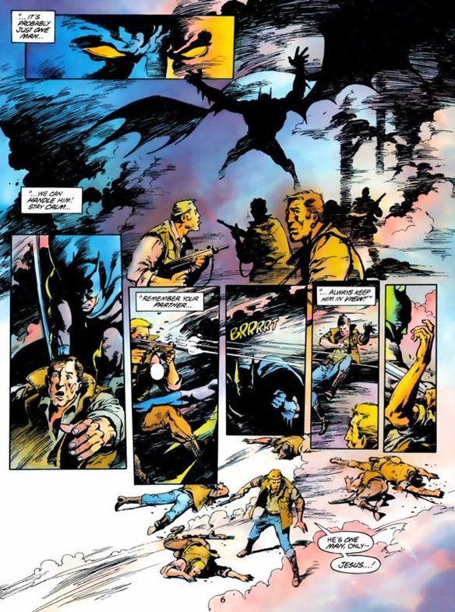
I'm pretty sure Batman even employs the skill of gymnastics and the kill of karate at some point.
19: "Blood Secrets" - Detective Comics Annual #2 (1989)
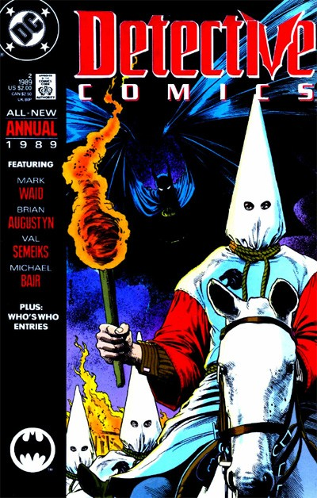
I'm not gonna lie, folks: I bought this one a few years back because a) I really like Mark Waid's work as a writer, particularly the run on Flash that saw him frequently co-writing with Brian Augustyn, and b) I really, really wanted to see Batman just straight up wreck a bunch of racists. Oddly enough, despite the promise of the cover, that's actually not what this one's about. Not exactly, anyway.
That's certainly an element to it; the story is related by Batman to an unknown listener who isn't revealed until the final page, detailing an adventure he had during the years he traveled around the world training to become Batman. In this case, his travels bring him to Huntsville, Alabama to learn the art of detection from Harvey Harris. This in turn finds him investigating a series of murders linked to a hate crime that took place 40 years earlier, as the men involved are turning up as the victims of an unknown killer.
It's a compelling mystery story with a twist ending, but the real story lies in Waid and Augustyn's examination of the Batman's morality.
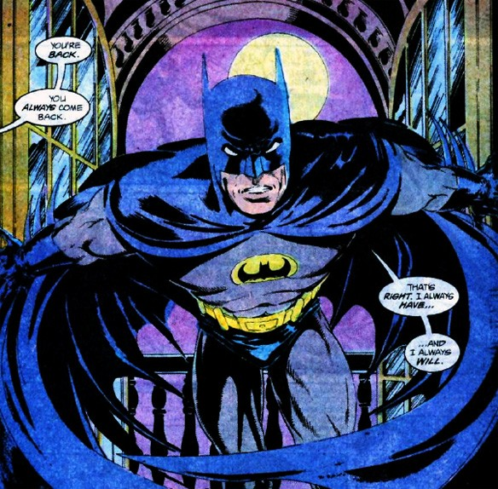
It's not just about solving a crime, but rather the precision with which he has to act, the level of detachment that he has to achieve, and how much of his motivation comes from vengeance and just how dedicated he is to punishing those he deems guilty. And as you might expect, those are things I'm pretty interested in.
18: Batman: Ego (2000)
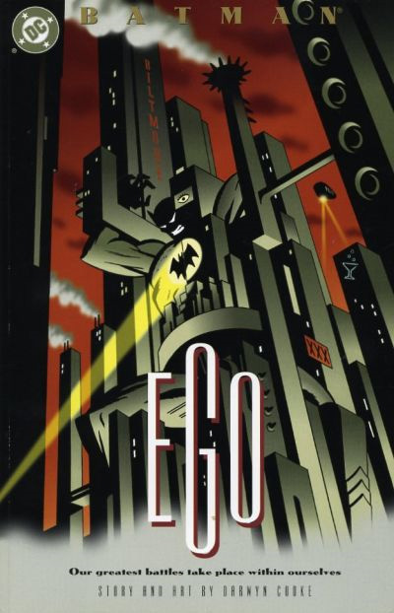
Considering that it was written and drawn by Darwyn Cooke, I'm always surprised that this one doesn't get talked about more. I remember it being something of a sleeper hit back when it came out, as it was one of the first things Cooke had done in comics, well before more high profile work like New Frontier.
Either way, it's awesome. It's set up as a psychological drama that examines the dichotomy between Bruce Wayne and Batman through an extended sequence where they argue with each other about whether or not "they" should do the world a favor and kill the Joker. And as you might expect from the fact that it's by Cooke, it's absolutely beautiful.
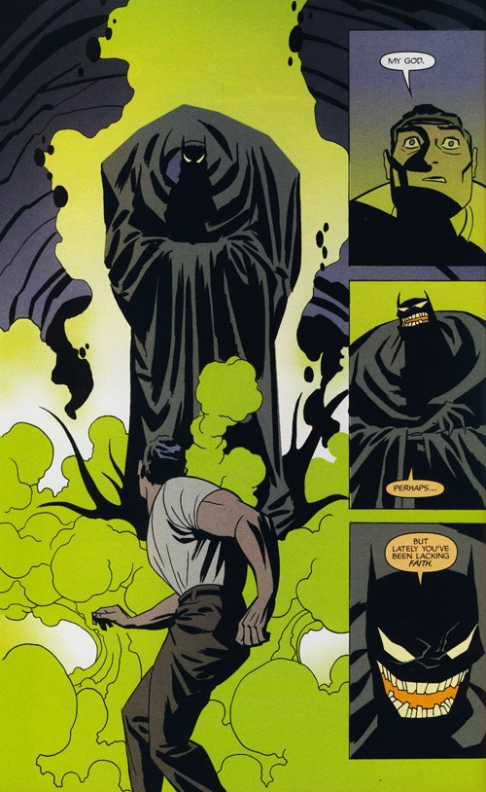
I've talked about the conflict between the different sides of Batman's identity before in this very column[Ed. See above], but Cooke's examination is every bit as smart as it is well-drawn. He spends a lot of time examining the roots of Batman's morality, and delves into just what the idea of Batman means, not only to criminals and super-villains but to the people of Gotham City and even what it means to Bruce Wayne himself. In the end, there's a reconciliation -- as there should be -- and while that's a foregone conclusion that's necessary for the character, the journey to it is one of the best character studies in comics.
Unlike a lot of the stories on this list, Ego actually has been collected in a nice volume that also contains Cooke's fantastic Catwoman story, Selina's Big Score, and a handful of short pieces he did with guys like Paul Grist and Tim Sale. If you don't own it, you should.
17: Batman and the Monster Men/ Batman and the Mad Monk (2006)
Speaking of excellent creators who have done underrated work on Batman, we have these two. Since Frank Miller dropped his definitive origin story for Batman 25 years ago, there have been dozens -- maybe hundreds -- of stories set in the "Year One" era, and very few of them even come close to being as good as Matt Wagner's two miniseries.
Rather than telling a new story of Batman's rookie season (which can certainly be awesome, as Morrison and Janson's Batman: Gothic proves), Wagner instead went back to the actual year one to tell modern versions of two of Batman's earliest adventures, and the results are incredible.
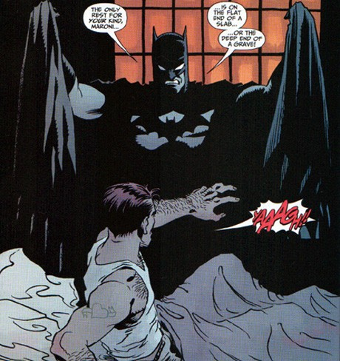
Much like Ed Brubaker and Doug Manhke did when they retold the first Joker story in Batman: The Man Who Laughs (which is also a darn good comci), Wagner manages to update the story while still preserving the elements that define it as a pulp adventure: Mad scientists creating hulking monster men and a vampire with a house laden with deathtraps. Wagner even manages to do a scene of Batman being vexed by a slowly closing set of walls with spikes sticking out of them and still makes it seem fresh and adventurous.

16: Batman: Death and the Maidens (2003)
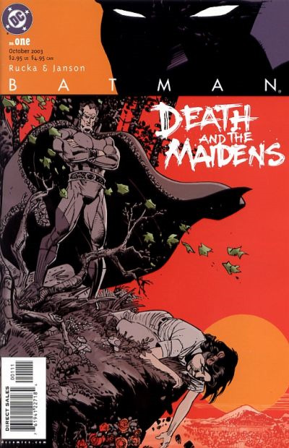
By all rights, Greg Rucka and Klaus Janson's Death and the Maidens should've been the last Ra's al-Ghul story. Unfortunately, as evidenced by the mystifying existence of the pretty terrible Resurrection of Ra's al-Ghul from a couple years ago, that didn't exactly work out.
But that doesn't mean it's not a great comic. It's essentially the capstone of what Rucka did in his tenure as the writer of Detective Comics, delving into a piece of al-Ghul's history while simultaneously setting him up for his demise, which also involves him bribing the location of the last Lazarus Pit out of Batman by giving him an alchemical solution that will allow him to see the spirits of his parents.
It's that last bit that makes the middle section of the story so interetsing, as Batman is put into the unique position of having to justify the choices he's made with his life to the people who may have inspired him, but never really wanted to see their son become a masked vigilante dressed like Dracula. Plus, you get to see Martha Wayne straight up slap her son in the face for being disrespectful.

[ed. Picture of Martha Wayne’s ghost slapping Bruce goes here.]
That's right, y'all. Martha Wayne is hardcore.
The only thing that isn't good about this story is how much it brings to the table that is then completely ignored in what might be the biggest waste of potential in the history of the Batman franchise. In their nine issues, Rucka and Janson introduce Nyssa Raatko, the successor to the title of "Ra's al-Ghul," who could have added an entirely new spin on things, but was instead killed off-panel in an issue of Robin, of all things. Truly ridiculous, but that doesn't make this story any worse.

15: "Dead Reckoning" - Detective Comics #777 - 782 (2003)
Another great artifact from the highly underrated Brubaker/Rucka era on the Batman titles is this one, a grand, sweeping murder mystery involving a conspiracy among all of Batman's major villains that focuses on Two-Face and answers the question of what Hush would be like if it were actually any good. Which, considering that both stories were going on at the same time, is pretty hilarious.
The actual story, however, is dead serious, absolutely brutal and meticulously plotted, to the point where it brings back a character that originally appeared 510 issues before in 1943, but done in such a way that it requires no prior knowledge to enjoy.
For reasons that I can't even begin to understand, this story -- and most of Ed Brubaker's run on the Batman books -- has never been collected in paperback, but it's not hard to track down and definitely worth doing so.
#14. The Batman Adventures v.2 #1 - 17 (2003)
A few years after Batman: The Animated Series finally ended, someone at DC had the brilliant idea to give that version of Batman one final send-off, and the even more brilliant idea of turning to Ty Templeton and Dan Slott to be the guys to do it. The end result was something that was absolutely amazing.
While the comic followed the continuity of the show, the fact that it was no longer on the air (and thus no longer setting the pace for stories) meant that they had the freedom to create something that reads like the unproduced final season, weaving together longer form story arcs in a way that DC's All-Ages line rarely got to do. Things were shifted around. The Penguin successfully ran for mayor of Gotham City. The Joker got conked on the head, lost his homicidal urges and devoted his time to expressing his love for Harley Quinn, which completely turned her off. Batman spent multiple issues undercover as Matches Malone. They even managed to work the redesign for Poison Ivy into the story as a plot point that played out in an extremely unexpected way.
But at its heart, it was still a book about telling solid, accessible stories that cut right to the heart of what the character's all about, like the one where Bruce Wayne goes to a therapist and has to bluff his way through a word association exercise, by Vito Delsante and Dean Haspiel:
[ed. A picture seems to be missing here]
Batman's definition of "play" alone is worth the price of admission.

13. "The Doomsday Book" - Detective Comics #572 (1987)
It occurs to me that Mike W. Barr is the only writer to make it onto this list twice, and with good reason: His run might've had a few missteps, but when he hit, he knocked it out of the park as one of the best Batman writers of all time.
This one's a great example of that. Released to celebrate the 50th anniversary of Detective Comics, this is an adventure where Batman, the Elongated Man and Slam Bradley team up with Sherlock Holmes to stop Moriarty's great-grandnephew from blowing up the Queen of England.

One more time: Batman teams up with Sherlock Holmes. Further discussion should not be necessary.

12. The Untold Legend of the Batman #1 - 3 (1980)
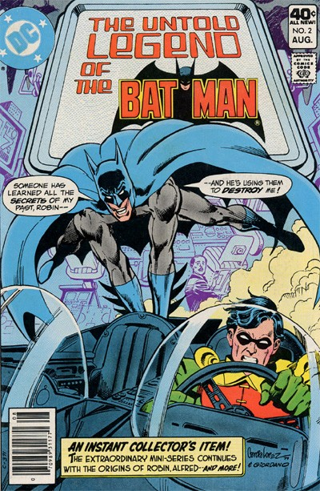
At this point in the article, it's probably pretty clear that I'm something of a Batman fan, and a lot of that has to do with the fact that I had a copy of Untold Legend when I was a kid. It's essentially a three-issue crash course in Batman history disguised as a story, and I absolutely loved it. Admittedly, my love for it also springs from the fact that my copy with an audiobook adaptation on cassette tape, but the point stands.
In order to provide Batman with a reason for him to talk about his past -- which, this being the Silver Age version, included Bruce Wayne being the original Robin and a recap of the story where he tracked down the man who killed his parents, revealed his identity, and sent him running into traffic -- writer Len Wein came up with a compelling story that reads like the Cliffs Notes version of Batman R.I.P.: Someone who knows everything about Batman is trying to destroy him piece by piece, starting by burning the "original Batman costume" worn to a Halloween party by Thomas Wayne.
This upsets Batman, and he starts straight up slapping men in the face.
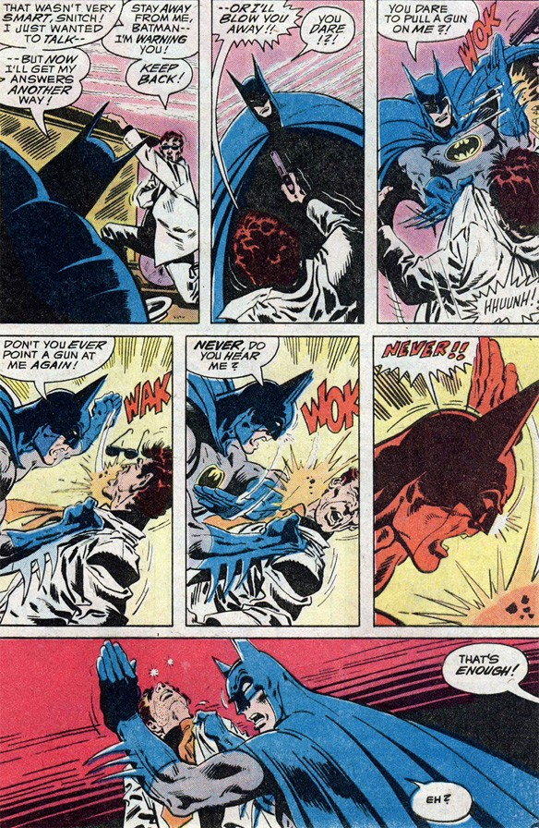
It gets even better when it's revealed at the end -- and Spoiler Warning, but c'mon, this thing is 31 years old -- that Batman's actually doing it all to himself having suffered a head injury leading to a psychotic break when Catwoman exploded a warehouse at him.
Thus it is proven: The only person who can destroy Batman... is Batman.
11: Batman Adventures #3 (1992)
It's pretty common knowledge that Batman: The Animated Series is one of the best depictions of the character outside of comics -- and that would be because it's completely true -- but even dedicated fans of the cartoon often overlook just how good its comic book companion was. Written by Kelly Puckett with regular artist Mike Parobeck and fill-ins from incredibly talented guys like Ty Templeton and Rick Burchett, The Batman Adventures was a master class in how to create tight, compelling plots that played out in 22-page stories that weren't just good for an all-ages book, they were quite easily the best Batman comics of the '90s.
The whole run's worth checking out -- #10 is one of the best Riddler stories of all time, right after "Dark Knight, Dark City" -- but it's the first three issues that sold me on this one back when I was a kid buying comics at the Piggly Wiggly. Each issue is self-contained, but there's an arc going through those first three that the Joker is manipulating other villains in preparation for something big, while at the same time hitting on what made these characters what they were, like the Penguin's aspirations to upper-class crime.
#3, though, is where it really comes to a head, as the Joker reveals his master plan, and no joke: It is essentially the template for Christopher Nolan's version of the Joker from The Dark Knight.
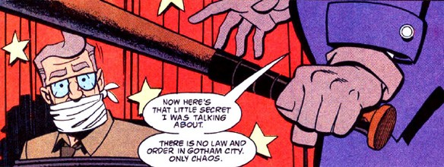

He wants to undermine the very idea of law in Gotham City and then unmask Batman as his final, humiliating defeat.
I remember reading this when I was 10 and being legitimately scared of the Joker for the first time in my life. I'd gone from watching Batman '66 for an hour every day after school to reading this story -- which again, was in a book for kids based on a cartoon -- where the Joker ties up Jim Gordon and breaks his arms with a baseball bat on live television while Batman watches, his face not showing any emotion other than grim resolve.
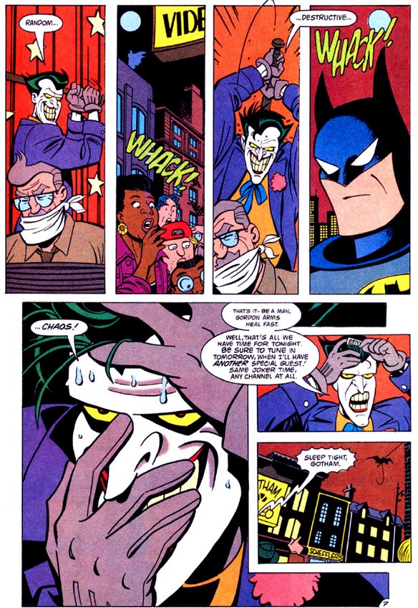
I've read the story a hundred times since then, and even without the lens of nostalgia, it holds up. That close-up of the Joker's face by Templeton and Burchett is still my favorite picture of the character, and everything you need to know about him is laid out for you in that one violent, terrifying sequence.
And that's just one page.

[from the comments:]
What's great about focusing on 11-20 is that it lets you give some attention to writers other than Bob Haney, who scripted all of the stories in the top 10.
Or am I forgetting something? –[Cole Moore Odell]

From Ask Chris #80

http://www.comicsalliance.com/2011/11/18/ask-chris-80-defining-the-batman-family/

Here at ComicsAlliance, we value our readership and are always open to what the masses of Internet readers have to say. That's why every week, Senior Writer Chris Sims puts his comics culture knowledge to the test as he responds to your reader questions!
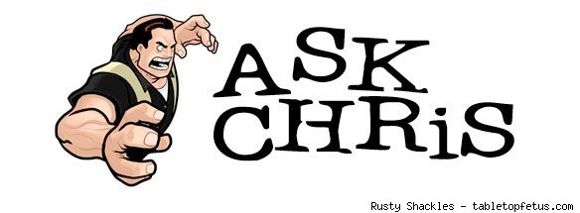
Q: Define "the Batman Family." Isn't the whole idea a contradiction when the main character is a violent loner? -- @Mike_Donachie
A: Hang on one second: You're telling me that this week, I've got a question I can answer by telling someone that they're totally wrong, and it's about Batman? Folks, Christmas has come early to ComicsAlliance, because this may in fact be the perfect Ask Chris question. So perfect that I almost hate to do this to you, but since you've set me up so nicely: Mike, you're totally wrong.
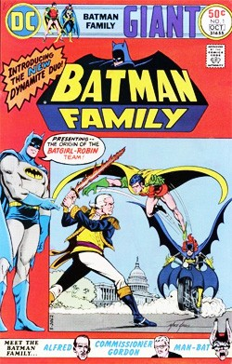Well, you're half-wrong, anyway. I mean, nobody in their right mind would argue that Batman's not violent. The man just flat-out loves to punch criminals, to the point where it's more or less become one of the most defining aspects of the character. I mean, he might be the World's Greatest Detective, but when you get right down to it, that's usually just a way to find out which person in Gotham City is the one who currently needs a good, solid smack in the mouth. Hell, they made two video games that sold millions of copies based almost entirely on that premise.
Of course, there's more to that violence than just the satisfying crunch of fist on thug, but I'll come back to that for a minute. The point is, given the past 70 years of Batman comics, it's impossible to argue that Batman's not violent.
But given the past 70 years of Batman comics, it's also impossible to argue that Batman's a loner. He can certainly be portrayed as self-reliant and as operating on his own, and he works very well in that sort of story, but a loner? Batman hasn't been a loner since 1940, when Bob Kane, Bill Finger and Jerry Robinson introduced Robin -- less than one year after the creation of Batman himself.
And that addition, right at the very beginning of what would grow to become Batman as we know him today, certainly wasn't the last. After Robin became the Sensational Character Find of 1940, Batman went on to have a ton of other sidekicks, partners, teammates, proteges, allies, surrogate parents... the dude even has a dog. And why? Because when you take them all together, they make up exactly what you asked about, and exactly what they were called in the comics: The Batman Family.
The idea of Family sits at the center of the concept of Batman, and not just because he uses his Family fortune to fight crime from a secret lair beneath his Family home, although those are part of it. Everything about the character's motivations and actions revolves around it, because it's all set in motion by the loss of Bruce Wayne's family:
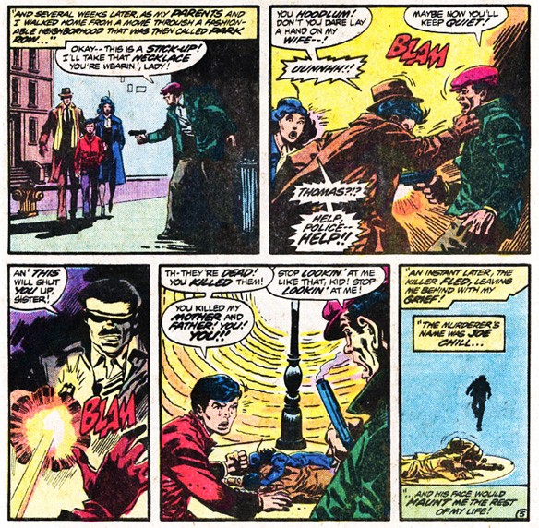
As I've mentioned before (even illustrating it with that same sequence of panels above, from Untold Legend of the Batman #1), there are very few things I think are quite so wrong-headed as stories where Bruce Wayne is an unhappy kid before the death of his parents. Those stories completely miss the point of what happens to him when his parents die -- there has to be a change for Bruce Wayne, and if he's going to do something as extreme as putting on a costume and dedicating his life to fighting crime, then the change has to be equally extreme.
In other words, Li'l Bruce Wayne's life has to be perfect, and it has to be that way because of his parents -- his Family -- so that it can be completely and irreparably shattered when they're taken away from him. It's a brilliant narrative device because there's so much metaphorical baggage that comes along with the idea of parents: Safety. Comfort. Love. Family.
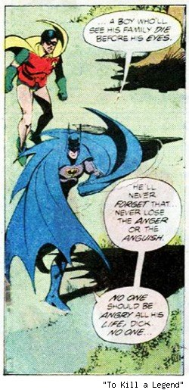
That's the moment that defines Bruce Wayne's life and dedicating his life to crimefighting. There's a beauty to that, maybe the thing that I love the most about Batman and how he works, that he's young enough to decide that ending crime is something he can actually do, and that the comics are built around him in such a way that he can actually have a pretty good shot at doing just that, all based on the simple idea that he is fully, keenly aware of what Crime can take away from a person. For Bruce Wayne, it's not even a question of whether or not he can do it; he can't not do it, because to let anyone else suffer a loss like he did is unthinkable.
And that brings us back, for a moment at least, to the idea of Batman as violent. He definitely is, but unlike the criminals that he faces, his violence is a means, not an end unto itself. Batman's not a character that's hell-bent on revenge. There's a little of that in there, sure, but it's not the focus in the way that it is for a character like the Punisher. The fact that he doesn't use guns, that he doesn't kill, that he rescues people from danger rather than just hunting down the guilty, it all points to something other than just simple vengeance.
Regardless of why those aspects were included in the stories, whether they were put there just to distinguish him from the Shadow or to make him more appealing to kids, in the context of the story, they all come together to take on a new meaning: Batman does things differently than the criminals, and so his violence is, at least in its intent, a different kind of violence. He's not a guy out to just get his kicks and satisfy his own need for revenge, a common misconception among people who want to sound smart without actually reading the stories, because that kind of self-serving violence is what created him, and what he set his life to opposing. Every act of violence that Batman commits, and every act of violence that he endures, is done in service of others.
Specifically, it's so that they don't have to suffer the way that he did. And if we can apply that logic to the way Batman fights, we can apply it to the rest of his life too, because it all goes back to that same motivation: The loss of Family.
Which brings us to Robin, and one of the most important and enduring examples of how the concept of Family affects Batman.
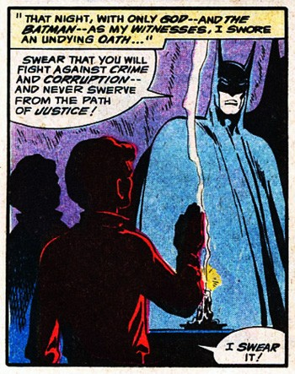
I've written about this pretty extensively before, but it's very, very important that when Batman meets Dick Grayson, he's essentially in the same situation that Bruce Wayne himself was in as a child. He's just seen his parents murdered. He's lost his family in a way that perfectly echoes the tragedy that drives Batman, but with one crucial difference: When Bruce Wayne's parents died, there was no Batman to help him. When Dick Grayson's parents die, there is.
Batman doesn't just help Dick track down the guy who killed his parents, he adopts him. He takes him in. Batman takes the place of his family, and in doing so, Batman also takes the first step in rebuilding his own family. And as a result, in one of the most brilliant evolutions of a character ever, Dick Grayson grows up to be a very different person than Bruce Wayne.
And from there, it expanded. The next family member was, of course, Alfred -- his family servant -- but over the next couple of decades, the idea of Bruce Wayne creating a surrogate family to deal with the loss of his parents was literalized in the way that only the Silver Age could do it. Specifically, they brought in a pair of obscure characters that, here in the 21st Century, have been all but forgotten.
The first was Bruce's Uncle Philip, a world-traveling explorer who got custody of Bruce after his parents died. I've never liked the idea of Uncle Philip, especially since he was mainly created for the sole purpose of explaining how this orphaned eight -ear-old was able to travel around the world learning to be a karate detective. The whole idea of Bruce actually having living relatives that he can go be with after his parents get killed softens the tragedy in a way I just don't like -- to be as effective as they need to be, Thomas and Martha Wayne need to represent all there is of the Wayne family.
The other character was Mrs. Chilton, and she is one of the all-time greatest examples of the Silver Age taking a concept to a hilariously ludicrous extreme.
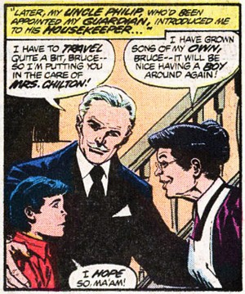
Why? Because Mrs. Chilton, the kindly Wayne family housekeeper who raised Bruce Wayne as her own son with the loving kindness of a saint, was actually the mother of Joe Chill, the man who murdered Bruce Wayne's parents. Completely. Insane. But at the same time, it's a great example of the focus that the creators of those stories had on the idea of Family as a driving force for the story of Batman.
Again, those characters aren't really all that appealing in the context of the greater story. There's a reason they've fallen into obscurity and been more or less excised from the elements that make up the "official" version of Batman. They both blunt the driving tragedy, and lessen the impact of the changes to Bruce's life after the murder of his parents. The shadow of his parents' murder needs to hang over Bruce's life, at least until he becomes Batman -- otherwise, the motivation to actually become Batman is lessened.
But once he's reached that point, we return to the idea that he can build a family of his own, and it's a family of his choosing. Robin, Batgirl, Alfred, Leslie Thompkins, even his alliances with characters like Superman and Commissioner Gordon are often played as being more than just "business partners." At the very least, they're friendships. Just like we do in our own lives, Batman builds a family as an adult that goes far beyond his actual relatives. And when you look at it as a family, it becomes an interesting reflection of what he does in the role of Batman. Crime takes away his family, so he builds a new family in order to better fight crime.
It's such an intrinsic aspect of who Batman is and what makes up his personality that it's almost impossible to separate it out from the rest of the character, even in versions that focus on Batman as being a singular hero. Christopher Nolan's movies are a great example. He's said before that he has no intention at all of putting Robin into his films, but the relationships between Batman, Lucius Fox and especially Alfred are played as extremely familial.
Since Bruce Wayne became Batman, he's never been alone. He's always had someone there for him, from Alfred all the way down to the Outsiders. So I'd define the Batman Family in the same way that I'd define my own. We all form and keep relationships in order to make our own personal worlds better, and so does Batman. He just happens to have a lot more capes in his.

[And from the comments…]
I can't help but wonder if the people who dislike the idea of the Bat Family are people who project a little too much onto Batman. They like the idea of a being a dangerous loner who could beat the crap out of anyone, anytime. Accepting that Batman has lots of friends/family conflicts with their own situations.
Actually, forget it, I hate pop psychology. I've literally no evidence to back up that statement. Nevermind.
It all boils down to this: No Bat Family = No Tim Drake or Damian Wayne, and that's a world no one wants to live in. – [Bear]

Now that's what I call Family Values. Take that, Moral Majority! – [Ben Siegel]
I always thought the most perfect example of why the Batman Family makes sense, and, really, the core of who Batman is as a character was shown in that final scene of the Batman/Planetary crossover, which isn't really where you'd expect to find it, but hey. He's asked by a character whose parents were also murdered how he goes on, and he responds;
"Do you remember your parents? Do you remember their smiles? Do you remember the times when they made you feel safe? That's what you hold on to. That's what you can do for other people. You can give them safety. You can show them they're not alone. That's how you make the world make sense. And if you can do that - you can stop the world from making more people like us. And no one will have to be scared any more."
It's not about vengeance, it's not about retribution, it's not about Bruce Wayne being violent and unhinged, it's THAT. – [Christian]

Now this is a story all about how
My life got flipped-turned upside down
And I liked to take a minute just sit right there
And tell you how I became the Batman of Gotham.
In West Gotham City, born and raised,
With my parents is where I spent most of my days
Chillin out, maxin, relaxing all cool,
All watching some Zorro on Park Avenue.
When a gun-slinging guy who was up to no good
Started makin' trouble in the neighborhood.
My parents got killed and it wasn't pretty
I swore to end crime in Gotham City.
I took in an orphan and when he came here
He had yellow tights and green underwear
If anything, I could say that this guy was lame (I had to have a rhyme, OK? :P)
But I thought, nah, forget it, let's go fight crime!

I swung around the city looking all cool
And yelled to the bad guys, "Yo homes, smell ya later!"
Looked at my city, I had my plan,
To sit on the rooftops as Gotham's Batman.
Yeah, it's not that great, I did it in about five minutes. But I felt inspired. :)
– [randomperson416]

I'd like to take a minute, and I don't want your pity
While I tell you how I became Batman of Gotham City. – [Adder Moray]

It's interesting how many of the big Batman stories of the last twenty years are so are a direct repudiation of the "dark loner" persona. Knightfall, No Man's Land, Tower of Babel (technically JLA, I know) Bruce Wayne: Murderer/Fugitive, Infinite Crisis, and Return of Bruce Wayne all devote major time to the idea that one of Batman's main strengths is the network of allies and friends he's built and how retreating into himself/banishing that network is disastrous for Batman/Gotham/the DC Universe.
-- [Road Flare]

From 11/03/2011

The 10 Best Episodes of 'Batman: The Animated Series' by Chris Sims
http://www.comicsalliance.com/2011/11/03/best-batman-animated-series-episodes/

With over a hundred episodes produced from 1992 to 1998, Batman: The Animated Series is commonly regarded as not just one of the greatest cartoons ever made, but one of the best depictions of Batman in any medium in the character's 70-year history. Under producers Alan Burnett, Paul Dini, Eric Radomski and Bruce Timm and with a note-perfect voice cast led by Kevin Conroy as Batman, The Animated Series racked up classic after classic, with stories that were marked by being truly accessible and exciting for all ages. It changed super-hero media forever, and created a legacy that continues today with Timm's work on the new Green Lantern cartoon.
In short, it's absolutely phenomenal and we love it. But even with the high standard of quality set by the series, there are some episodes that stand out beyond the others as the best of the best. So today, I've gone through the entire series to bring you ComicsAlliance's picks for The Ten Best Episodes of Batman: The Animated Series!
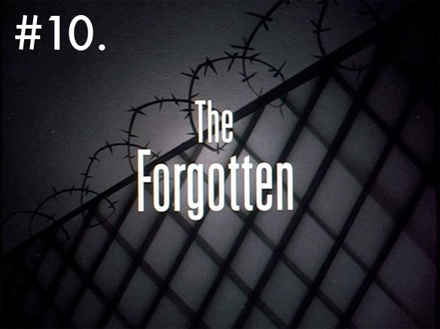
The Forgotten
Story: Jules Dennis, Richard Mueller & Sean Catherine Derek
Director: Boyd Kirkland
Any top ten list for something as beloved as Batman: The Animated Series is going to provoke its fair share of disagreement, and I fully realize that there are people who are going to count my opinion as absolutely worthless for giving one of the episodes that's commonly regarded as the worst of the series a top slot over classics like Harley's Holiday or the award-winning Robin's Reckoning. But to be honest, there are two kinds of people in this world: Those who think Cool Hand Luke starring Batman is awesome, and those who don't.
As much as you can decry this episodes as being a shameless, blatant... well, let's just be nice and call it an homage to that film, as much as the sequence of events that follows Batman being conked on the head, getting amnesia and having to labor in a prison camp while his disguise somehow stays firmly in place, and as much as this really just boils down to a story that pits the world's greatest crimefighter against a fat guy...
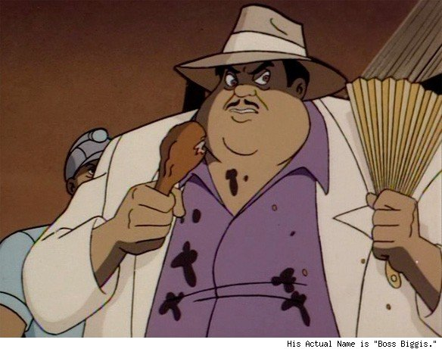
...those are all things I love about it.
The Forgotten is unique. It breaks almost every rule of the series. It's not set in Gotham City, there's no arch-criminal, there's barely any actual Batman (most of the issue is spent with amnesiac Bruce Wayne), there's a complete lack of logic in the fact that nobody recognizes one of the richest men in the world or puts things together when he goes missing and Batman shows up, and it even has scenes with actual sunlight. There's a good reason why most fans of the series write it off, but it not only proves how adaptable the show's version of Batman really was, it shows a crucial side of Batman's character. The title of the episode points it out: The men who were abducted to work as slaves were forgotten by everyone -- except Batman. He's not just a billionaire who gets his kicks by putting on tights and punching out guys who want to blow up the water supply, he's a man utterly dedicated to saving those around them from the criminals who would ruin their lives.
It's heavy handed, it's illogical, it's goofy as all hell, but when Bruce Wayne remembers what he does and why he does it, and Conroy's voice shifts back into his almost snarling Batman growl to tell the other prisoners "We're getting out of here," it also brings us one of the best moments in the entire series.
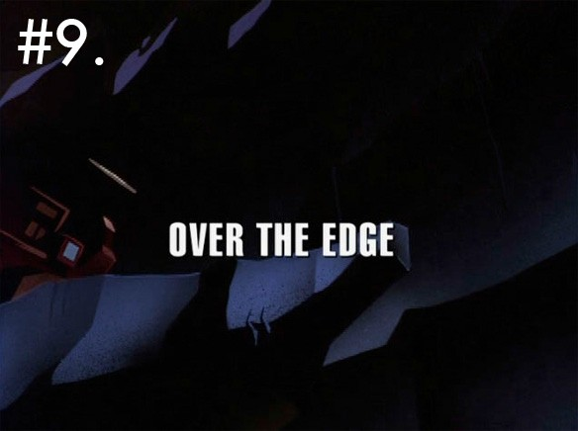
Over the Edge
Story: Paul Dini
Director: Yuichiro Yano
While we're on the subject of stories that shouldn't work, we have Over the Edge. Under normal circumstances, a story that ended with "but it was all a dream!" would be automatically consigned to the dregs, but here, it works.
Part of that just comes from context. Paul Dini's script is working with a world that has already established dreams, hoaxes and imaginary stories as viable concerns, both in the larger tradition of super-hero stories and on Batman: The Animated Series specifically. The truly amazing Perchance to Dream, in which Batman battles his way out of an dream world because it's quite literally too good to be true, had not only set up the rules, but provided the perfect context for what happens in this one.
But what really makes it work is its sheer brutality. Like The Forgotten, Over the Edge lives up to its title: Batgirl's death leads Jim Gordon onto a grief-stricken path of revenge that sees him declare outright war on Batman, discovering his secret identity, destroying Wayne Manor, bringing down Nightwing and Alfred in chains. It's the worst case scenario for the good guys, and it's not the villains bringing them down, it's that they turn on each other out of vengeance.
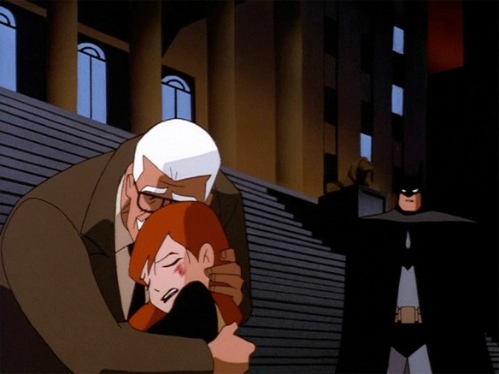
And unlike most stories that use the device, the fact that it all happens in Barbara Gordon's dreams doesn't detract from the drama -- they add to it, and builds her character in an interesting way that before then, the show hadn't really addressed. It reinforces the danger that she's living with as a character. Not the physical danger of death or injury, but the emotional danger of the deception that comes along with hiding her identity from her father, and how it's his trust in her and in Batman that's at risk.
It's an interesting exploration of character and consequences that doesn't talk down to the audience even when it's conveyed in sequences built on violence and shock value, a tightrope that only the best stories manage to walk.
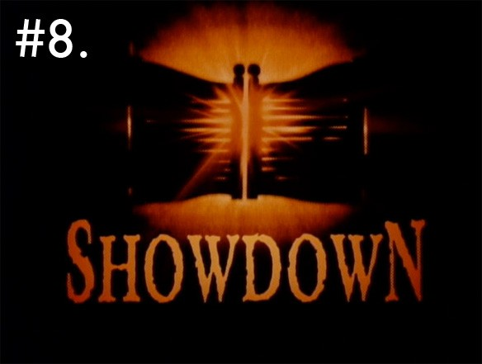
Showdown
Story: Kevin Altieri, Paul Dini, Bruce Timm and Joe Lansdale
Director: Kevin Altieri

Generally speaking, it's a bad sign when Batman barely shows up in your Batman story, but Showdown is one of the most memorable episodes of the series, for a lot of reasons.
For one thing, it's got one of the best set pieces, and that's saying something. Owing to the influence of the Max Fleischer Superman cartoons and movie serials of the '40s -- which led to the beautiful aesthetic of the show's title cards -- an awful lot of Batman: The Animated Series was built around those dynamic, memorable set pieces. Even mediocre episodes like Prophecy of Doom, in which Batman fights a balding con man duping gullible rich folks out of their inherited millions (basically the opposite of The Forgotten), features that incredible scene where Batman fights a guy in a gigantic planetarium where Saturn had razor-sharp, damsel-threatening rings. Why the hell did this small-time confidence man have a planetarium deathtrap set up? Who cares, Batman punched a dude right through Uranus! That's amazing!
But I'm getting off the subject. In this episode it's steampunk airships in the wild west raining cannon fire down on locomotives, which makes for a great visual -- and despite the fact that the first frame of the opening credits had a blimp in it, it's not the sort of thing you usually saw in the dark, art deco noir setting of Gotham City:
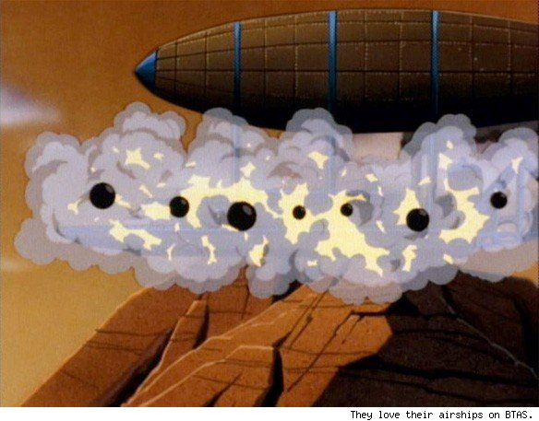
The second thing Showdown accomplishes is that it fixes one of the few problems with one of Batman's greatest villains: Ra's al-Ghul. The first rule of good writing is that you show instead of tell, but because Batman's adventures take place in the present -- whenever that present happens to be -- we just have to take Ra's's word for it when he says he's an immortal who's been kicking around for 500 years. By this point in the series, we've seen him go into a Lazarus pit and come out a little stronger and a little more nimble, but that doesn't show that he's an immortal. He tells us and we go with it.
In this issue, even though it's related as a flashback told by Ra's, we're shown everything, and made to understand that yes, this guy has been working these schemes for longer than Batman's been alive. It both validates his claims and suddenly makes him scarier -- if he was able to do everything he does in this episode a hundred years ago, what can he do with the resources that he has today? -- and at the same time, the end of the episode also humanizes him, making him sympathetic.
That's one of the things that The Animated Series excelled at -- fleshing out the vilains just as much it fleshed out its heroes. There aren't a whole lot of recurring characters on this show that don't have layers crafted into their personalities, and the hint of pleading that David Warner gives to Ra's al-Ghul's voice when he speaks to Batman, his worst and most persistent enemy, adds an immeasurable amount to the character.
The most memorable element of this episode, though, is who acts as our protagonist in the absence of Batman: Jonah Hex.
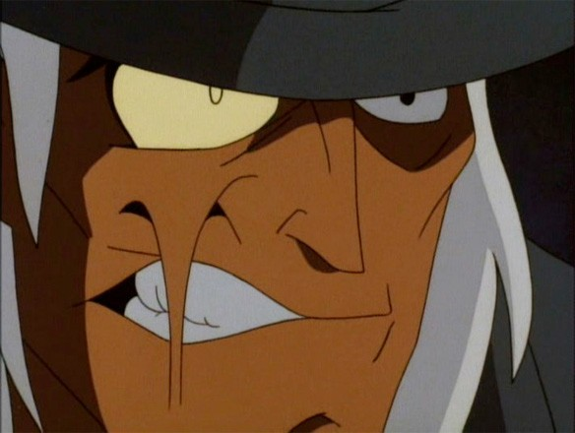
Before The Brave and the Bold, before Justice League, before Superman: The Animated Series, there was Jonah Hex on Batman: The Animated Series, and our first hint of a larger animated DC universe beyond Gotham City. Even the Zatanna episode took place in Gotham, with Batman as the focus and a version of Zatanna that fit more easily into a supporting role -- she was just a stage magician. Here, however, we have a fully-formed protagonist on his own.
Hex is a different kind of character than Batman -- we know within the first five minutes that he's a killer and a bounty hunter -- but Lansdale's script goes out of its way to draw parallels between him and Batman. It all leads to the creation of the fully shared universe that would arise later on in the franchises that would follow after Batman's success, all while telling its own grand adventure.
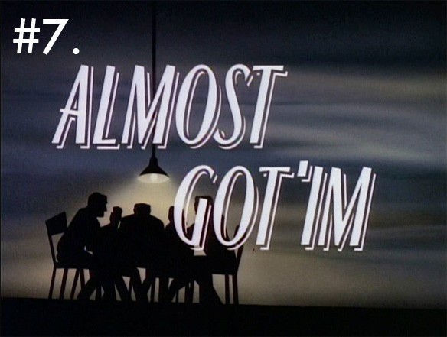
Almost Got 'Im
Story: Paul Dini
Director: Eric Radomski
Almost Got 'Im is unquestionably one of the most beloved episodes of The Animated Series, to the point where I'm sure there are people who won't believe that I'm saying it's only better than 102 others.
Either way, it's expertly crafted on just about every level, right down to the way it was animated. Right from the opening sequence, in which the villains are introduced solely by close shots of their hands as they play poker, and it's a testament to how sharp and distinctive the designs were that you can identify them by such a small piece.
And then there's the big reveal at the end, where Batman's shadow emerges from Killer Croc's body as a light swings back and forth over him. There's a similar reveal at the end of a previous episode, The Cape and Cowl Conspiracy, and it's done well there, but this sequence -- credited in the DVD commentary to animator Glen Murakami -- blows it away in terms of sheer style. It's just this perfect example of the visual language of comics translating to animation in one beautifully memorable sequence.
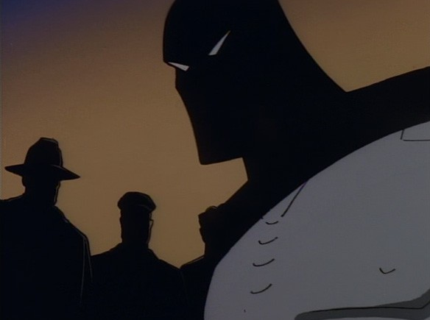
It's also hands-down one of the smartest episodes. The premise alone is a brilliant inversion on the traditional formula, having the bad guys casually hanging out telling their stories, in which Batman is their villain. I imagine it was pretty tough to pull off, too -- it's a 22-minute cartoon that manages to tell stories with four villains, plus Catwoman and Harley Quinn, plus a surprise reveal that makes the second time you see it even better than the first.
It all comes back to the set pieces, and it's there that Dini shines, with his animated origin for Batman's giant penny that sets a tone of slapstick Silver Age fun, then transitions smoothly into the Joker gleefully electrocuting Batman and attempting to chop Catwoman into actual cat food.
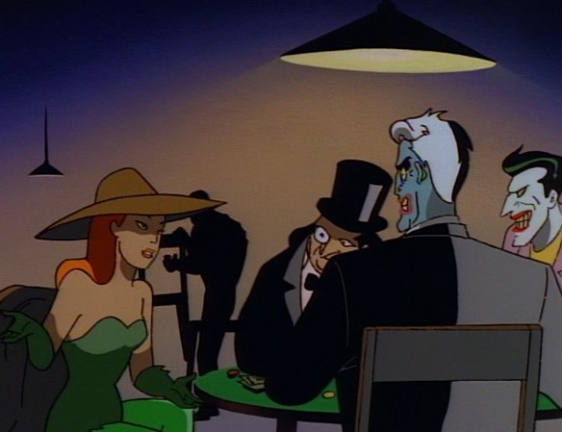
It's the perfect blend of genuine, threatening danger and lighthearted fun that worked so well for the series, and it's only underscored once you get to the point where you realize that Killer Croc's rock-stupid lines and pratfalls were all just Batman in disguise, showing the bad guys how dumb he thinks they are while doing the most villainous thing of all: Luring them into a trap.
Like I said, it's a fantastic inversion of expectations, right down to Batman responding to Harley Quinn's taunts of only being able to capture her or save Catwoman -- the classic love-interest-in-distress trap -- by casually turning off the deathtrap and pasting her one.
Unlike some of the other episodes on this list, Almost Got 'Im doesn't add anything to the show's grand mythology, with the possible exception of the rarely seen moment of Batman enjoying himself. All of its pieces are already in place when it starts, from the established relationship between Poison Ivy and Two-Face to the sexual tension between Batman and Catwoman, and nothing really changes at the end. But it takes all of those pieces and puts them together so well, with stylish animation and enormously clever touches, and ends up making one of the most perfect episodes of the show.
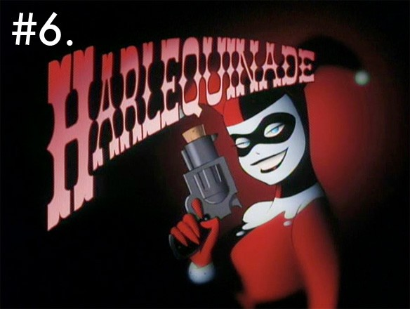
Harlequinade
Story: Paul Dini
Director: Kevin Altieri

To say that Harley Quinn was the breakout character of Batman: The Animated Series is underselling things quite a bit. She was hugely popular with fans, and for good reason: She's at the center of some of the show's best episodes, from the slapstick, relatively uplifting comedy of Harley's Holiday to the miserable tragedy of Mad Love. But of all the Harley-centric episodes, Harlequinade does it the best.
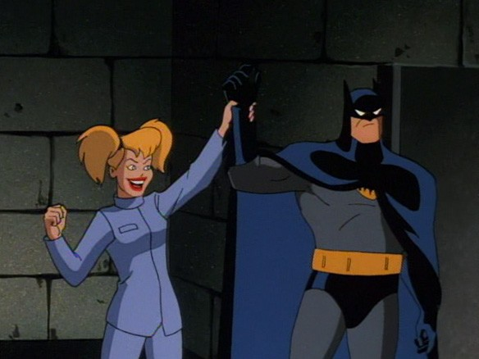
It doe severything you want a Harley Quinn story to do, and it does it with the absolutely perfect setup of having Harley and Batman team up in order to stop the Joker from blowing up Gotham City with an atomic bomb -- a plot that would be flat-out ridiculous in most cartoons, but works perfectly with this show's concept of the Joker.
Just from that, you've got the buddy-cop comedy that comes from contrasting Harley's giddy enthusiasm with Batman's grim, eye-rolling exasperation with her -- Conroy's subtle frustrated sighs and furious orders to behave are the perfect foil for Arleee Sorkin's delivery -- but as the episode goes on, it gets deeper. It has those same notes as Harley's Holiday, where you want her to succeed and get away from the Joker, but with that same note of heartbreak because you know she can't that shows up again in Mad Love, but combined into something better.
And, just to cap things off, it's the only episode of Batman: The Animated Series to feature a genuinely hilarious musical number, in the form of a catchy tune about domestic abuse from 1946 called "Say That We're Sweethearts Again."
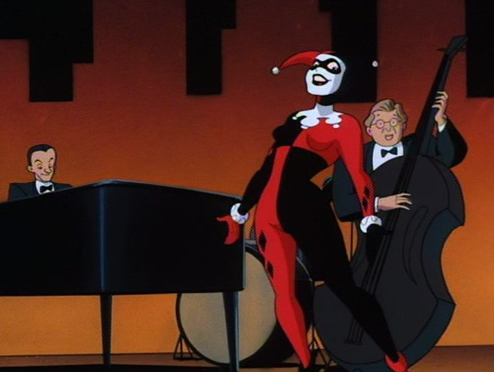
Batman slamming his forehead into a table while Harley sings will never not be hilarious, and the same goes for the Joker's Snoopyesque World War I Flying Ace routine at the climax of the episode.
And again, it's that comedy that makes the sadness of Harley's relapse into loving a man that was about to blow her up with an a-bomb -- even if it's done in the form of a goofy Honeymooners reference -- have an emotional weight to it that her other appearances just don't match, no matter how hard they try to recapture the feeling of this one, or how enjoyable they manage to be in the process. It's rare for any series to do an episode where the main character steps aside to take a supporting role to let a minor character shine, and for it to be done this well is downright unheard of.
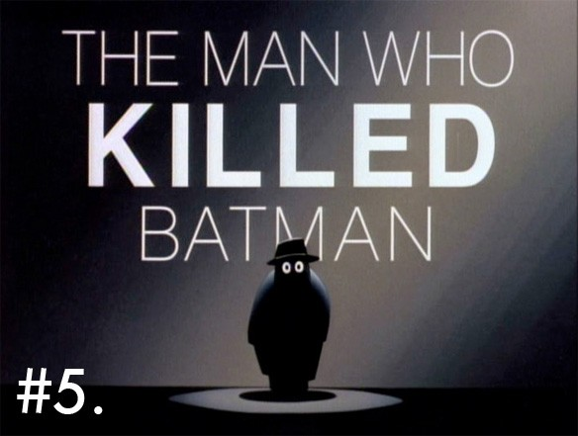
The Man Who Killed Batman
Story: Paul Dini
Director: Bruce Timm
The Man Who Killed Batman is one of those perfect high concept plots that sells itself to the reader immediately, just on the strength of the title and the image that goes with it. The very idea that Batman could die is unthinkable -- the show itself is named after him, so even the kids the series was aimed at would have a hard time buying that he actually died -- but the fact that it's some wide-eyed, lemon-shaped goon cowering underneath that title immediately makes that question irrelevant, and replaces it with "okay, well how did this guy do it?"
And the rest of the episode lives up to that title, using it as a springboard to tell a story that's almost unbelievable in how clever and sharp it is. Everything about the episode is designed to increase the reputation of both Batman and the Joker. We learn from the very beginning that the regular criminals of Gotham City have pretty much resigned themselves to Batman's presence and given up on attempts to kill him themselves and decided to take a completely different set of tactics -- Sid the Squid is brought in by his "pals" for the sole purpose of slowing down Batman while he beats the crap out of him. And when he actually does kill Batman -- or at least, when he seems to -- everything changes around him.
The best bits of the episode, though -- and this will come as a surprise to no one -- are from the Joker.
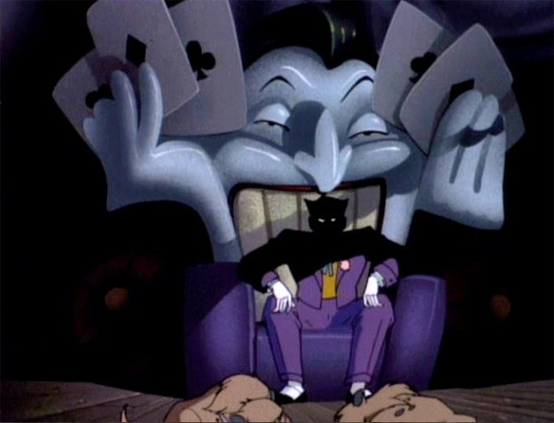
The genuine sadness that the Joker feels at Batman being killed takes a layer of his character that shows up in the comics and translates it to the small screen version with a beautiful economy, and the same goes for his rage that someone else managed to accomplish it. The scene where he quietly tells Harley to put the loot back because there's no point in committing crimes without Batman -- the only time in the series where Mark Hamill's voice drops out of the high-strung, theatricality that he ususually uses for the Joker -- is just remarkable.

In the end, it all comes back around to building Batman into a towering, mythical figure. It's not just that he explains how he survived with the blunt "I swung away before it exploded" in the casual, off-hand style that anyone else would use for "I went to the grocery store," it's how he makes his entrance. Everyone believes that he's dead, but then gunshots -- deadly to a lesser man but less than an inconvenience for him -- and then he just cold into a man's house, dossn't even break stride as he disarms him with a shuriken, and then starts throwing a crime boss through the furniture.
And it's not even for our benefit we see all this happening -- presumably, if we've been watching this show, we already know Batman is a badass. We've seen him as the hero in every episode. But here, and this is what makes this episode remarkable, seeing Batman the way the criminals see him: Unstoppable. Ruthless. Terrifying.
It's also worth noting that Dini manages to pull off a script that gives almost everyone a happy ending. Batman's alive and well in Gotham City and punching out crime boss Rupert Thorne, so he gets what he wanted, Sid the Squid goes to prison with the reputation that he always wanted, and even the Joker gets to fight Batman again, which is exactly what he wanted. And we get a phenomenal piece of television.
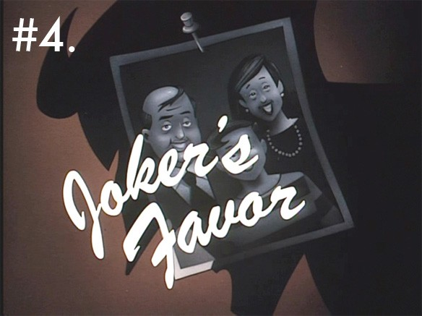
Joker's Favor
Story: Paul Dini
Director: Boyd Kirkland
If The Man Who Killed Batman is the perfect illustration of why Batman is so terrifying to the crooks of Gotham City, Joker's Favor is the other side of the coin: An incredible story of why the villains are so terrifying that Batman is necessary.
When the focus is on Batman, it's easy to lose sight of the tension that's being created. Again, the set pieces the show used so well come to mind: Once you've seen Batman survive a deadly roulette wheel or the Maze of the Minotaur or Sid the Squid's explosion or a Death Planetarium, day after day, week after week, it becomes routine. We start to know that there's nothing they can really throw at Batman that can stop him, and the fiction, the illusion of danger, becomes fragile.
But in this episode, the focus shifts to someon elese, someone who's the diametric opposite of Batman. Charlie isn't the exceptional billionaire crimefighter, he's just a dude who wants to get through a traffic jam. He's the everyman. He's us. And when he becomes the target, we become the target, and suddenly the Joker's scary again.
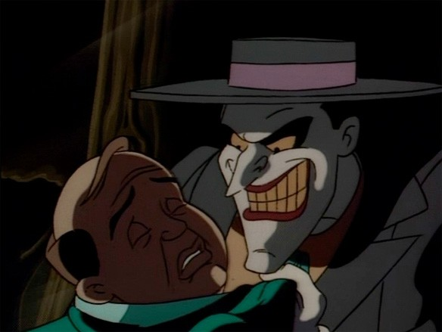
You can't hide from the Joker. He'll find you. He'll kill your family. There's nothing you can do to stop him, because you're just some dude and he's the most terrifying criminal mastermind in a city of criminal masterminds. And you never know what he's going to do, or when he's going to do it
As much tension as there is in the Joker effortlessly cutting through the Witness Protection Program and the sinister threat that goes along with it, the best part of this entire episode is when Charlie finds out that all the Joker wants from him is to hold a door open for Harley. It plays right into the unpredictability that makes the Joker such a great villain, and acts as a false resolution that makes the next twist -- that he's leaving Charlie to be blown up along with Commissioner Gordon -- hit even harder. It's a murder set up like a joke -- setup, escalation, punchline, kicker -- that fits his character perfectly.
Joker's Favor gives us an adventure with comedy and tension that conveys two crucial ideas. First, that while Batman himself is the indomitable, unstoppable crime-fighter, the people around him are not. They're fragile, and the things that he deals with on a daily basis are unimaginably dangerous to him. It changes the stakes -- Batman doesn't "lose" by coming to harm himself, he loses by by failing to stop others from coming to harm. That's where the tension is in this episode.
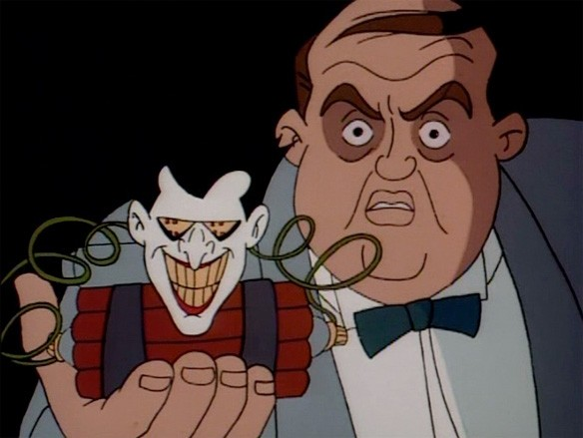
The second idea spins directly out of that, subverting it for the surprise when it's not Batman who defeats the Joker, but Charlie himself. And if Charlie's us, then we beat the Joker. It might verge on pandering, but it's an incredibly satisfying and pretty inspiring ending. Plus, the Joker's melodramatic terror and cowardly running to Batman for protection is a genuinely funny visual, and an incredible contrast with his menacing actions earlier in the episode. It only reinforces the theme of the Joker's unpredictability, and does so in a phenomenally enjoyable way.
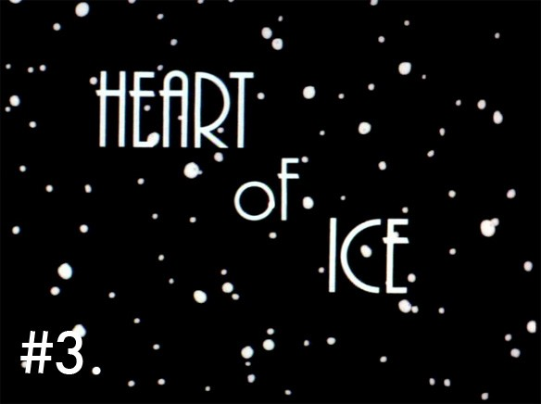
Heart of Ice
Story: Paul Dini
Director: Bruce Timm

If there's one defining strength of Batman: The Animated Series, it's the humanity that it gave to its characters. It's not just that they were well-rounded, it's that they felt like real people that viewers could identify with. Characters like Ra's al-Ghul and Poison Ivy weren't just unrepentant bad guys, they were people with legitimate complaints taken to an extreme -- much like Batman himself, but with a morality skewed to destruction while his was built on protection. And in Heart of Ice, took that idea and applied it to Mr. Freeze with an award-winning skill.
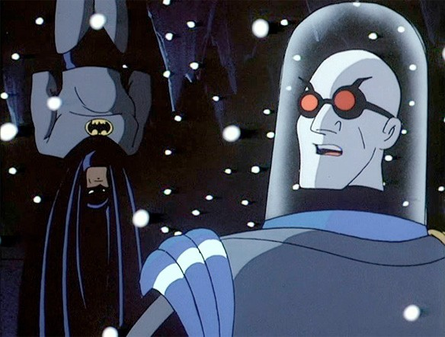
The fact that they were able to do this at all is impressive. The fact that they were able to do it with a blue man in a robot suit and a bubble head who gets defeated by chicken soup is mind-blowing. Dini and Timm provided what is unquestionably the definitive take on Mr. Freeze, making him a character whose emotionless evil is a facade that hides a brutal, sympathetic tragedy.
The fact that he leaves one of his own henchmen to his fate after his legs are frozen solid is the perfect way to characterize Mr. Freeze as a ruthless, unfeeling monster, and in a lesser show, that would've been where it stopped. But as Heart of Ice continues, it becomes clear that Freeze is anything but -- he attempts to deny himself his emotions because he can't take the pain of them. Even the way he phrases it himself is, if you'll pardon the expression, chilling:
"You beg? In my nightmares, I see my Nora behind the glass, begging to me with frozen eyes."
This isn't a man who doesn't feel. It's a man who feels too much, and that's the most humanizing element of all.
Even the fact that Batman catches a cold in this episode -- which leads to both a ridiculous pun and a gag ending that are completely forgiven both because of how fun they are and what surrounds them -- gives us a piece of vulnerability for the character that we rarely see.
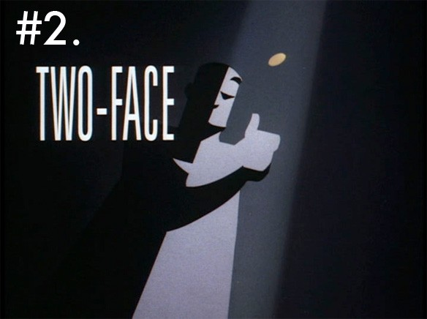
Two-Face
Story: Alan Burnett and Randy Rogel
Director: Kevin Altieri
Heart of Ice got a lot of press (and an Emmy award for writing) and it deserved every bit of it, but in terms of crafting a villain with humanity, Two-Face is even better.
The origin of Two-Face -- done, of course, in two parts -- succeeded not just because the episodes themselves are great, but because the larger show itself had taken the time to establish Harvey Dent as a character in previous episodes. He's portrayed unambiguously as one of the good guys -- he's even the unsuspecting victim in the episode that introduces Poison Ivy -- all of which leads to the idea that he's someone Batman has to save. So when we finally get to his tragic fall and his rebirth as a villain, it not only has more emotional weight because we know Harvey Dent -- or at least, we think we do -- it's one of the few times that we see Batman fail.
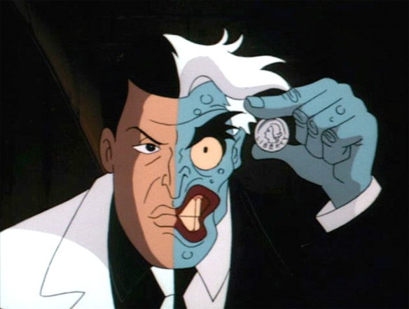
Based purely on that setup, Two-Face had a lot going for it, but the way the episode itself played out took things to the next level. There's an amazing brutality in the crime story at the heart of it -- the good man being brought down by the city full of corruption, as much at war with the darkness in himself as he was with evil around him, the fact that his happy ending is taken away from him, that he can never be with Gilda even though she still loves him, every bit of it is gut-wrenching.
And that's before Batman is even involved in a story that reflects his own tragic origin and the old chestnut of the duality in himself. It tests him on a mental level that brings a level of moral ambiguity that the average super-villain plot never reaches. Batman has to turn against his own friend --a friend to both Batman and Bruce Wayne -- to protect someone he hates, because he's devoted to a higher ideal.
If Batman: The Animated Series is marked by never talking down to its audience, then this episode is the best example of how. It's a story with no happy endings: Everyone loses, and because their story continues, they all have to live with that.
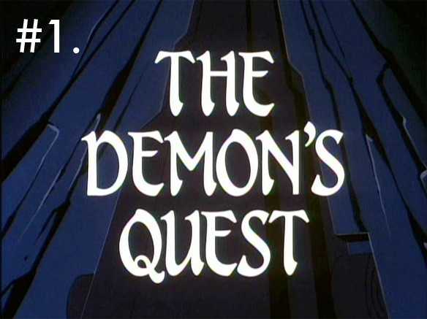
Story: Dennis O'Neil
Director: Kevin Altieri
Let's get this out of the way right up front: There is no episode I could've chosen as the best that everyone who loves Batman: The Animated Series would agree with, and I'm well aware that for some fun-loving sticklers, picking a two-part episode that's nothing more than a strict adaptation of a story from the comics is doing a disservice to all the episodes that were unique to the show. Whatever episode you're thinking of that I forgot about, believe me, I considered it.
But The Demon's Quest is perfect.
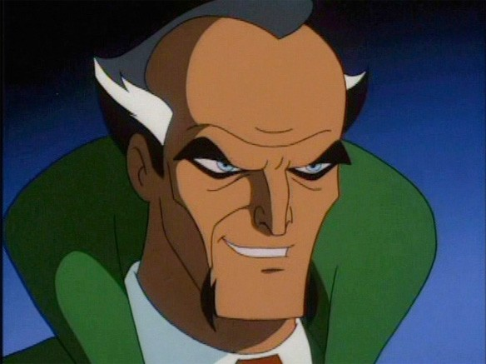
There's a reason the comics this episode is based on are considered to be some of the best Batman stories ever printed, and The Demon's Quest is a perfect translation. It's not just a showcase of everything that's great about Batman, it's a showcase of everything that's great about adventure fiction, period.
There are exotic locations. Clever detective work. Thrilling action. Danger. Doomed romance. Plot twists. A villain that, more than any other opponent that Batman faces over the course of the series, is shown to be his equal on every level, from wealth to skill to sheer cunning. It's an episode that shows what Batman is up against, and builds on the idea that he’s not only devoted to fighting against crime and evil, but fighting for justice and life. And when he kisses Talia at the end, then leaves her alone to return to Gotham City, we see how devoted he is to his mission, above his own interests and happiness.
We never need to be told that Batman is dedicated, or that Ra’s is ruthless, or that there’s a connection between Batman and Talia – we learn it all through the grand action of the story.

And then there’s the technical aspects of it. Ra’s al-Ghul and Talia are beautifully designed, and David Warner’s voice, with the refined menance that it brings to the part, fit him perfectly. Ubu’s design makes him simultaneously a threatening physical presence and an incredible source of comic relief, and the reveal that it’s not the gigantic musclebound bodyguard that presents the threat, but the slight, older man in crisp suit is an incredible reveal that makes Ra’s seem even more threatening by contrast.
The action moves from one thrilling set piece to the next, all rendered in some of the best animation on the series, 57uilding to the iconic confrontation between Batman and Ra’s, a duel set against a backdrop of flames, as the world explodes around them.
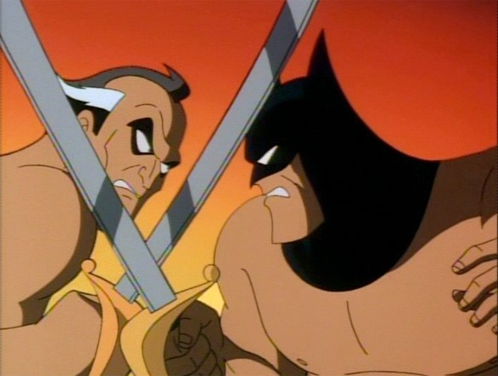
Forget about adamantium, y’all: That is the hardest metal known to man.
The character, the humanity, the drama, the action, the music, the animation – everything about this episode is perfect. It adds to the characters while defining them, and it takes something that was already great and brings it to the screen in a way that feels uniquely exciting – which is exactly what the series as a whole did. It’s the perfect example of how the show built on, added to and in some ways even defined a character and his world that had already existed for half a century, and does it so perfectly well.
It’s everything that’s great about the entire series boiled down to one single adventure, and that’s what makes it the best.

[And from the comments…]
I never really warmed up to Over the Edge. It's got some shock value to it but I found its handling of its concept unimaginative.
None of the Clayface episodes?! His origin and Mudslide are probably the best animated episodes of the entire series.
Finally, while I like Harley as a character, a little bit of her goes a long way with me, especially when Dini is writing (I just don't think the guy is that funny, sacrilege, I know) , which is why I'm not as high on the Harley-centric episodes as a lot of fans. – [Andy]

It's all in the ending -- Gordon's rampage in Barbara's nightmare is one long setup to him as much as telling her that's not what would happen (and by the way I'm not stupid and I know who all four of you are but let's please pretend I don't). THAT'S the big twist in the episode -- not her apparent death, not the ensuing events, not the dream ending, but a single line from Gordon that speaks absolute volumes.
Actually I really like the eps that focus on Gordon's relationship with Batman. Their New Year's Eve meetup at the end of Holiday Knights is just perfect, and I Am the Night is a classic as well. – [Thad] (in reply to the above)

"There's a reason the comics this episode is based on considered to be some of the best Batman stories ever printed, and The Demon's Quest is a perfect translation."
BETTER than perfect. The comic meanders a bit in the end, and has a few goofy 1970's touches going on (a caption box that actually SAYS "Batman just figured something out! Can you tell what it is?" or suchlike); the cartoon improves it.
Anyhow, I'll agree with The Forgotten as a favorite; Bruce Wayne in a soup kitchen is an image that we don't see enough of. He doesn't just fight crime with punching; he has compassion for the less-fortunate. (We get it again in Things Change, where Nightwing reveals he parted ways with Batman when the latter got particularly brutal in interrogating a thug; he later finds out that Bruce Wayne went on to hire that same thug and help him get back on the straight and narrow.)
Feat of Clay is pretty great, even though it treads a lot of the same beats as Two-Face. And It's Never Too Late is an extremely affecting episode, for my money. – [Thad] (again)

There's so much to enjoy about the Ventriloquist episodes: the awesome guest voicework, the fact that Scarface always has the same gang (Rhino!), the obvious glee the show has in finding new, hilariously brutal ways to destroy the puppet at the end of each episode (in the commentaries Timm relates how much the staff enjoyed being able to let loose and destroy puppets and robots after feeling restrained by Fox's Standards and Practices limits on fight scenes involving humans).
"Read my Lips" is my favorite though, because it sets up Ventriloquist/Scarface as a serious (and fairly creepy!) threat while simultaneously acknowledging how weird the whole situation is. You can definitely see Joe R. Lansdale's influence. It also has one of my favorite "ominous" endings. – [Road Flare]

From Deconstructing the Complete and Utter Insanity of Batman: Odyssey

http://www.comicsalliance.com/2011/03/08/batman-odyssey-neal-adams-insane/

With the recent release of Batman: Odyssey #6, we are now exactly halfway into the yearlong tale that we feel comfortable claiming, without hyperbole, is the most insane comic book we have ever read. If there is a comic book equivalent of the hilariously nuts cult film The Room, it is surely Batman: Odyssey, a miniseries illustrated by legendary Batman artist Neal Adams and written by legendarily terrible Skateman writer Neal Adams.
Today, Editor-in-Chief Laura Hudson and contributor David Wolkin sit down and attempt the nigh-impossible task of figuring out exactly what happens in Odyssey, a book that has both challenged and redefined our notions of Batman, comics, and our tenuous grasp on sanity.
Laura: Have you read any of the Neal Adams interviews about Odyssey? Because hearing him explain the book really helps set the stage for me, in a couple of ways.
"I have simply wandered along this trail, like a deer stalker you might say, and retrieved all these bits and pieces that have been left lying around."
David: I don't think that's what deer stalkers do. I'm pretty sure that deer stalkers shoot deer, right?
Laura: I think he might be confusing them with hobos. Oh man, how hard would I read Batman: Hobo by Neal Adams?
David: Can you imagine the amazing things he would carry in his bindlestiff?
Laura: I think you mean his Bat-Bindlestiff.
David: And the Batmobile would just be... a passing train. And Robin would be one of those punky teenagers that I used to have to kick out of that headshop I worked at in college.
Laura: The Batcave would be a cardboard box. And Catwoman would just be a cat who keeps stealing his food.
David: There's a relationship implied there that I'm not entirely comfortable with.
Laura: But here is the best quote from a Neal Adams interview about Odyssey:
Q: Can you give us an overview of the plot?
Adams: I cannot give you an overview of the plot.
David: Did he really say that?
Laura: Yes.
David: Laura, I've read every issue of this comic no less than three times and I can't give you an overview of the plot. As far as I can tell, there are at least three separate plots within the book itself. I think.
Laura: And I'd also like to say before we go any further that for this reason and many others, I do actually love this book. I hope it never stops.

David: I agree 100%. There are many things in this book that I adore, not the least of which is the task of attempting to understand it.
Batman Odyssey: Issue #1
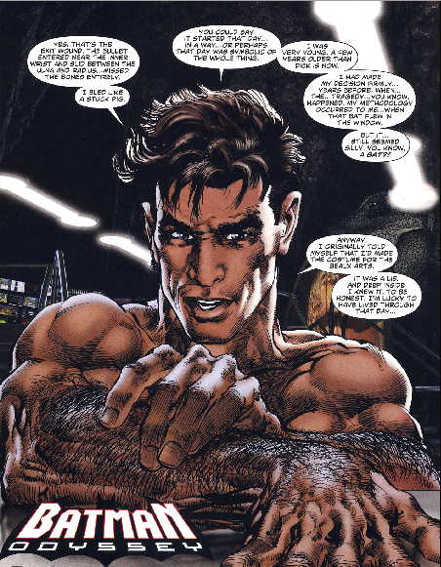
Laura: We open on Bruce Wayne, who looks faintly like Chace Crawford of Gossip Girl, expositing the hell out of what he is doing in copious word balloons. First question: Who is he talking to?
David: It's unclear, but it seems Shirtless Batman is talking to the reader. Every issue opens this way, and it literally gets sexier every single time. It is as if the reader just had a one night stand with Bruce Wayne and wakes up to him telling a story on a monthly basis. 12 issues, 12 Sexy Nights with Bruce.
Laura: It's pretty clear from the get go that neither Batman nor anyone else he encounters will have a single thought, no matter how mundane, that will not be shared with the reader. Within the first two panels, you have no less than two characters both speaking and thinking in separate dialogue bubbles simultaneously, about absolutely inconsequential sh*t including but not limited to: the history of trains, and why Bruce Wayne should bang the conductor's daughter.
David: Plus narration boxes!
Laura: And suddenly, Batman is charging up a train with a loaded gun. A gun that he is trying to hold in one hand while he climbs.

David: Which was a stupid thing to do. We knows this because the thought bubbles are telling us that he's thinking that drawing the gun early was stupid while the box is telling us how future Bruce feels about carrying guns.
Something to consider: Imagine you are on a date, and your date is saying everything that Bruce is saying in the narration boxes.
Laura: And then there is the caption box where Adams manages to actually insert Bruce's thoughts, in quotes, INTO THE CAPTION. Beside his thought bubbles. And at one point there is a caption that says "I thought..." right next to a thought balloon.
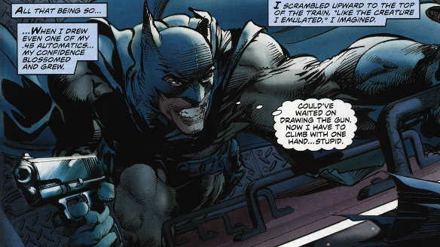
David: Did you know that bats scramble on the sides of trains? It would help if Batman also thought some trivia about bats at us so that this could be an educational book too!
Laura: I appreciate this both because 1) He is telling us something that we can see with absolute clarity and 2) he is reminding us that Batman is a character who emulates bats, through the voice of Batman.
David: The issue you're alluding to will bring us to one of the primary challenges of this comic, I think. Which is the multiple plots and how they overlap. Like, shirtless Bruce is telling this story right now, but then it seems like he's actually telling a story about this time that he was telling Robin a story about the time that he was on the train. And that's when things start to get crazy.
Laura: You mean when we discover that there's a maniac there with him on top of the train? A Spanish maniac? Whose codename is MANIACO?
David: He is a maniac, Laura.
Laura: Meanwhile, back in the Batcave, Batman gives a handgun to his child sidekick, who is immediately lost in the throes of gun fever. Batman gives Robin this gun in order to explain how important it is that Robin stay away from firearms.
David: "I was a fool to pack guns. Robin, hold this gun."
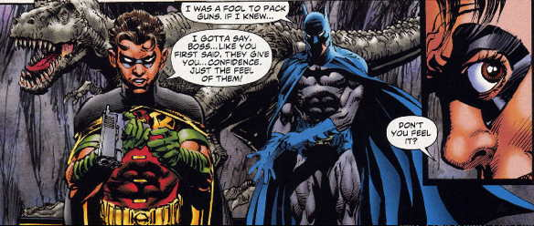
David: And then we get our first non-sequitur guest star! The first of many. I'm not really sure what happens here. Man-Bat just sort of shows up, and then Batman scolds him a bunch?
Laura: The best part is that Man-Bat attacks Robin right in the middle of the lecture about guns--
David: --and Batman doesn't even notice.
Laura: Neither of them do! Man-Bat flies Robin up to the ceiling, and flings him across the Batcave, while Batman and Robin continue their philosophical debate about guns as though absolutely nothing is happening. While Robin is hurtling towards a stone wall, he's still answering Batman's hypothetical question about the best way to survive a gun battle.
Then after three or four pages of fighting that is never acknowledged in the dialogue, Batman finally notices Man-Bat, who turns to him in a moment of Lynchian non-sequitur and says that "the answer is 8."
David: I think you mean "B."
Laura: Is that what it says? I mean, either way. He literally could have said anything and it would have made the exact same amount of sense.
David: That's the beauty of this. And then Shirtless Batmans's captions go insane. (Or should I call him Nude Bruce?) This guy is completely unstable. He goes from completely freaking out at Man-Bat to hopping towards the Batmobile with Robin and making some very uncharacteristic jokes.

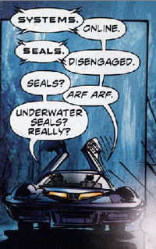
David: That happens. Batman makes a joke about barking seals. Oh, and they just leave a highly unstable Man-Bat in the Batcave

Laura: But not alone!
David: Of course not. There is another, larger Man-Bat there.
Laura: Who starts freaking out about not letting Batman see the cave, which is not the cave they are in at all, but another cave.
David: Do you know what cave he's talking about?
Laura: I can only assume it is Plato's Cave, which sounds a lot like reading this book: Desperately trying to ascribe meaning and order to the bizarre, jumbled images projected before you without any context.
David: I don't know what to believe anymore.
Laura: What else of note happens in this issue?
David: The Batmobile is a car, then it's a plane, then it's a boat, then there is a panel that is pretty much right out of All-Star Batman and Robin.
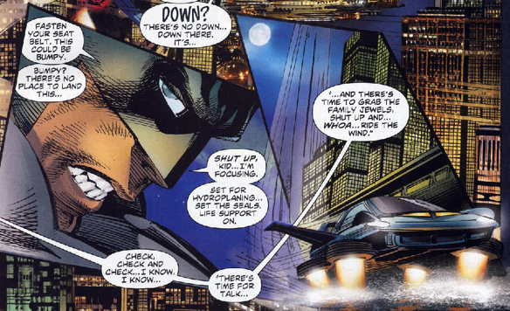
Laura: I love how everyone freaks out non-stop about everything that happens in this book. Riding in the Batmobile BLOWS Robin's mind. Batman deciphering the plan of a villain BLOWS Gordon's mind. Everyone is in a state of perpetual shock and excitement about each incremental advancement of the plot.
David: Yeah, they show up in the awesome Corvette Batmobile, but then they just whip out hang gliders and float away. And Commissioner Gordon and all the cops act like Batman's their crazy rich uncle who buys everything in the SkyMall catalog.
Issue #2
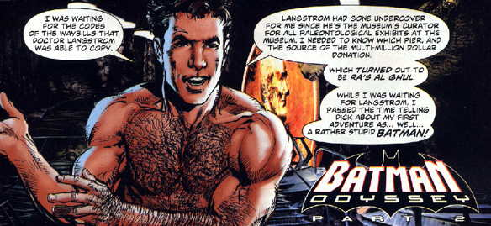
David: Issue #2 is easily the best and most insane issue in the series, without a doubt. The first page is when it becomes clear that Nude Bruce is telling us a story about the time he was telling Robin a story about what happened on the train. And while he is telling the story about the train to Robin, all of these other things are happening, which Nude Bruce is also telling us about. SO: he is simultaneously attempting to tell us two stories, and in Story A, he happens to also be telling Robin about Story B.
Laura: Is there a way to make a narrative map of this?
David: Yes: http://en.wikipedia.org/wiki/M%C3%B6bius_strip
Laura: The dialogue is so amazingly tone-deaf in ways both small and large, but in such an interesting way. Like the father who tells his roughly 7-year-old daughter to "stay organized" when they are held at gunpoint by criminals.
David: It's much more fun to imagine one person shouting these things, like the narrator on the Watchmen motion comic. Sometimes I read it aloud, too.
Laura: For this reason, I have helpfully created an Xtranormal video that reenacts the pages and pages of bizarre dialogue wherein Batman tries to explain the inner workings of a hydrogen engine to the world's stupidest criminal.
Also, the evil plan concocted by the villains at the museum, as I understand it, is to steal dinosaurs and inexplicably shoot tanks of hydrogen.
David: No, Laura. It's a hydride. Everyone knows this. The doctor knows this. The doctor's small daughter knows this. Batman knows this. The guy with the gun? He refuses to accept it.
Laura: Even after Batman pauses for several pages to conduct what is essentially a very violent AP chemistry class.
David: This was exactly like my high school chem class. Someone explaining something very simple to me three times, and continuously calling me an idiot. And then I'd get punched in the face.
Laura: Batman rescues the professor, but then gets assaulted by goons with automatic weapons in a splash page that plays out like Passion of the Batman. And/or an amazingly bloody krumping battle.
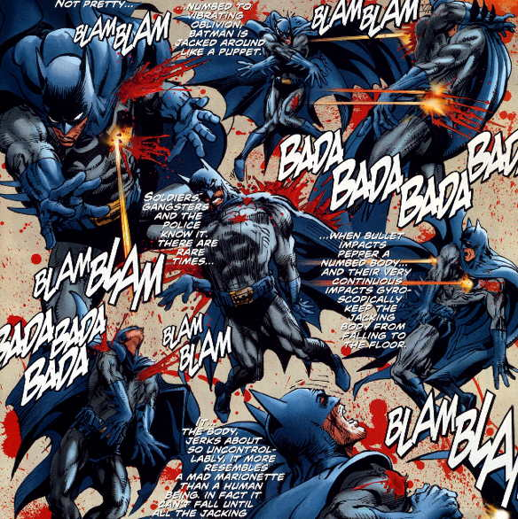
David: This might be the best page of comics in 2010. I once spent an hour trying to figure out the dance moves that he does in here. There's at least one Charleston.

Laura: Then while he's lying on the floor, spattered in blood, we get the caption: "Dis-attached, Batman's brain floats off..." An image I deeply wish had been illustrated. Seriously, a separate plot thread featuring the adventures of Batman's floating brain would have been amazing.
David: But Batman's brain floats back to the first plot thread, so you technically get exactly what you want.
Laura: Oh crap, it really does. And it begins "I don't even know why I didn't finish the story for Dick." Which is basically a meta-acknowledgment of how disjointed this story is, by the writer himself. Batman doesn't know why he didn't finish the story. Adams doesn't know why. Nobody knows.
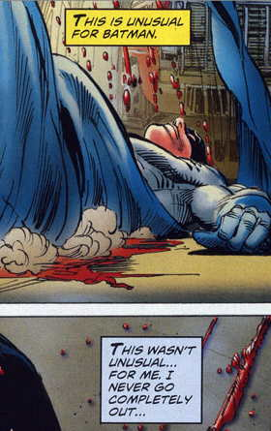David: Also, let's acknowledge the emergence of the yellow caption box. I believe that's third person omniscient, out of nowhere?
Laura: Yes. Side by side with the blue caption box, which is Batman narrating first person from the original plot thread. At one point, and this is amazing, after the yellow caption says, "This is unusual for Batman," literally a panel below Batman completely contradicts the OMNISCIENT NARRATOR and says, "This wasn't unusual... for me." Fight! Fight for control of your fictional reality!
David: Also, do you realize that Maniaco suddenly goes from helping Batman stop the guy who was blowing up the train to being the guy who is about to blow up the train?
Laura: Holy crap, you're right. Then all the original bad guys jump off the train, and Maniaco says, "It's like they were never here!" And he's so right, because we are suddenly in a totally different story.
Also, Maniaco has a transmitter with a button that when pressed will blow up the train... five minutes later. I love how Batman takes it apart and tries to figure out how to "unpress" it. I'm pretty sure that after you have sent a signal through the air to an electronic device, you cannot "unpress" that signal by pulling the button up again. But I am not a technical genius like Batman.
David: He's like my grandparents were with email. "DEAR LORD HOW DO I CLICK UNSEND?" But it's all right, because those five minutes give Batman time to shoot at everybody on the train. And it is the Best Thing Ever.
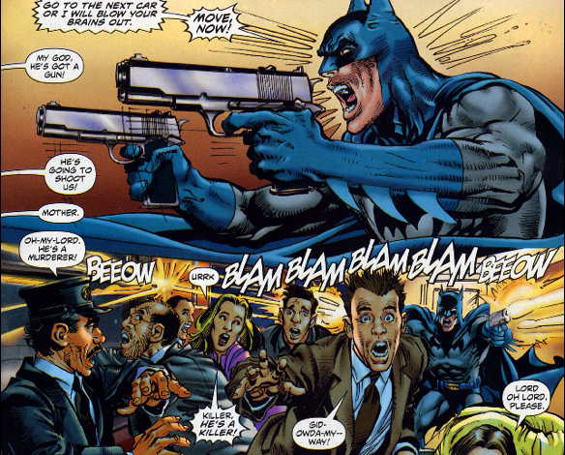
David: The passengers won't leave the train because they think he's crazy. So he shoots guns at them. He shoots AT them.
Laura: Yeah, he he doesn't just fire a gun into the air. He unloads multiple clips while shooting TOWARDS the passengers, action movie villain style. If it were possible, I'm pretty sure he'd be lunging at them in slow motion, screaming while spittle flies from the sides of his mouth.
David: I don't really get how he didn't accidentally hit anyone.
Laura: I mean, maybe he did? How would we know? He fired an incredible number of bullets at a large crowd of people in a small metal room. Then the train explodes, and for one panel Batman basically says that he died, which would kind of be a fantastic new twist to the story -- if he were actually telling it from beyond the grave, including the story of the first plot thread where he's telling the story of the other two plot threads where he's telling stories.

David: This is, appropriately enough, the most confusing explosion that I've ever read in a comic. Explosions, by definition, are not meant to be confusing things.
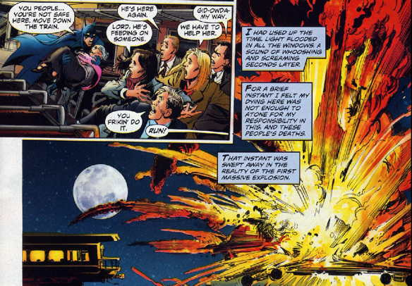
Laura: But because it is Neal Adams, it still looks amazing. Actually, you know what? I think I have discovered the secret to reading this comic: Don't look at any of the words. Just look at the pictures, because Adams is still a great artist who understands visual storytelling.
David: It's a good point. It's strange that Adams sort of undermines his own gifts as an artistic storyteller with all of this unnecessary narration. Or perhaps it's another meta thing happening here. The confusion is essential for us to understand Batman's state of mind as everything is unfolding around him.
Laura: Is the entire series a metaphorical representation of what it's like to be shot? Because so far it is basically an anthology of disconnected stories about Batman getting riddled with bullets.
David: Perhaps what it's like to be shot twice in the same spot in 20 minutes? That angry guy after the train crash actually shoots him through a bullet hole.
Laura: I really, really hope at the end we find out that Batman really did die in one of these shootings, and that the entire series represents the fractured recollections of his life that ran through his mind in his last moments, An Occurrence at Owl Creek Bridge style.
Regardless, after we see Batman lying near death from the train wreck shooting, nude Bruce appears again and explains that incident at the train was actually a flashback he had in the plotline at the museum. Even more confusing, issue #3 opens with Alfred nursing Bruce as he tries to recover from a bullet wound, except that it's impossible to know which shooting it's from.
David: Incorrect. Issue #3 opens with Bruce leaning in to kiss you.
ISSUE #3
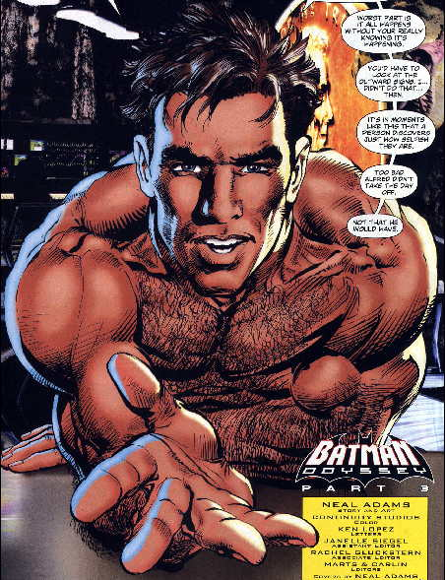
Laura: The urgency in Nude Bruce's eyes seems to increase with every interlude.
David: Then we flash back to Alfred taping Bruce up from the train situation, and then the two of them have the weirdest conversation.
Laura: Are you sure that's from the train shooting? Because apropos of nothing, he's talking about how some man named Harry Tree – whose name we have never heard before – just killed another woman.
David: Yeah, you're right. So this is after the situation where Batman played dead at the museum. I THINK.
Laura: Or maybe it takes places after an entirely new shooting at an entirely different time. I think this is genuinely a real possibility. Regardless, his conversation with Alfred includes this touching exchange:
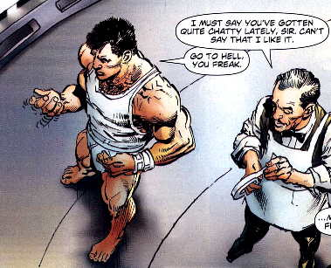
David: Also, more evidence of Batman's looming insanity. He goes from getting ready to sucker punch Alfred, to having a puppy dog face and opening up to him.
Laura: Batman in Odyssey is basically an abusive boyfriend checklist. Is he prone to extreme mood swings? Does he call you names and demean you? Does he threaten you physically if you don't do what he wants? Does he own a gun?
David: So there's a little bit of Lifetime movie in here too! Starring Meredith Baxter Birney as Alfred Pennyworth.
Laura: I want to make an animated gif of the angry face and the puppy dog face just flipping back and forth into each other:
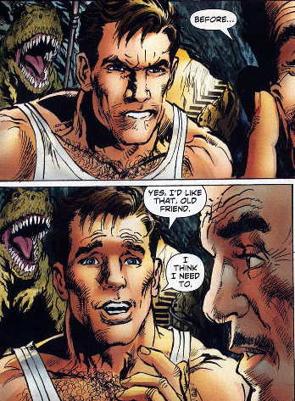
David: And then we flash back to the museum where Batman is pretending to be badly wounded, and we get the best narration ever as two thugs talks about shooting Batman in the face.
Laura: While Batman also talks about them shooting him in the face. From the future. I honestly think this is a fair paraphrase of their conversation:

Batman: Then they decided to shoot me the face.
Alfred: Shoot you in the face?
Batman: Shoot me in the face.
Thug #1: You should shoot Batman in the face!
Thug #2: I'll shoot him, but... in the face?
Thug #1: Shoot him in the face!
Batman: Then he shot me in the face.
Thug #2: I'm shooting him in the face!
And then he shoots him in the face.
David: Let me just say that Batman is incredibly gifted at describing, in literate prose, the time that a guy shot him in the face three times. Also, you realize that this is now the second time that Nude Bruce is telling us about the time that he told someone else about that time. First he told us about the time that he told Robin about the time on the train. And now he's telling us about the time that he told Alfred about the time at the museum.
This. Is. Insane.
Laura: Again, it makes a lot more sense if you don't read any of the words, and just look at the pictures. Of Batman getting shot in the face. Except it turns out he actually has a bulletproof voice-activated clear facemask that drops down to protect him, so he doesn't really get shot. Then he jumps up and kicks their asses, while turning into the world's most awkward Sun Tzu.
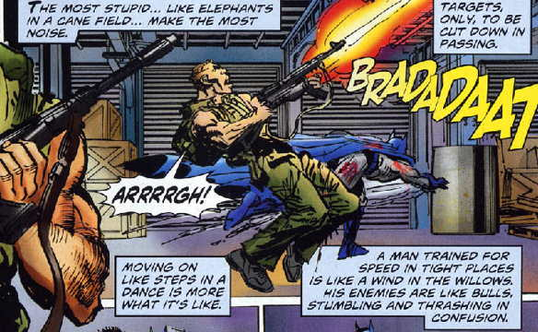
Laura: Then he says this: "They are still POIGNANTLY DANGEROUS."
David: I don't know what that means.
Laura: Nobody does! I think what we're seeing here is the exact moment when he discovers Thesaurus.com.
David: I wonder which Batman is narrating this part, by the way. Is he telling Alfred this stuff? Like, he was really angry and needed to open up, so he busts out this soliloquy about the art of hand-to-hand-combat?
Laura: Oh wow. And then he completely gives up on trying to describe the art of fighting and just says that his martial arts moves were totally like a scene out of Seven Samurai.
David: I didn't even get the whole Seven Samurai thing. He's just like, out of nowhere, "one time I watched this movie about with fighting in it. I am fighting right now."
Laura: Adams is asking the reader to visualize the combat as though it is a battle from a Kurosawa flick. Which is so nuts, because we are working in a visual medium RIGHT NOW. You can show the readers what it is looks like with actual pictures, in sequence. But instead he just draws a picture of Batman punching someone and tells us to imagine that it actually looks like a totally sweet Japanese martial arts film.
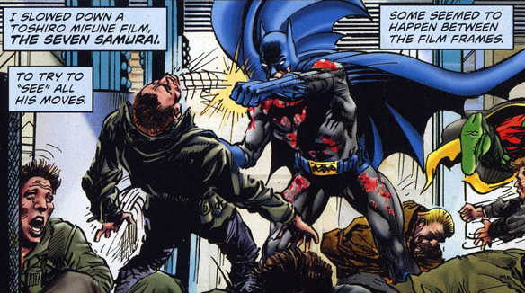
David: Warning: Random people are about to appear literally from nowhere. And Batman and Robin actually do a "whaaaaaaaat?" Something that helps me read this comic is to imagine Robin is played by a young Joey Lawrence, by the way.
Laura: We also learn that the enigmatic riddle from the, uh, Riddler was far, far dumber than we'd previously imagined. Dear English speaking people of the world, riddle me this: How would you please complete this sentence, which was supposed crafted by an evil riddle supergenius:
Too full to eat one bit more
Too loaded you can't order
Time to hear a friendly hint
How 'bout an after dinner _____
David: You realize that the Riddler actually says "mint" the page before Batman figures out mint, right?
Laura: NO. This is the best part. It turns out the answer is actually "WATER." Because we all know after we've completed a hearty meal, that's traditionally the moment when a hostess presents her guests with the customary after dinner water.
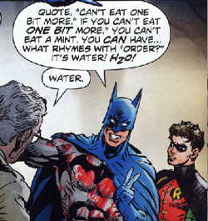
David: There is no logic to be found in that statement whatsoever.
Laura: Not least of all because order does not actually rhyme with water. Unless you have a terrible, terrible Boston accent.
Issue #4
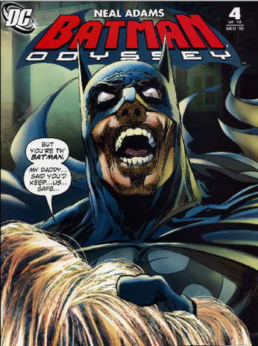
Laura: On to issue #4! Which kicks off with a cover where it appears Batman is about to eat the hair of a small child!
David: Tucker Stone pointed out to me that they appear to have Photoshopped real hair onto the cover.
Laura: In this issue, Batman confronts the Riddler, who is not actually the Riddler, a fact we learn thanks to the amazing shoutout to the 1997 Nicholas Cage/John Travolta movie Face/Off where Batman ACTUALLY PUNCHES RIDDLER'S FACE OFF.
David: Do you have any idea why Batman says "Reuben Blades" right before tearing off The Riddler's face mask? But what does Panamanian singer and actor Ruben Blades have to do with this?
Laura: Have we ever heard this name before? Ever?
David: In real life, yes. He was in Predator 2. It's weird that Adams randomly decided to name this assassin after a famous Panamanian superstar.
Laura: OK, so Reuben Blades is pretending to be the Riddler because something something, and then for roughly the same reason, he shoots a little girl that happens to be standing nearby. Which appears to be Batman's cue to drop catastrophic amounts of LSD.
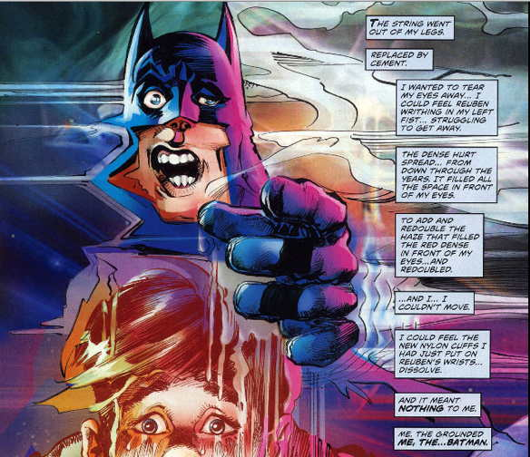
Laura: It's interesting how the father of the girl seems to show absolutely no anger towards the actual murderer -- Reuben Blades -- and turns immediately on Batman instead.
David: Batman straight up beats the hell out of Reuben.
Laura: Yes, but not before Reuben punches Batman while saying, "Hero! Jerk hero!" Because in addition to the father, the ACTUAL MURDERER has decided to blame Batman for her death, seconds after killing her.
David: It's more interesting how everybody freaked out about the girl being dead, but no one is actually paying attention to the little girl, who as it happens? ALIVE. It was a flesh wound. Batman almost killed a guy over a flesh wound.

And then Batman grabs a guy's camera and takes a picture of Reuben's brutalized face!
Laura: The best part of this issue is that after Batman has spent exactly six pages trying kill Reuben while Commissioner Gordon tries desperately to pull him off, the little girl lives. And then Gordon says, "You were going to kill that guy."
And Batman says:
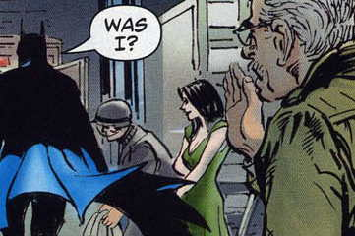
Yes. Yes you were.
David: Your abusive boyfriend theory works way too well.
Laura: And then for no reason, Deadman.
David: "And then for no reason" is something that basically holds this story together.
Hold on. We need to go back to the most important panel in this entire series:
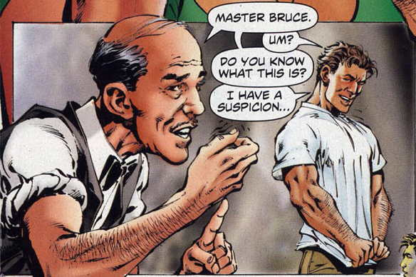
David: I could write a book about that panel.
Laura: The second Alfred/Bruce conversation is almost as nuts as the first, and includes a panel of Bruce Wayne laughing hysterically while saying, "Sworn to secrecy, ha ha! Such a thing! Such an octopus of a thing!" What.
David: Then Bruce brings Talia back to the cave, but is it the Batcave or THE CAVE HE DOESN'T KNOW ABOUT? Remember that?
Laura: No, wait, now suddenly they're on a pier or something. God, this is like trying to describe the plot of a dream. She shows him a photo album where there's a picture of them together as children, and OUT OF NOWHERE Ubu appears and tries to steal it, and calls Batman a "eunuch." Then, and this is completely true, a giant manta ray flies out of the ocean, and stabs Ubu in the heart, in a tragic parody of the death of Steve Irwin. TOO SOON.
Also, who is the purple guy in Huntress drag? Who shows up and calls Ubu a jelly roll?
David: I don't know? Also suddenly another Robin, who is blond, appears for two pages, says nothing, isn't explained, and then disappears. And in at least one panel, he has a tail.
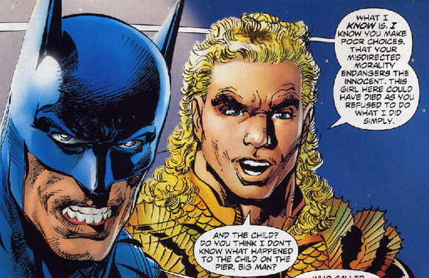
David: Plus, the best cameo ever: KENNY POWERS AQUAMAN.
Issue #5
David: Finally in issue #5, it's sexy banana time with Nude Bruce!
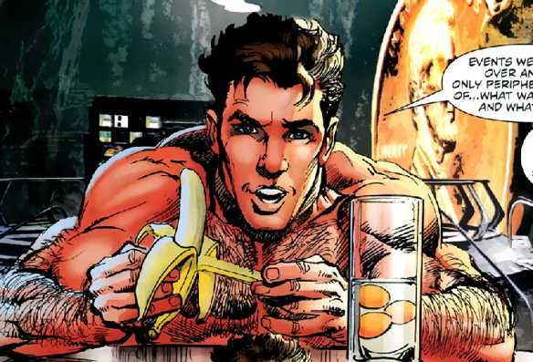
Laura: I can not believe Nude Bruce is actually eating a banana.
David: Oh, and on page one we learn that the Riddler impersonator's name was actually Reuben Irons. So yeah, the Reuben Blades thing was an error!
Laura: I still don't know who either of them are.
David: You know who Reuben Blades is. Trust me.
Laura: Nude Bruce takes us back to the docks, where where Batman is swimming around with Aquaman and a whale. And suddenly the manta ray who impaled Ubu brings him back to he surface where we learn that like every other character who appeared to die in the series, he's not dead.
David: You know something that Batman is not in this comic? A detective. Everything surprises him.
"Aquaman has a whale in the ocean? That's CRAZY!"
"That guy that someone called Ubu before is actually Ubu? And Talia knew? INSANE!"
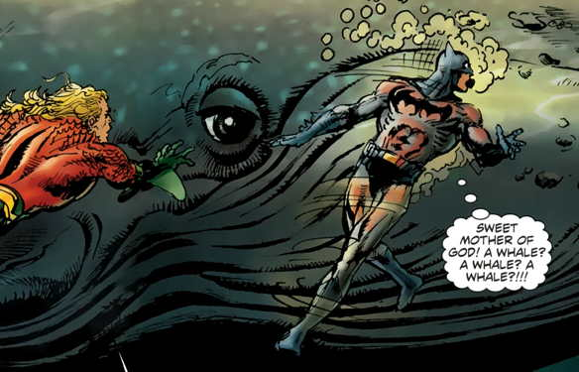
Laura: Talia finally tells Batman about the secret history between their families, sparking a grating couples argument that is about as much fun to read on the comics page as is it would be to experience while locked in an elevator with them in real time. This conversation goes on for pages and pages while Batman takes off all his clothes. In public.
David: And Deadman is kvetching the whole time.
Laura: I don't understand anything.
David: Then you are just like Batman.
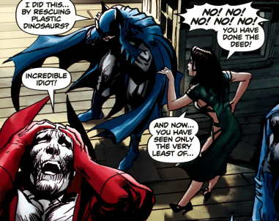
Laura: Meanwhile, somewhere else, three dudes that look like the Joker are slicing a dude's face open. Should I even ask how we got here? Or how Batman did?
David: Nope!
Laura: And then the cops show up but they're not the cops?
David: Right. Real cops don't say things like "drop dat clown." "Dat" is a word used exclusively by petty thieves, henchmen and thugs.
Laura: So instead of handing Joker, who is now only one person, over to the fake(?) cops after mutilating a prominent member of the community, Batman takes Joker for a joyride in the Batmobile, where they say the word CLOWNS about 20 times as the Joker explains that all Batman does is catch CLOWNS. Because clowns clowns clowns clowns clowns clowns clowns clowns clowns.
David: The next Batman movie should be called "Never... Just... Clowns," by the way.
Laura: By the fourth page I honestly could not believe I was still watching them talk about clowns.
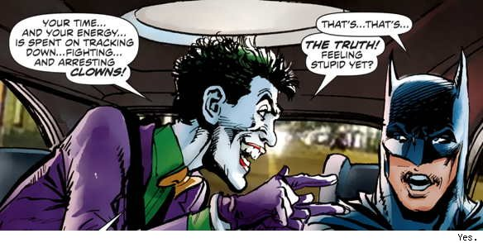
Laura: And suddenly Man-Bat attacks Batman again for no reason, gives him a mysterious key, and a bunch of things happen that I don't understand. Am I missing anything significant?
David: Let's see. A series of inexplicable and seemingly unconnected things happen in the course of 4 pages?
Yeah, you've got it.
Issue #6
David: Laura, upon looking at the first page of issue #6, I've had something of an epiphany: Whoever Bruce is talking to on the first page of each issue is clearly tied to a chair and gagged.
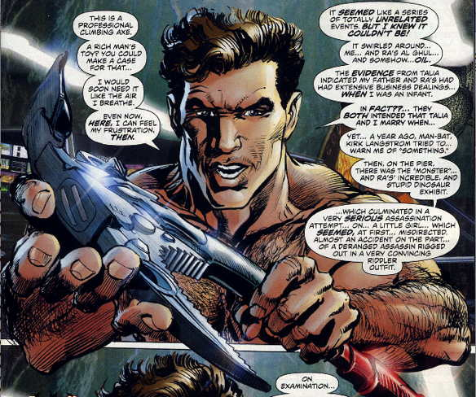
Laura: The axe is genuinely a little frightening.
David: That's what I'm saying! Sh*t just got REAL. He's basically about to torture a guy!
Laura: He's about to torture US. It's like a prelude to some sort of Reservoir Dogs moment. The collective audience is about to lose an ear.
David: If you read the book as if Bruce has been telling all of this to a hostage, it becomes a totally different story, and at least 3-5 times better.

There is also a shocking number of ellipses on this first page.
Laura: Wait, does the text in these speech balloons even meaningfully connect? This is exactly what they say: "In fact?? They both intended that Talia and I marry when... yet... a year ago Man-Bat, Kirk Langstrom tried to... warn me of something." It's like Bruce Wayne is talking his way through a stroke.
David: And then in the bottom... half of the... page... He starts talking about the murder of a child... except: THE.. CHILD... WAS... NOT... MURDERED.
When you get to the second page, though... I am reminded once again about Neal Adams saying that a lot of comic will be how Batman is unable to keep up with the tech of his enemies. And here he has a 3-D display coming out of his damn belt. Batman has a crotch computer.
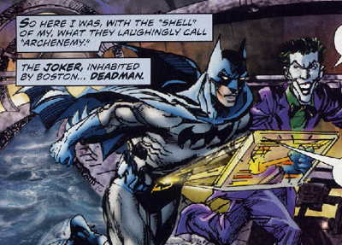
Laura: I prefer to think of it as a groin projector.
David: I wonder how he controls the cursor.
Laura: Now we're introduced to yet another new villain, a man named Doctor Slattern. Does Adams know what "slattern" means? Because it specifically refers to women. And it means "slut."
David: Words seem to mean so many things in this book. Although we are told that Doctor Slattern "needs help with the climax of his experiment." Maybe Doctor Slattern is in charge of all the SEXY experiments at Arkham, did you think of that?
Also, he actually wants to be called Trigger, and not like the horse. Because Batman wasn't sure about that. "Oh, this guy with guns wants to be called Trigger. I'm the world's greatest detective. It's probably after the horse, but let me ask just in case it's actually about guns."
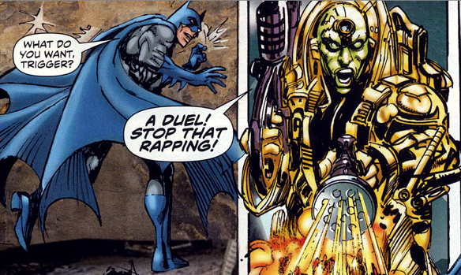
David: And what ensues could possibly be considered the best rap battle in Batman history.
Laura: After the inevitable defeat of Trigger in the impromptu rap battle, we also learn that Batman can literally run through walls. Just straight up run through them.
David: I like to think of it as "Batman likes to be prepared for walls."
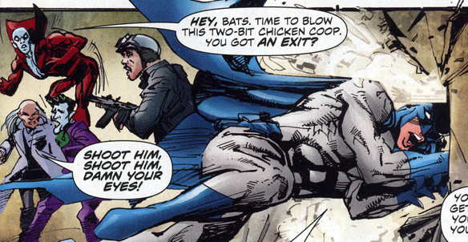
David: So after Batman lays down some raps and leaps through a wall, we're suddenly returned to the Batcave, right? But WHEN?
Laura: I'm looking right at it and I really don't know. Because it seems like we're jumping backwards in time to when Batman met Deadman for the first time, but Deadman is floating down into the scene from the panel where Batman escapes, implying it happens after.
David: Neal Adams broke the Fifth Wall. ...Is there such a thing as a... fifth... wall?
Laura: Doesn't matter. Neal Adams is making new walls just so he can break them. Also, when they talk about Deadman's apparently random shooting by a league of assassins, Bruce says, "Do you know who fingered you?" Which is really a very personal question.
David: And his answer to that question is a "plock of spit." Deadman was fingered by a plock of spit. I am the first person in human history to type that sentence.
Then on the next page, we get the Best Bruce Face ever.
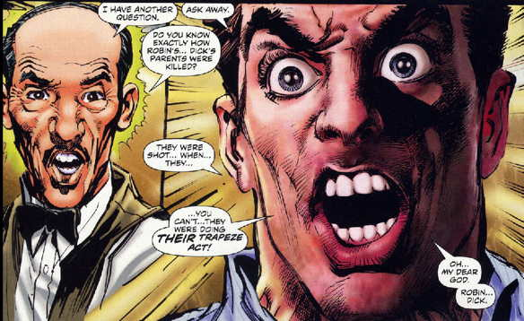
Laura: Oh my god, this face. It's like Bruce Wayne is about to turn into Large Marge from Pee Wee's Great Adventure
David: YES!!!! "Tell em Ra's Al Ghul sent ya!"
Laura: Everyone in this book is in a nonsensical state of total disbelief at all times, like they can't believe the comic is actually happening. You and me both, you guys.
David: Turn the page again and Ra's and Ubu show up. The Batcave officially has an open door policy in this book.
Laura: We also finally get to meet the blond Robin who showed up before with no explanation. His name is Primus, and he apparently can't stop slugging an old-fashioned Coke long enough to say hello to freaking Batman. In a moment entirely representative of the book, Robin says, "Oh man, you have got to hear this guy's story!" And then never tells it.
Look at his face in that bottom right panel. It is HORRIFYING. I think he's about to unhinge his jaw and eat regular Robin.
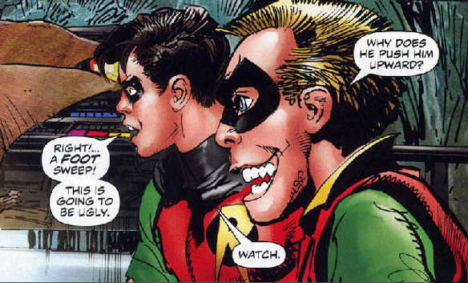
David: Please note that Ra's Al Ghul, a man of Middle Eastern descent, refers to Batman as "Senor Murcielago." Meaning that Ra's could very well have been in disguise as El Maniaco on the train.
And just who the hell is this other guy, Jamroth Bok? I'm getting nothing off Google. AND WHY IS HE IN A HUNTRESS COSTUME?
Laura: I have no idea. And why is Bruce fighting Ubu again?
David: Something that keeps happening in this book: 4-6 people will inexplicably gather and 2 of them will fight, while the others stand around and casually converse with each other.
Laura: Wait, they actually do explain why Ubu is fighting Bruce, and I guess it's a weird S&M thing:
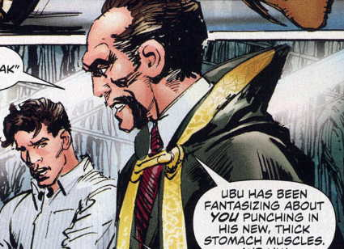
Laura: I don't know how to make that not gay. Really, the plot of the series would make a lot more sense if it were a porno. People show up out of nowhere, get physical for the most bizarre, tenuous reasons and then cut to other scenes at unconnected times where it all happens again with different configurations if people.
David: Do you think that somewhere on the internet there is a fan for whom Bruce and Ubu are OTP?
Laura: Let's ask Google! Wait. David. I just did a search, and... Have you been asking questions about Bruce Wayne's sex life on internet forums? You can tell me.
David: THAT'S NOT ME!
Laura: Suuure it isn't.
David: Just get ready, because the next few pages are going to make your head explode.
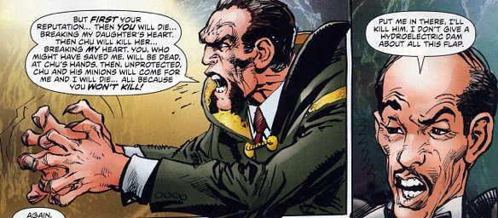
Laura: Wow. Alfred offers to straight up murder a dude.
David: Yo, he don't give a hydroelectric dam, Hudson.
Laura: Then, in the best of all possible endings, our first six-issue run concludes when Bruce Wayne actually lies down in the middle of a tense debate with Ra's. And takes a nap. While Deadman screams over him like this is the cover of Crisis on Infinite Earths.
David: Yes, yes and yes. A fitting bookend to the first half of this tale.
Laura: It also closes with Bruce announcing that now he is finally to go on his ODYSSEY to an unspecified place. And it should be clear to us where it's going next, because as Batman says, he's given us all the clues.
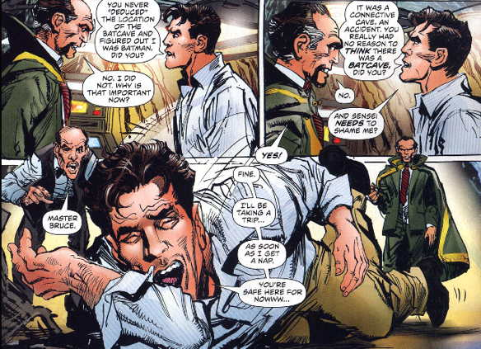
Laura: Tell me, David. Where do you think he is going on his Odyssey?
David: You already know my answer is I have no idea. I would like to think that there will be a Bat-boat involved.
Laura: I think you're not being ambitious enough. You know it is going to be way crazier.
David: Is that even possible? Like, the next six issues will be Batman traveling through the tattered remains of the Ultraverse, trying to find Ra's Al Ghul's long lost forgotten child?
Laura: Are you questioning the ability of this comic to take you to depths of madness heretofore unseen? Some people might call that hubris, David.
David: You're right. If anything, I've been humbled by this book. I thought that after 15 years, I knew how to read comics. Clearly, I do not.
Laura: I mean, we've seen so many things at this point.
David: We saw Aquaman as Kenny Powers. We saw Alfred making sex hands.
Laura: We saw a giant manta ray leap out of the water on to a dock and stab a human bat in the chest.
David: We saw Batman shoot at a crowded train full of civilians.
Laura: We saw naked Bruce Wayne in a sexually charged scene with a banana. We saw the look in his eyes as he prepared to torture us, personally, with an axe.
David: We saw the best typo in comics history lead to an unintentional mention of Panamanian super-celebrity Ruben Blades.

Conclusion
David: I have to be honest. I've read a lot of comics with Neal Adams art, and I've always loved it. He's truly a legendary creator. This is the first thing I've ever read of his that he's written, and at this point, as much as I'm enjoying it in my own way, I simply have no idea what to make of it. Part of me wants to believe that this is totally leading somewhere, that everything ties together in a very real way, and that even the ultra-confusing use of overlapping thought bubbles, speech bubbles, caption boxes, and mulitple sources of narration from the same person at different times is actualy serving the larger story in some sort of brilliant way.
Laura: I don't think it's intentionally serving the story in any way. But that doesn't mean it can't be brilliant a la Tommy Wiseau.
David: Reading this feels like waking up in a ballpit filled with every action figure of every Batman character ever made and then at the moment you open your eyes, they all start telling you their life stories.
Laura: It feels like a digital upload of every Batman comic in existence to my brain went horribly wrong and this is the David Lynchian fever dream my brain constructed to make sense of the phantasmagoria of images scattered around my consciousness.
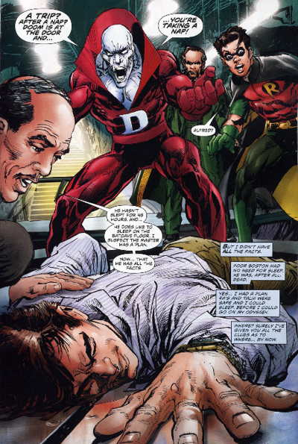Seriously, doesn't it seem like dream logic sometimes? People that no one has ever seen before show up for no apparent reason, but everyone just seems to know who they are. No one explains anything, except when they do and it doesn't really make sense but it doesn't matter. Things change without warning and reality warps to embrace it as we bounce back and forth to different scenes without any sort of logical transition.
David: Do you think maybe someone is performing Inception on Batman?
Laura: Actually, that makes a lot of sense. All the different temporal points are different dream layers. And Naked Bruce is at the top in "reality," controlling all the machinery and threatening our prostrate bodies with an axe while our minds remain locked in deeper and deeper worlds of fictional madness.
David: Or... Oh my God, I know who else Nude Bruce might be talking to. Neal Adams himself.
Laura: You're right. That's how he knows this story.
David: Can you imagine if someone were to ask Adams about his writing process, and he was all "Oh, Batman tells me all of this."
Laura: Batman appears to have some serious structural issues in his storytelling.
David: Or perhaps it is simply impossible for a mere human being to replicate the supreme storytelling abilities of The Batman.
Laura: Interpreting the divine gospel is difficult for every prophet. We are but imperfect vessels of the infinite.
David: Think about the best Batman stories as gospels. And in like 2,000 years, some religious scholar will be like "And then there was the Lost Gospel of Neal."
There's a necessary recovery period that comes from reading these comics all at once. But I am so pumped for whatever is coming in the second half of this, even though I'm not mentally prepared for it at all.
Laura: Yeah. I'm not sure if I can handle it, but I can't wait.


