Your Secret Santa gift is some artwork of various characters from Princess Pri. First, little preamble.
Couldn't in good faith do a full review. Not enough to say. Wander around at look at things for an hour. Dialogue is a little spicy. Is fine. For what it is and was made for, pretty good, actually. There's not a distinct tonal shift between acts, so the 'swap in the middle' aspect was pretty successful.
Noteworthy bugs:
- Right near the end of the first half of the game, for the library room and when Andra showed up, the Message Window was misplaced into the centre of the screen and not the bottom of it. It seemed to me that it switches between two styles of MWin, as that centre of screen is what it does when picking up items, and simply didn't get switched back until 3-4 minutes later.
- It's possible to retreive an infinite number of keyrings from the cell next to Caprsi. Ultimately harmless, though.
- I think I saw two minor typos, but ultimately neglected to write them down. Both in the first half, I think. Probably not worth hunting down.
I'll also mention that I was initially looking at doing a review of Vertigo Temple, but the game would keep freezing about 30 seconds after the first phone video; shortly after it dumps the player back in your house. Combined with it not appearing to have a save, I could tell I wasn't going to be able to get far or do much with it.
Anyway:
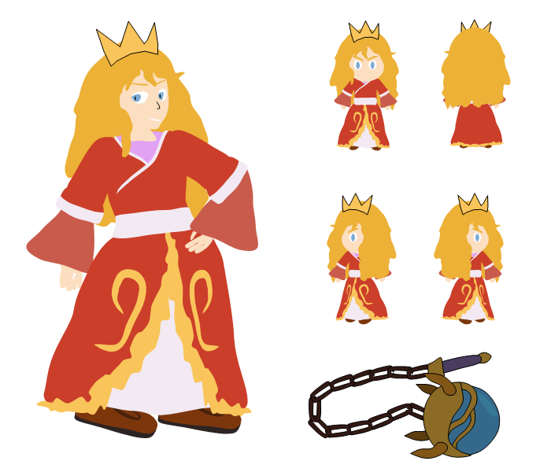

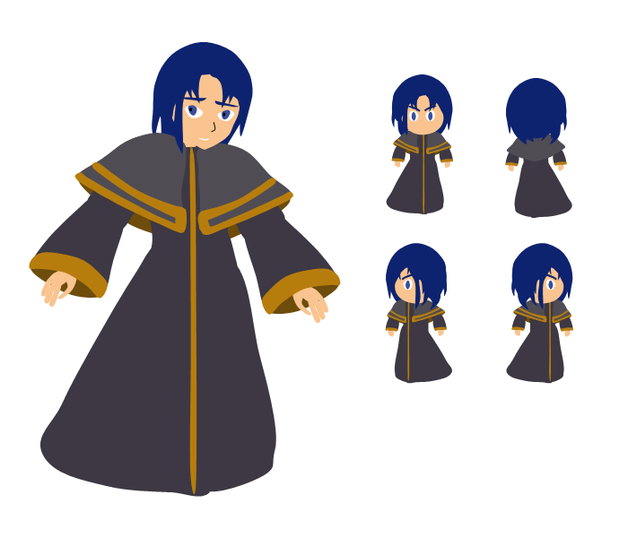

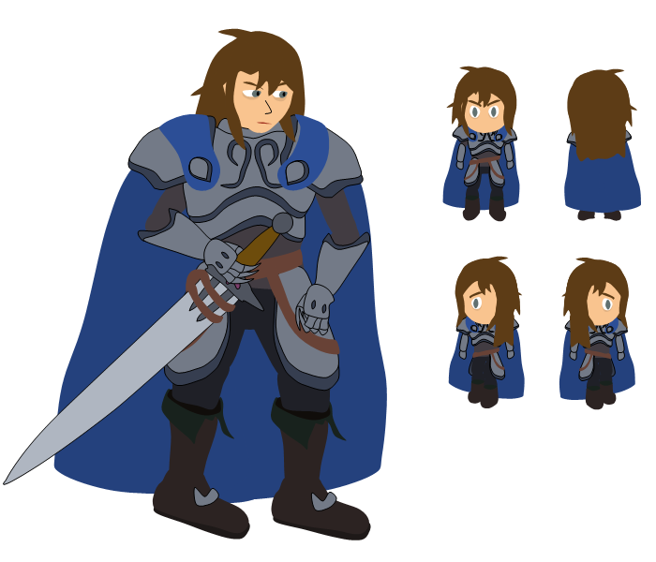
Regarding the magic-looking morning star by Pri, I made it as a reference to her sock-book-flail and water magic, but ultimately didn't show her holding it, as it might've felt too out of character. And also I don't think she'd look quite as sassy with it.

